**GAUSS’S LAW**

**Exercises**

**Section 21.1 Electric Field Lines**

**17.** **Interpret** This problem involves associating electric field lines to charges. Given the electric field lines and the magnitude of a single charge, we are to find the net charge.

**Develop** The number of field lines emanating from (or terminating on) the positive (or negative) charges is the same (i.e., 14), the charges have the same magnitude. The field lines are pointing toward the middle charge, which means that a positive charge placed in this field will experience an force attracting it to the central charge. Thus, the central charge must be negative (i.e.−3 μC). The field lines point outward from the outer charges, so they are positive charges. Because the same number of field lines emanate from the outer charges as from the central charge, they must have the same magnitude, so the outer charges are +3 μC. Sum the charges to find the net charge.

**Evaluate** The net charge is thus +3 μC + 3 μC − 3 μC = +3 μC.

**Assess** If the magnitude of the central charge were less (greater) than 3 μC then fewer (more) lines would terminate on this charge.

**18. Interpret** This problem is an exercise in drawing electric field lines to represent the field strength of a charge configuration.

**Develop** We follow the methodology illustrated in Figure 21.3. There are 16 lines emanating from charge +2*q* (eight for each unit of +*q*). Similarly, we have 8 lines ending on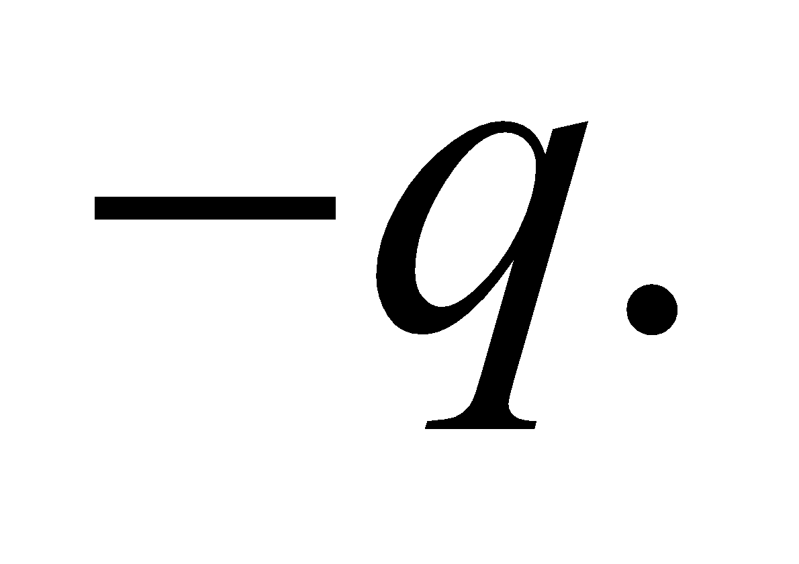

**Evaluate** The field lines of the charge configuration are shown in the figure below.



**Assess** Our sketch is similar to Fig. 21.3 (f) with twice the number of lines of force.

**19. Interpret** In this problem we are asked to identify the charges based on the pattern of the field lines and the given net charge.

**Develop** From the direction of the lines of force (away from positive and toward negative charge) one sees that *A* and *C* are positive charges and *B* is a negative charge. Eight lines of force terminate on *B*, eight originate on *C*, but only four originate on *A*, so the magnitudes of *B* and *C* are equal, while the magnitude of *A* is half that value.

**Evaluate** Based on the reasoning above, we may write 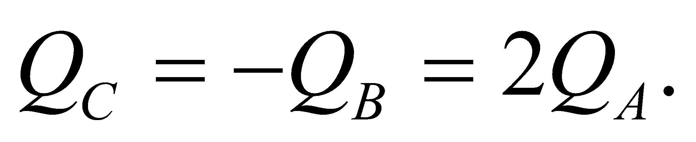 The total charge is 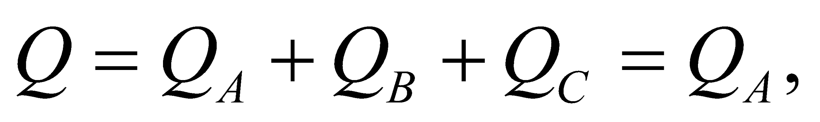 so 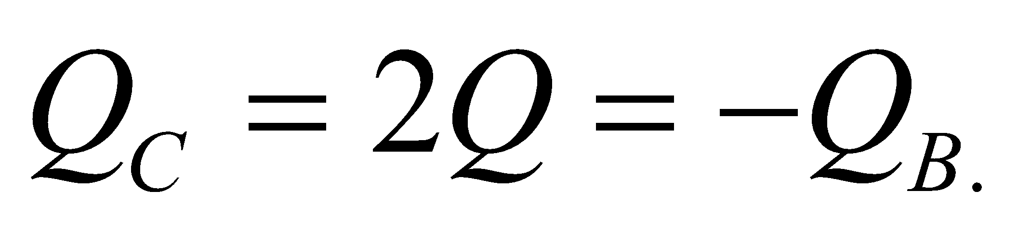

**Assess** The magnitude of the charge is proportional to the number of field lines emerging from or terminating at the charge.

**Section 21.2 Electric Flux and Field**

**20.** **Interpret** This problem is an exercise in finding the flux given the electric field, a surface area, and the relative orientation of the surface with respect to the electric field.

**Develop** The electric flux is defined by Equation 21.1, 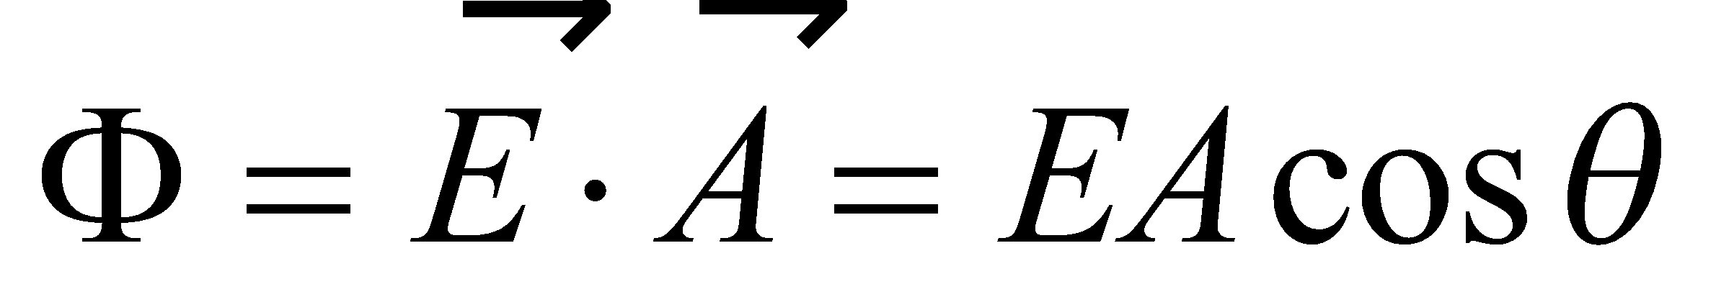, where 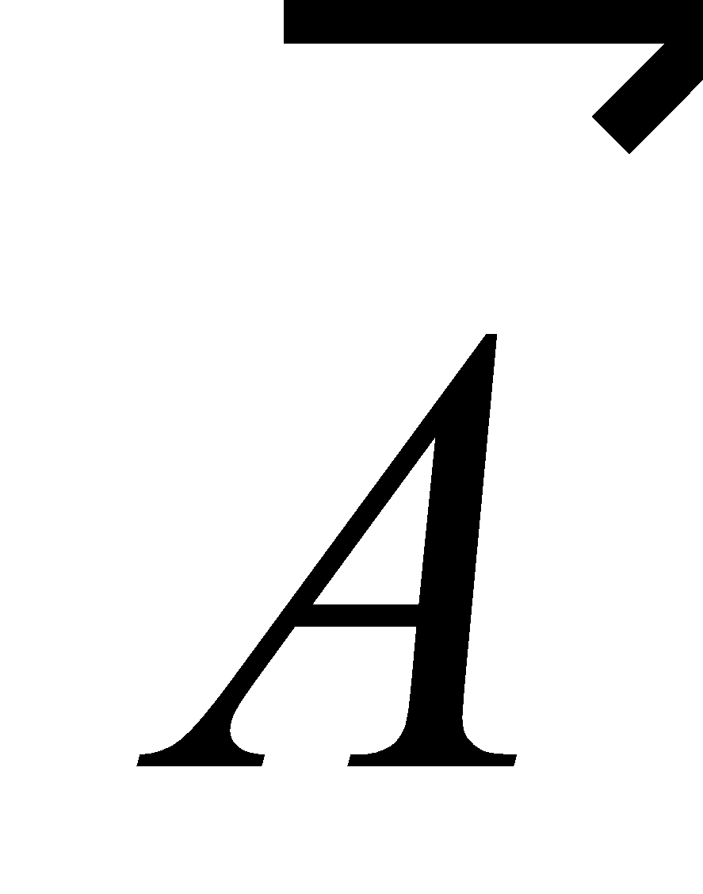 is a vector whose magnitude is the surface area and whose direction is normal (i.e., perpendicular) to the surface, and *θ* is the angle between  and 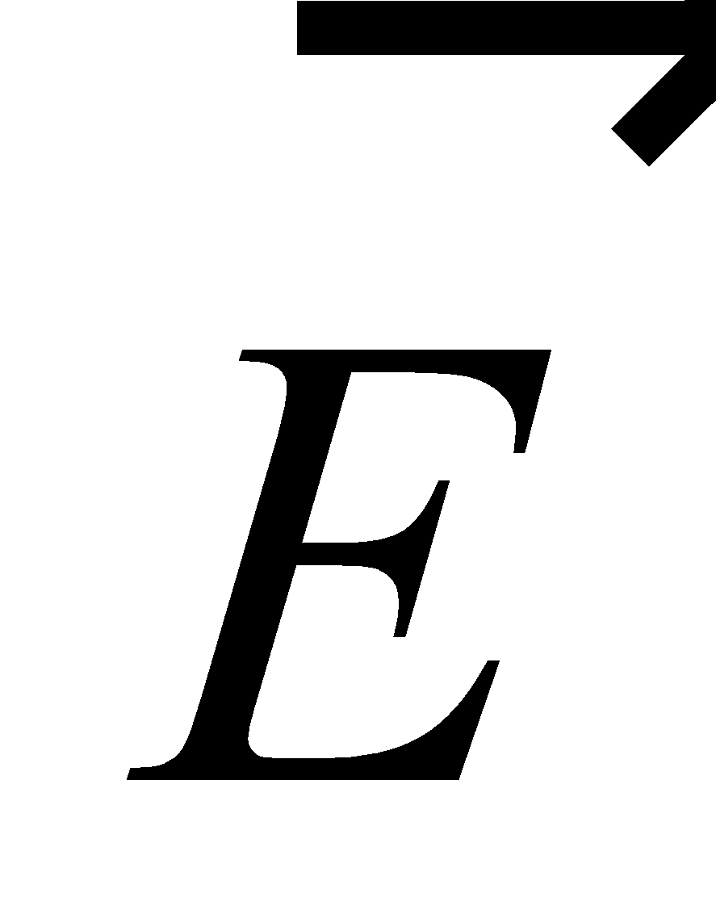. Given that the magnitude of  is *A* = 2.0 m2 and *E* = 850 N/C, we can find the flux for the given angles.

**Evaluate** (a) For *θ* = 90°, the flux is



(b) For *θ* = 45°, the flux is



(c) For *θ* = 90°, the flux is



**Assess** Note that the angles given in the problem statement are between the plane of the surface and the electric field, whereas the angle *θ* is the angle between , which is perpendicular to the surface, and the electric field.

**21. Interpret** This problem involves finding the electric field strength, given the flux through a given surface.

**Develop** The flux is given by Equation 21.1,



where  is a vector whose magnitude is the surface area and whose direction is normal (i.e., perpendicular) to the surface, and *θ* is the angle between  and . If the surface is perpendicular to the electric field, than *θ* = 0° or 180°, so cos*θ* = ±1. The magnitude of the flux through such a surface is thus

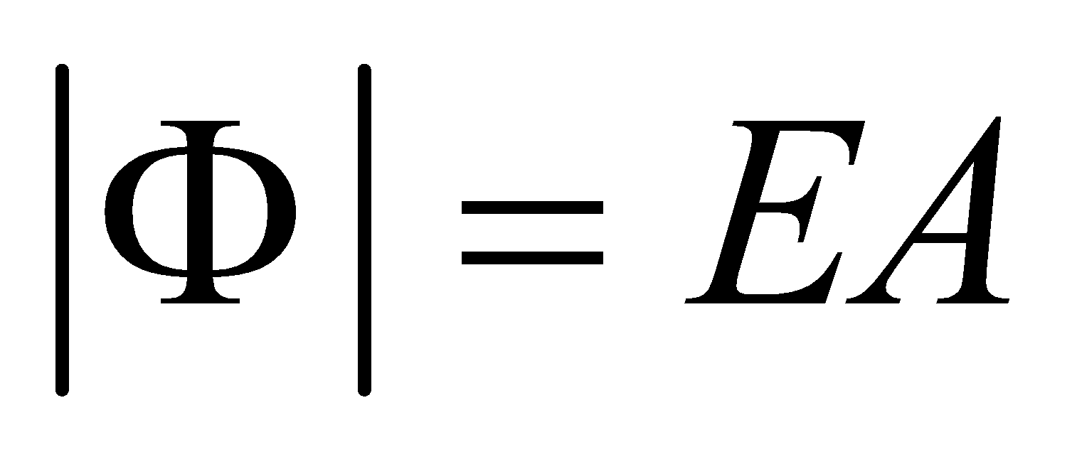

**Evaluate** From the equation above, we find the field strength to be

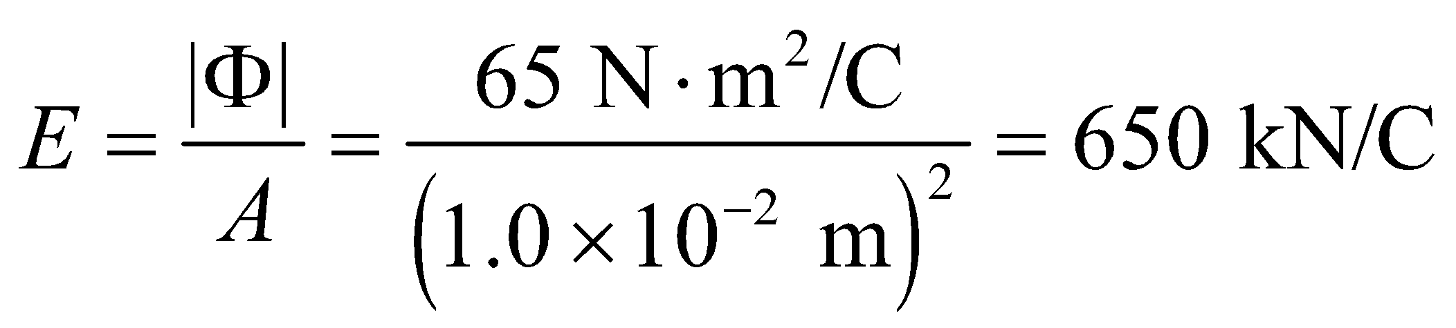

**Assess**  We see that when *θ* = 0°, Φ = *E*/*A* is a maximum, and when *θ* = 180°, Φ = −*E*/*A* is a minimum.

**22.** **Interpret** This problem involves calculating the electric field flux through a surface. We are given the relative orientation of the surface and the electric field.

**Develop** The surface lies in the *xy* plane, so its normal is in the 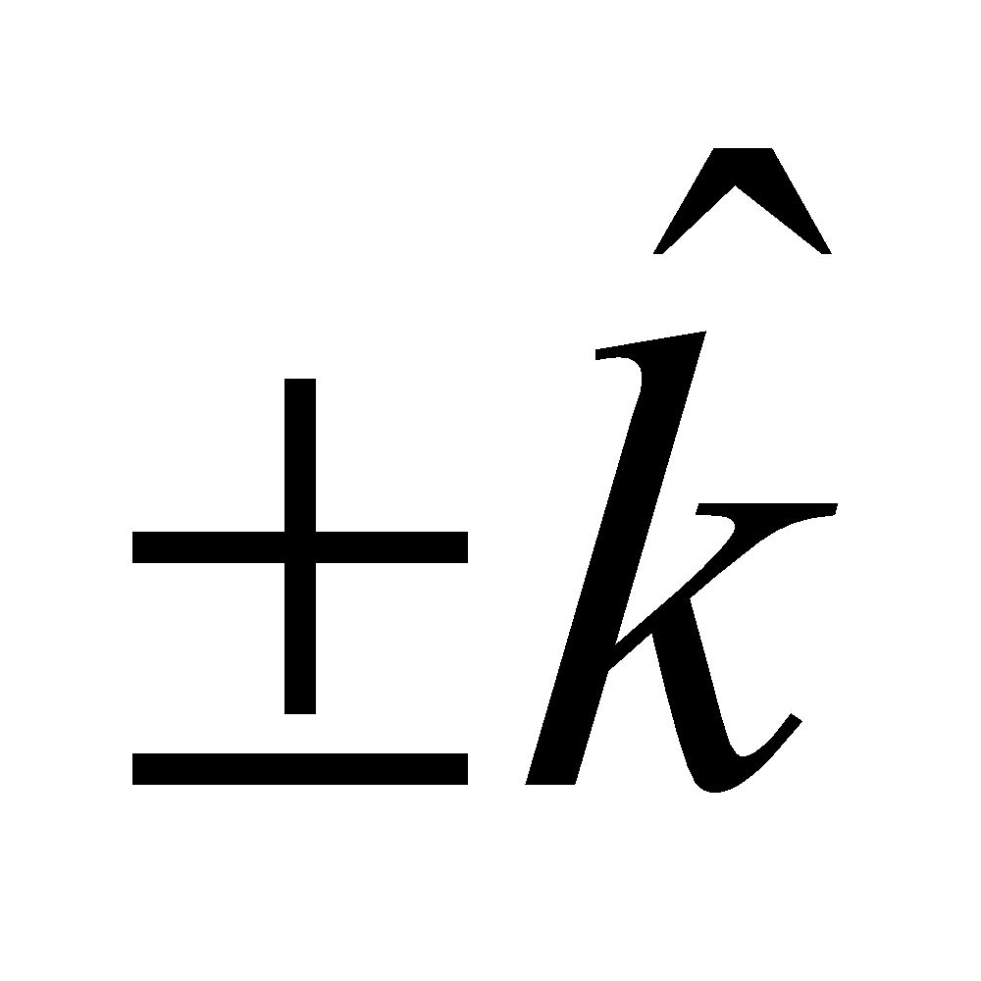 direction. Therefore, the surface can be represented by a vector area 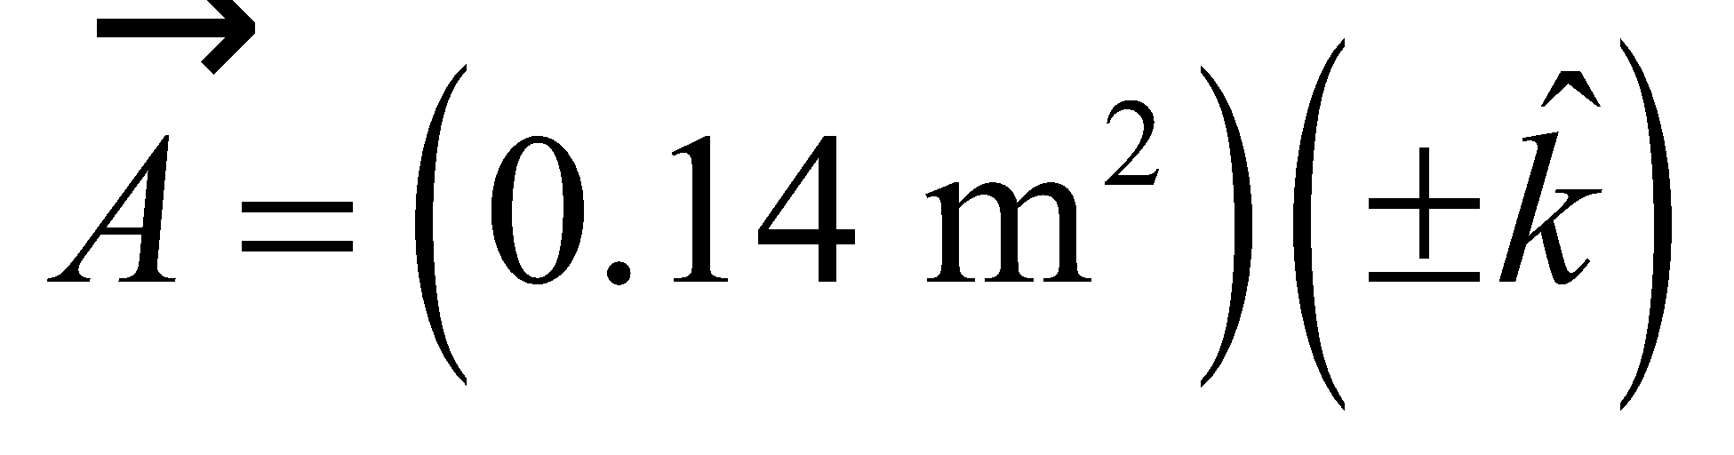. The electric field flux is given by (Equation 21.1)

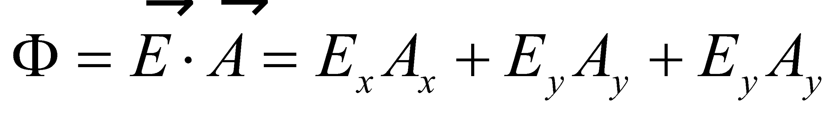

which we can evaluate given the electric field in component form.

**Evaluate** The electric field flux is



**Assess** Only the 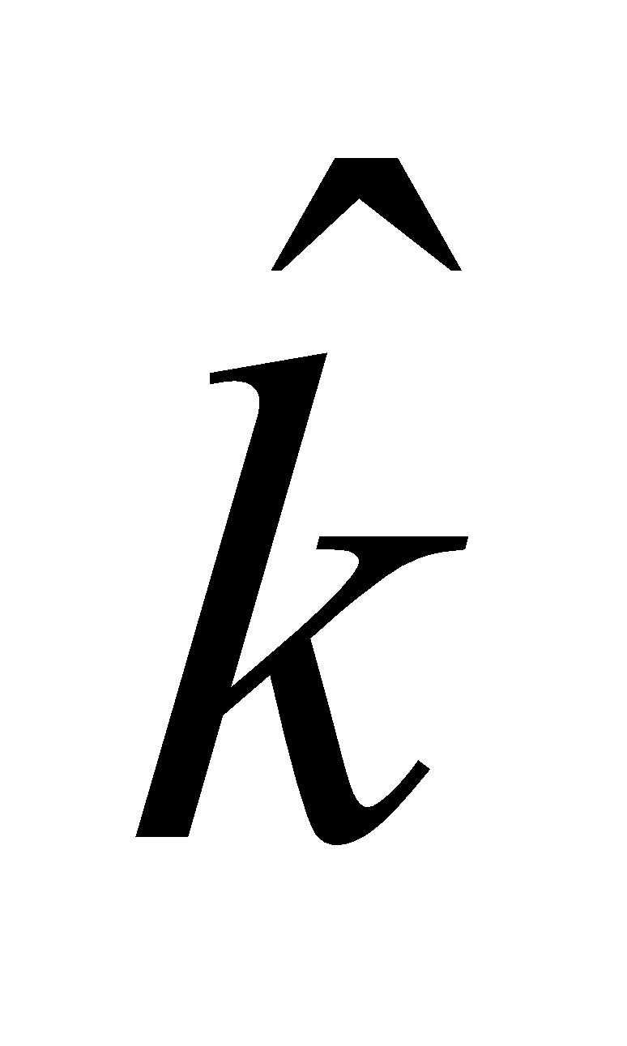 component of the electric field contributes, because the other components are perpendicular to the surface.

**23. Interpret** This problem involves calculating the electric flux through the surface of a sphere.

**Develop** The general expression for the electric flux *Φ* is given by Equation 21.1: 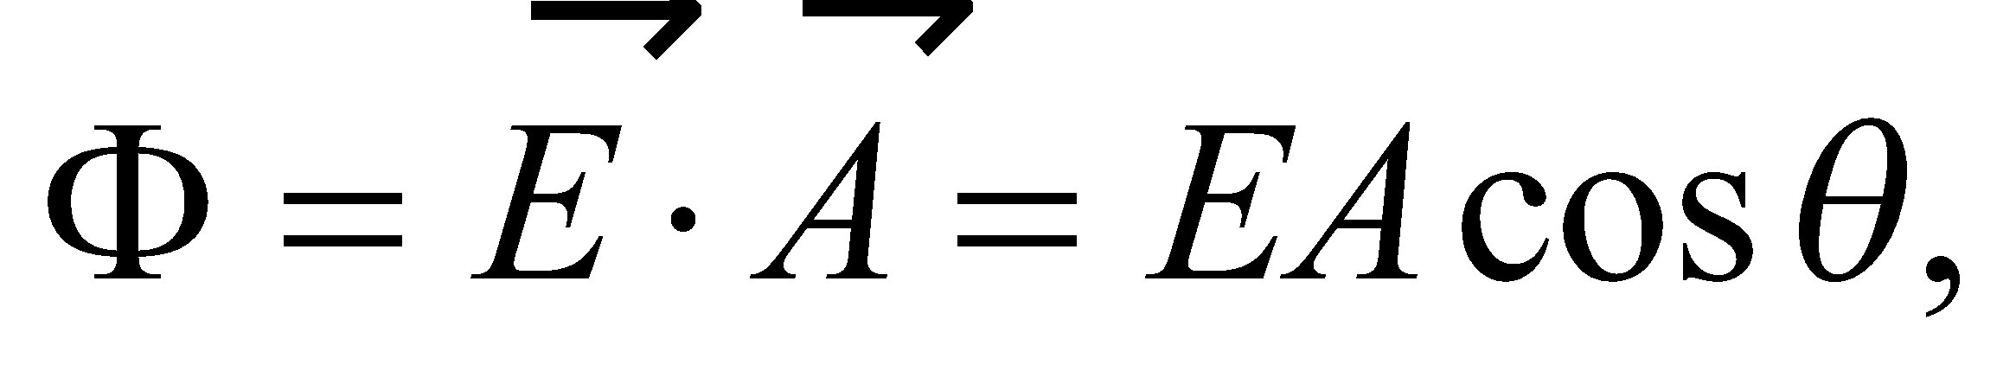 where

*θ* is the angle between the normal vector  and the electric field 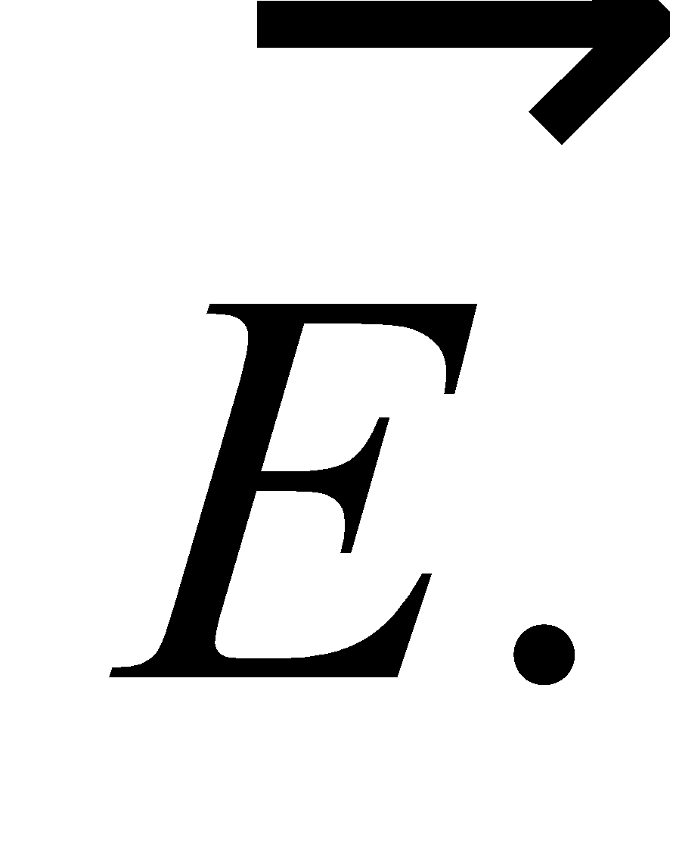 The magnitude of the normal vector  is the surface area of the sphere: 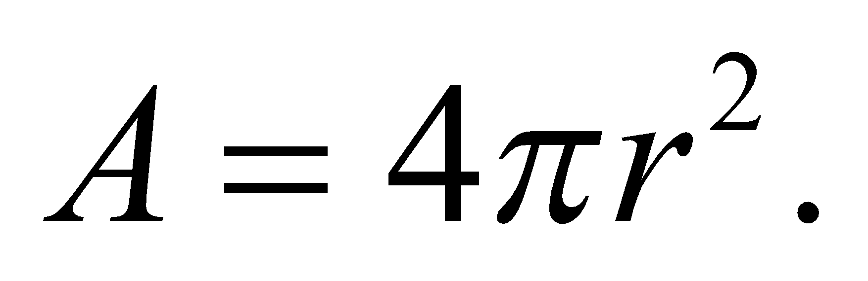

**Evaluate** For a sphere, with  parallel or antiparallel to , Equation 21.1 gives

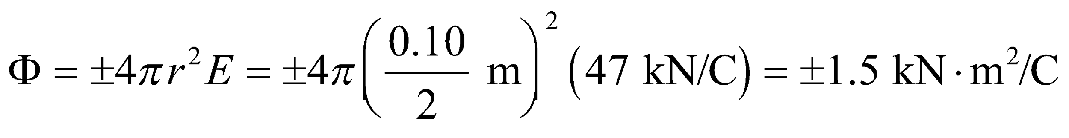

**Assess** The flux Φ is positive if  points outward, and is negative if  points inward.

**Section 21.3 Gauss’s Law**

**24. Interpret** We are to find the total electric flux through a surface surrounding a given charge *q*. This is the simplest application of Gauss’s law; integration is not required.

**Develop** According to Gauss’s law (Equation 21.3), the flux through a closed surface is proportional to the charge enclosed by that surface:

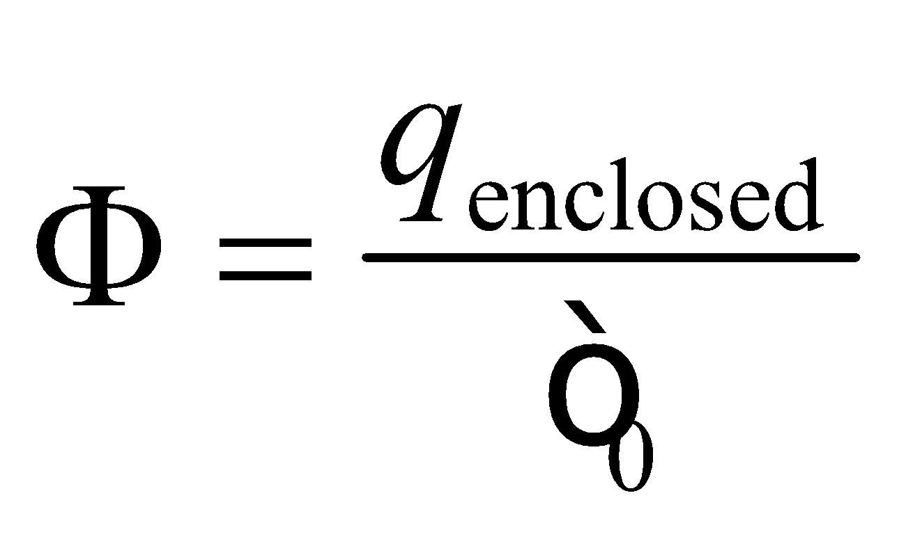

The total charge is  where  is the charge of a single electron.

**Evaluate** Inserting the given quantities into Gauss’s law gives

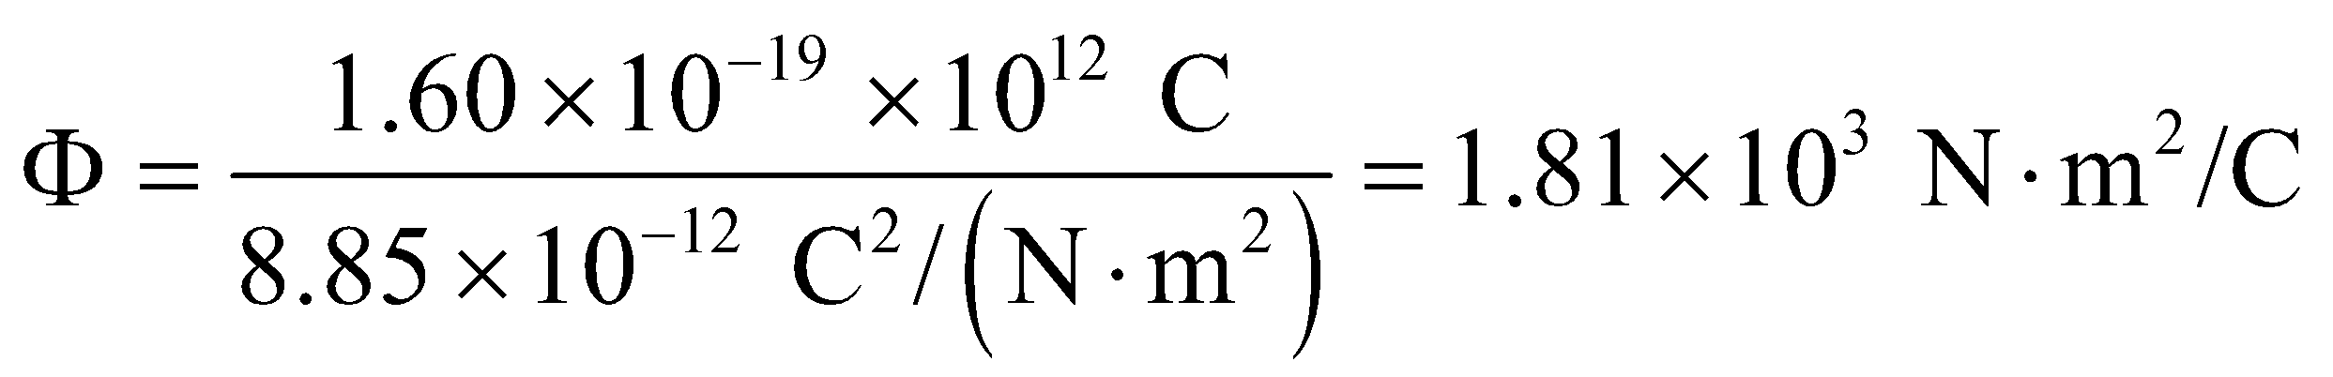

**Assess** We could also use Gauss’s law to find the approximate electric field in the area surrounding this sock.

**25. Interpret** This problem is about applying Gauss’s law to find the electric flux through a closed surface.

**Develop** Gauss’s law is given in Equation 21.3 and states that the flux through any closed surface is proportional to the charge enclosed:

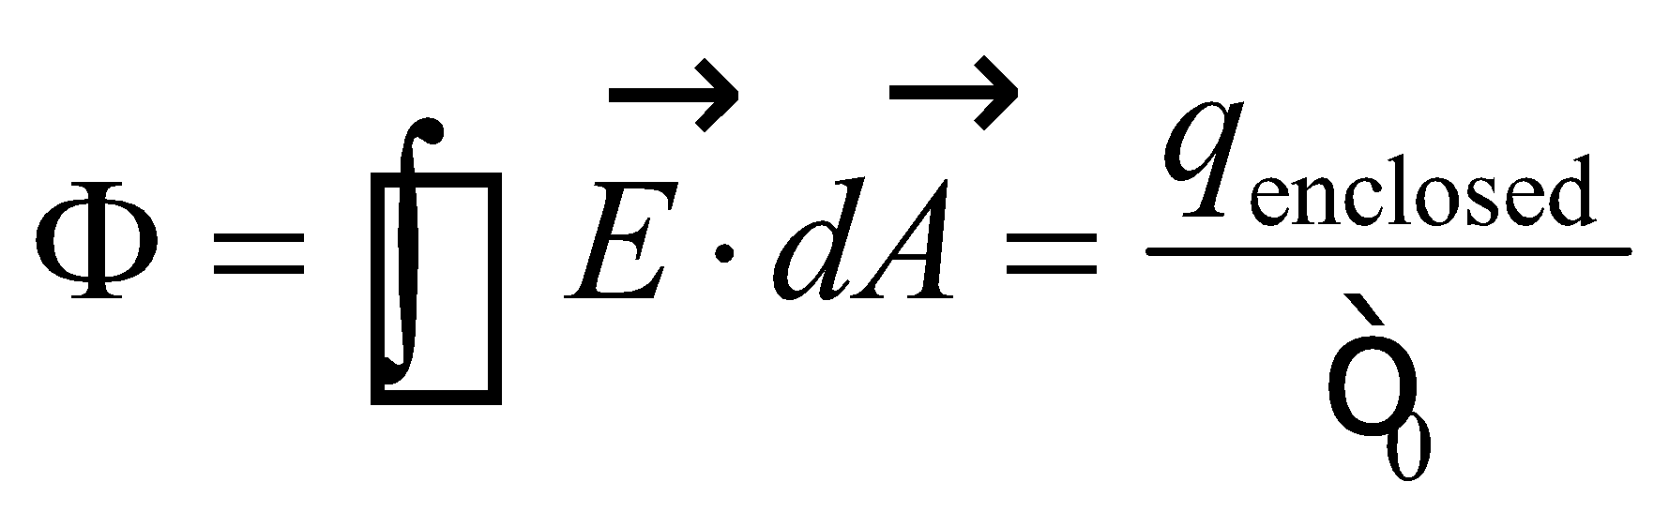

**Evaluate** For the surfaces shown, the results are as follows:

**(a)** 

**(b)** 

**(c)** 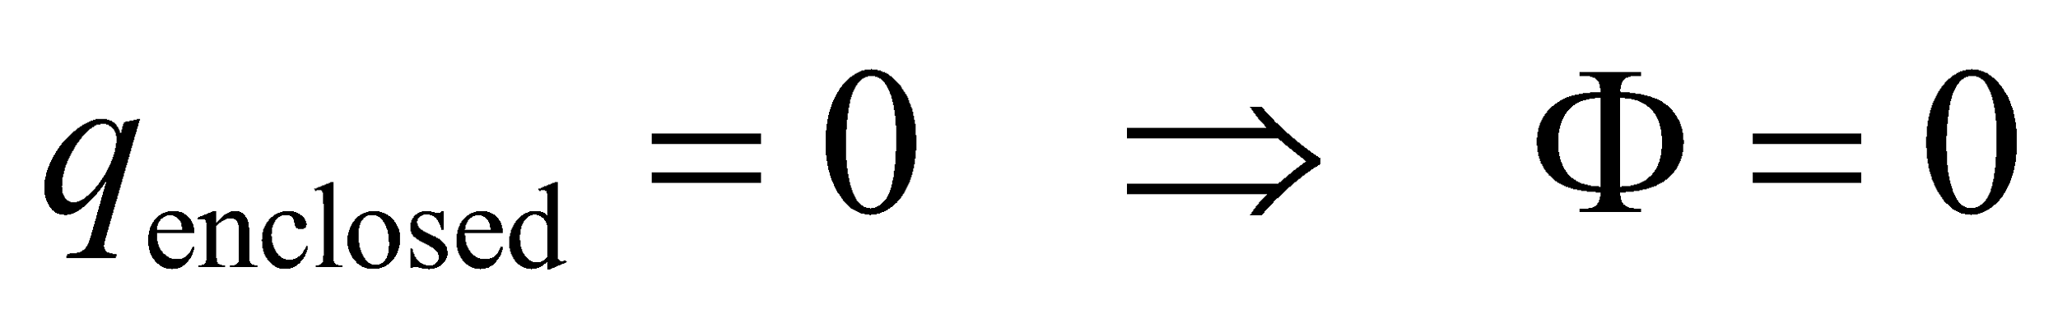

**(d)** 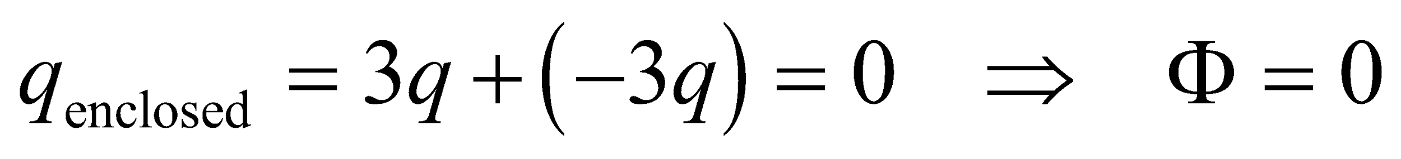

**Assess** The flux through the closed surface depends only on the charge enclosed, and is independent of the shape of the surface.

**26.** **Interpret** This problem involves applying Gauss’s law to find the electric flux through a sphere that encloses a given charge.

**Develop** Gauss’s law (Equation 21.3) states that the electric flux through a closed surface is proportional to the charge enclosed. Specifically,



so given *q*enclosed, we can find Φ.

**Evaluate** The electric flux is

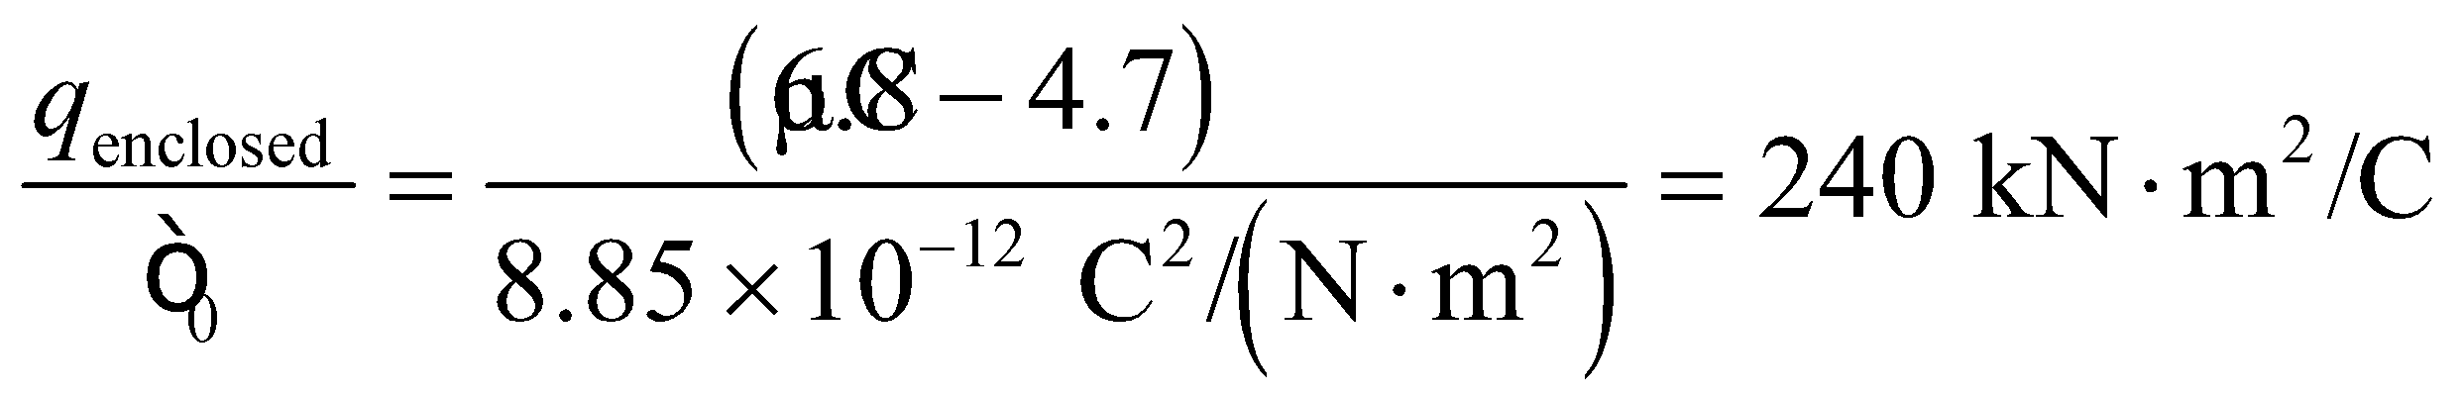

**Assess** The electric flux does not depend on the size of the sphere, only on the charge enclosed.

**27. Interpret** This problem involves applying Gauss’s law to find the electric flux through the surface of a cube that encloses a given charge.

**Develop** Gauss’s law, given in Equation 21.3, states that the flux through any closed surface is proportional to the charge enclosed:

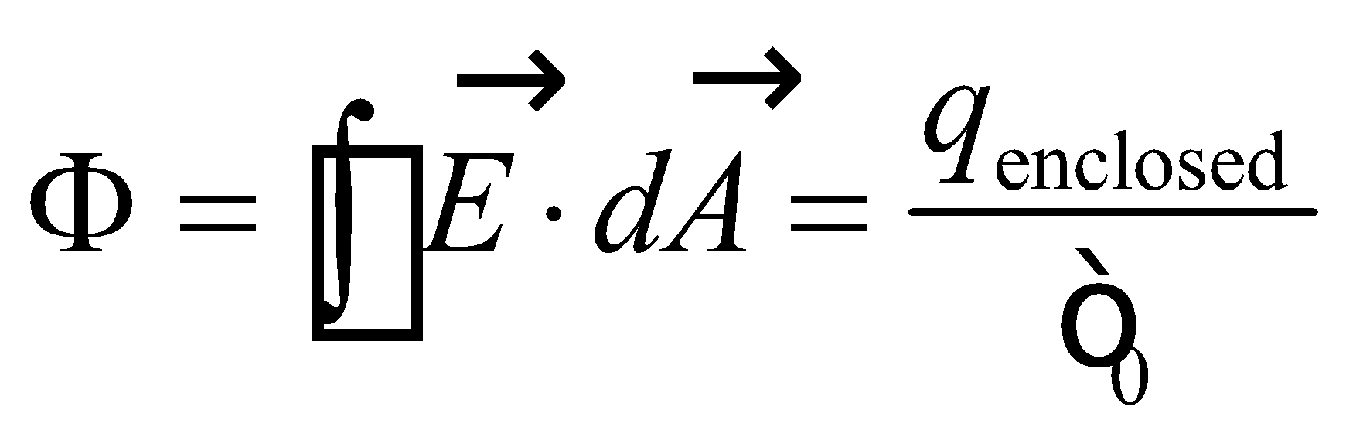

The symmetry of the situation guarantees that the flux through one face is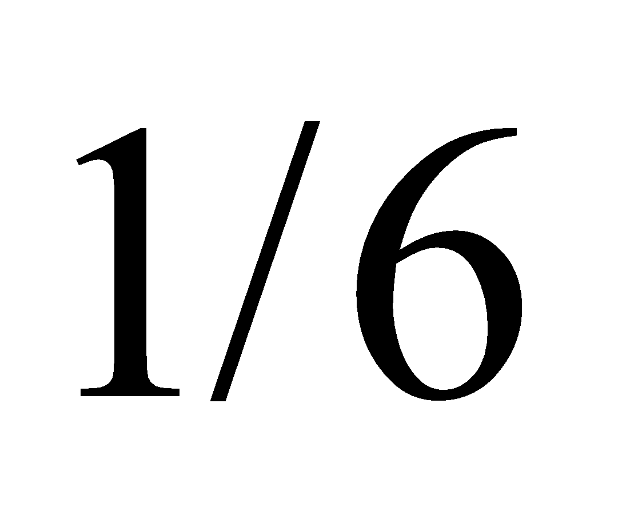the flux through the whole cubical surface.

**Evaluate** The flux through one face of a cube is



**Assess** Because the flux through each surface is the same, the total flux through the cube is simply

 which is proportional to

**Section 21.4 Using Gauss’s Law**

**28.** **Interpret** This problem involves using Gauss’s law to find the strength of the electric field a given distance from the center of a uniformly charged sphere. Note that the symmetry in this problem is spherical symmetry, which we can exploit in solving the problem.

**Develop** As discussed in Example 21.1 an in the text just following this example, the electric field of a spherically symmetric charge distribution of total charge *Q* is the same as that of a point charge *Q* at the center of the sphere. Thus, the field is proportional to 1/*r*2 for *r* > *R*, where *R* is the radius of the spherical charge distribution, which means



**Evaluate** Inserting the given quantities into the expression above and solving for *E*(*r*2) gives

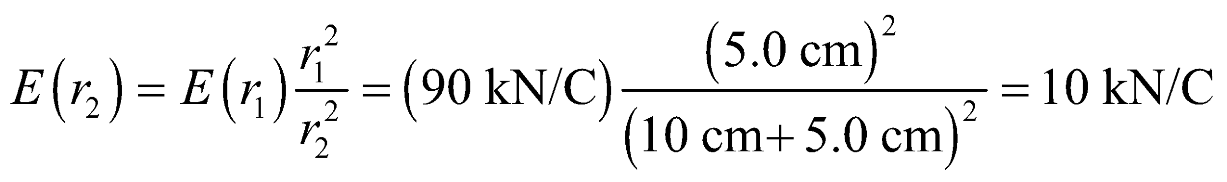

**Assess** As expected, the magnitude of the electric field has decreased because we are farther from the charge.

**29. Interpret** This problem involves applying Gauss’s law to calculate the electric field. Our charge distribution has spherical symmetry.

**Develop** The charge distribution is exactly that considered in Example 21.1. This example derives Equations 21.4 and 21.5, which express the strength of the electric field inside and outside the sphere of radius *R* = 25 cm. The result is



which we can evaluate at the points given.

**Evaluate** **(a)** At  (i.e., inside the sphere), we can use the upper formula, which gives

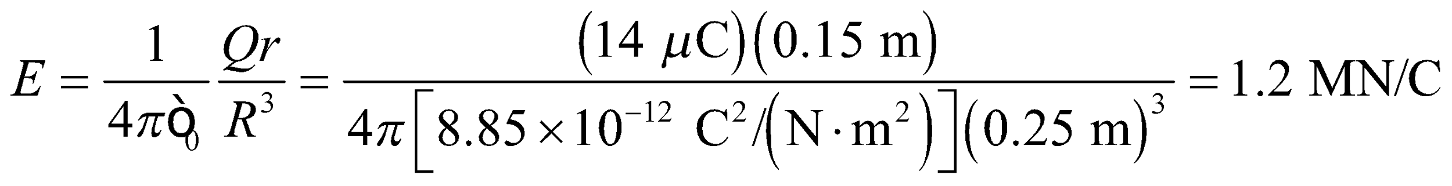

**(b)** At *r* = *R*, we can use either the upper or the lower formula. The result is

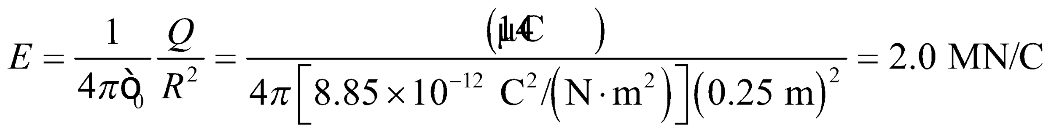

**(c)** At *r* = 2*R* = 50 cm (i.e., outside the sphere), we use the lower formula, which gives

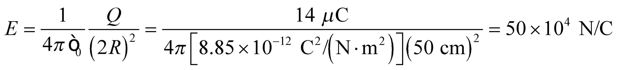

**Assess** Inside the solid sphere where *r* < *R*, the electric field increases linearly with *r*. On the other hand, outside the sphere where *r* > *R*, the field strength decreases as 1/*r*2. Gauss’s law can be applied in this problem because the charge configuration is spherically symmetric.

**30.** **Interpret** This problem involves a charge distribution that is spherically symmetric, so we can apply Gauss’s law to find the electric field at the various points. Also, because the total electric field may be thought of as the electric field due to the central point charge and the electric field due to the charge distribution, we can apply the superposition principle as well.

**Develop** The total electric field is the superposition of the field due to the point charge and the field due to the charge on the spherical shell. Both charge distributions are spherically symmetric about the same center. We will consider the fields due to each charge distribution individually, then sum them by invoking the superposition principle to find the net field. Consider first the field inside the shell with no point charge (*r* < *R* = 8 cm). The field Esphere here is zero, as explained in Example 21.2, so we have



Consider now the field *E*pc due to the point charge, which is simply given by Equation 20.3



For this problem, *q*pc = 10 nC. The total field is the sum of these two

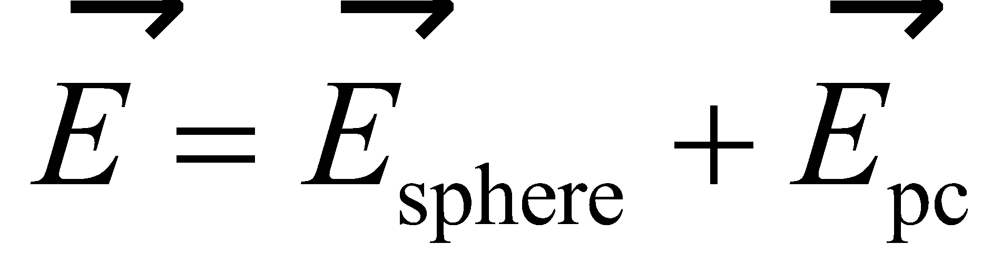

For part (c), we are considering a point outside the sphere, so the result of Example 21.1 tells us that the field here due to the charge distribution on the sphere is the same as if the total charge were located at the center. Thus

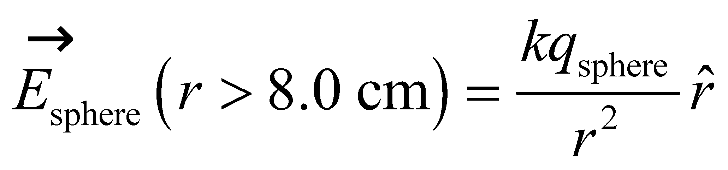

For this problem, *q*sphere = −20 nC. The expression for the field due to the point charge is the same as given above, so we can find the net field again by summing these two contributions.

**Evaluate** (a) For *r* = 2.0 cm, the net electric field is

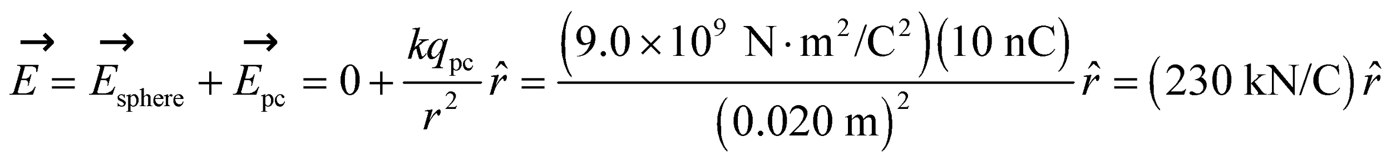

to two significant figures.

(b) For *r* = 6.0 cm, the net electric field is



(c) For *r* = 15 cm, the net electric field is



**Assess** For parts (a) and (b), the net field is oriented outward. For part (c), the net field is oriented inward because the net charge for *r* < 15 cm is negative.

**31. Interpret** In this problem we are given the field strength at two different points outside the charge distribution and asked to determine the symmetry possessed by the configuration.

**Develop** The symmetry of the charge distribution can be determined by noting that the electric field strength decreases as 1/*r*2 for a spherically symmetric charge distribution, and as 1/*r* for a line charge (see Examples 21.4 and 21.1).

**Evaluate** We write 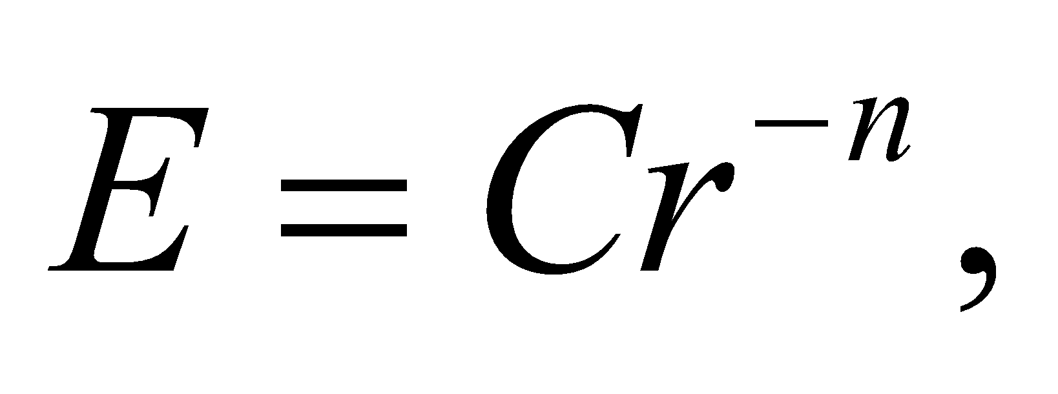 for some constant *C*. This gives

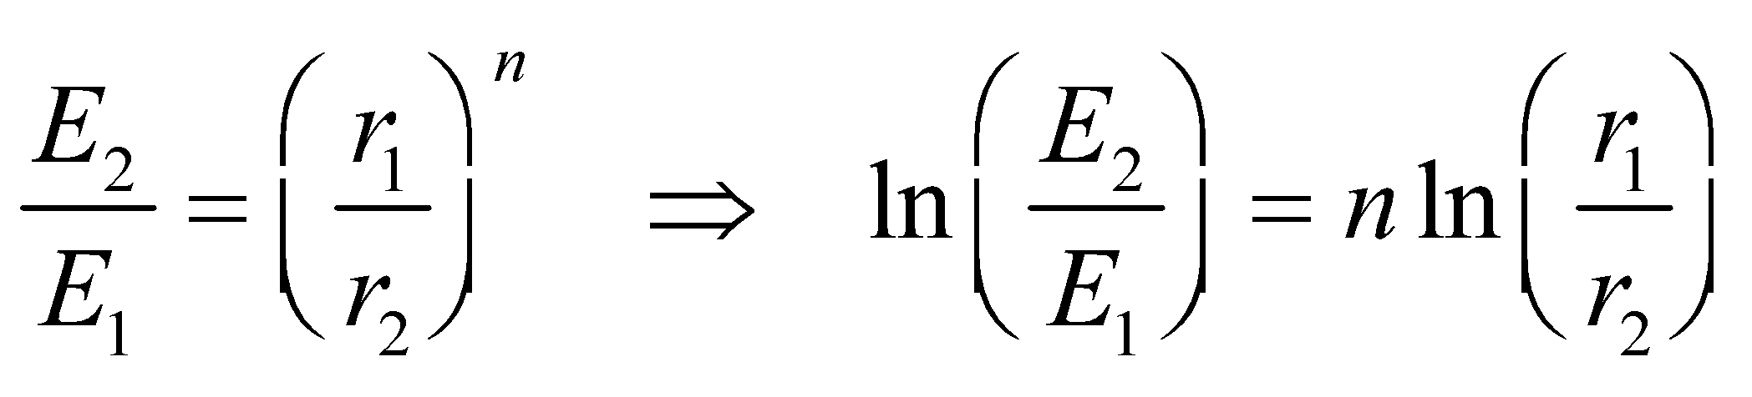

Inserting the values given, we obtain

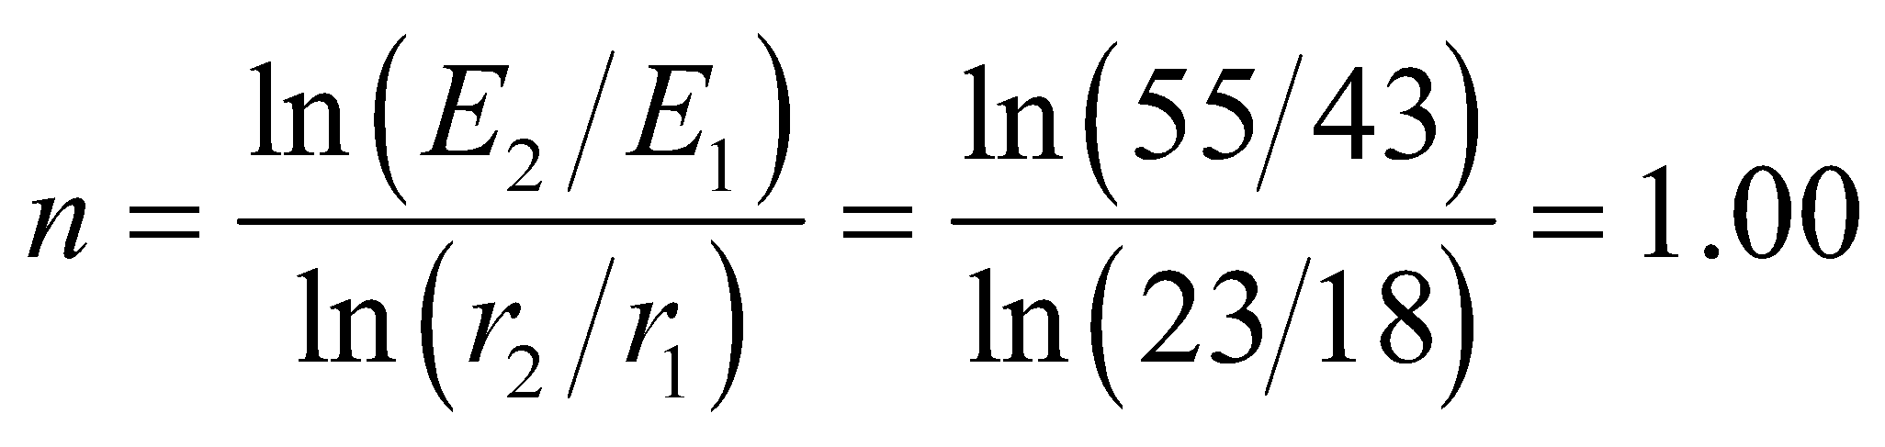

Thus, we conclude that the charge distribution possesses line symmetry.

**Assess** The 1/*r* dependence characteristic of line symmetry can be readily verified by taking the field strength to be of the form .

**32. Interpret**We are given the force on an electron near a sheet of charge, and are asked to find the surface charge density on the sheet. This problem has planar symmetry, and we will use the result for the electric field near an infinite plane of charge.

**Develop** The force on a charge isandnear a plane of charge. We note that the electron (a negative charge) is repelled, so the charge on the plane must be negatively charged as well. The charge on the electron is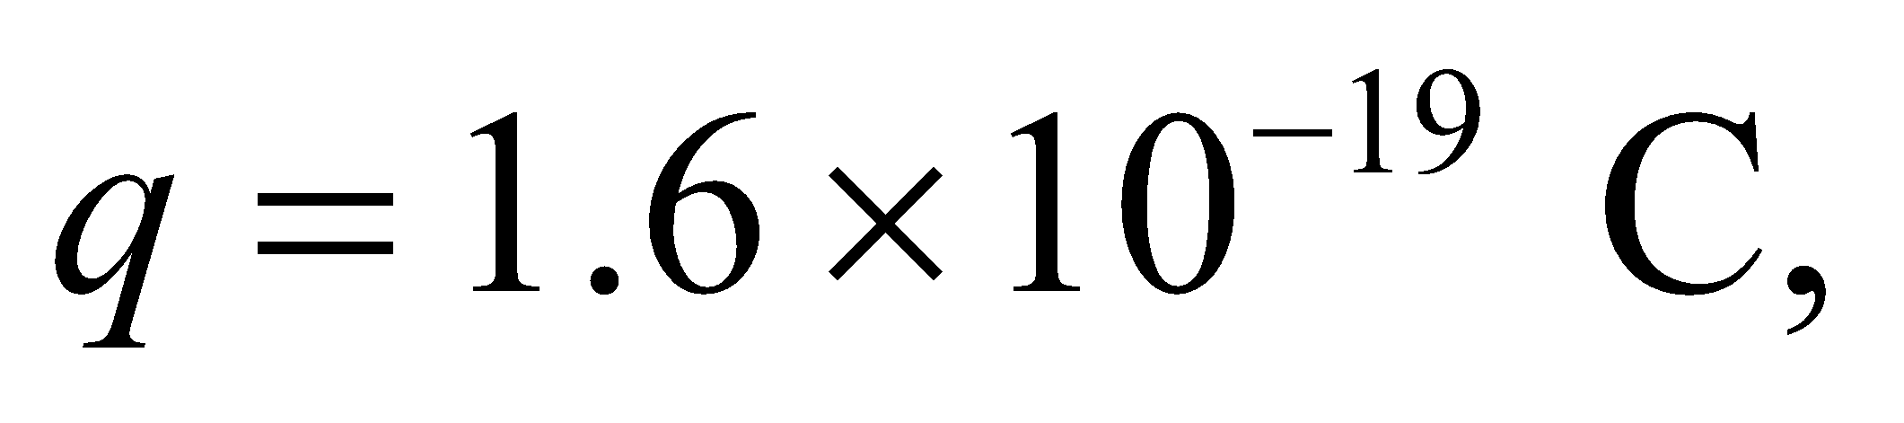and the magnitude of the force felt by the electron isWe solve for 

**Evaluate** 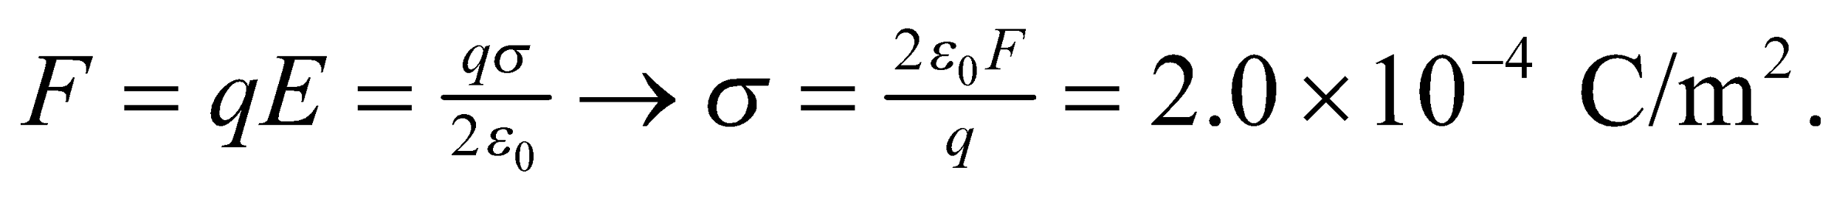The charge on the plate must be negative, so

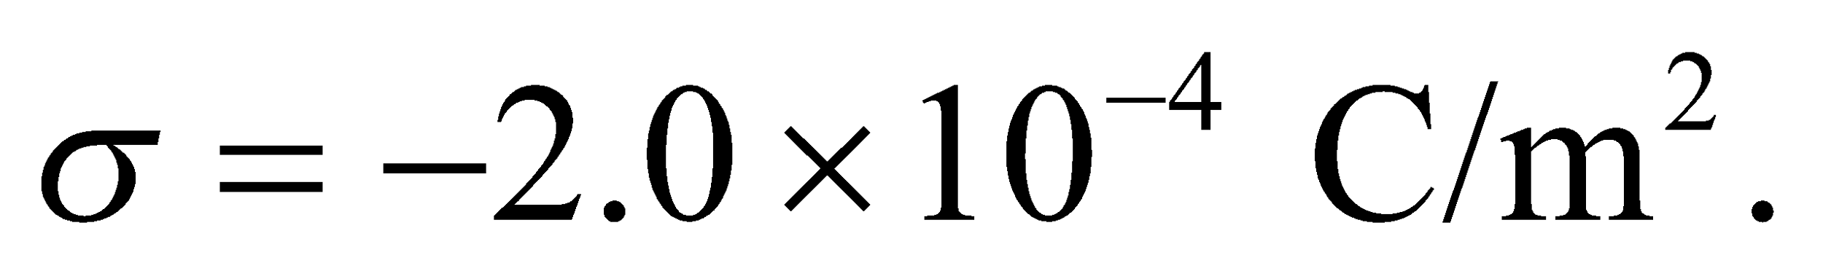

**Assess** We could also get the sign of the charge sheet by being more careful about *F* and *E.* They are both vectors!

**33. Interpret** We are to find the electric field produced by a uniformly charged sheet. This problem has planar symmetry, so we will use the result for the electric field near an infinite plane of charge (Example 21.6 and Equation 21.7).

**Develop** Example 21.6 derives the electric field near a uniform sheet of charge with charge density *σ*. The result is (Equation 21.7)



The charge density given in the problem is 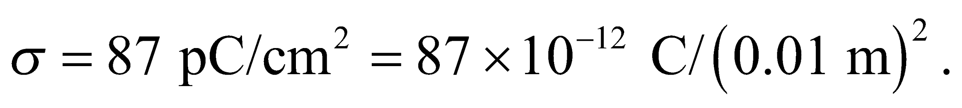

**Evaluate** Inserting the given quantities into the expression above gives



**Assess** Although this seems at first to be a small charge per area, the resulting field is quite large. Remember that a Coulomb is a very large charge.

**34. Interpret** We are to find the uniform surface charge density that will produce the given electric field at points nearby. This problem has planar symmetry, so we will use the result for the electric field near an infinite plane of charge (Example 21.6).

**Develop** Example 21.6 derives the electric field near a uniform sheet of charge with charge density *σ*. The result is

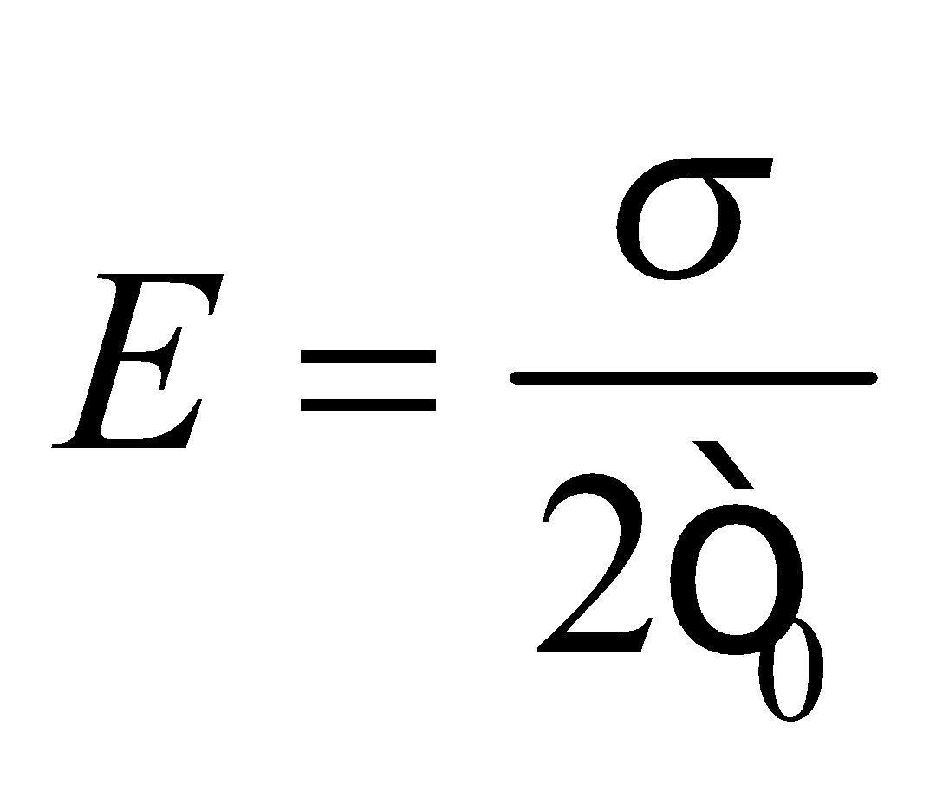

The electric field given in the problem is 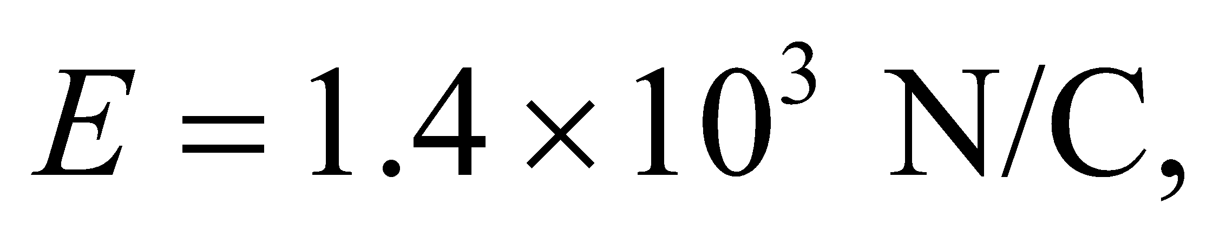 so we can solve for *σ*.

**Evaluate** Inserting the given quantities into the expression above gives

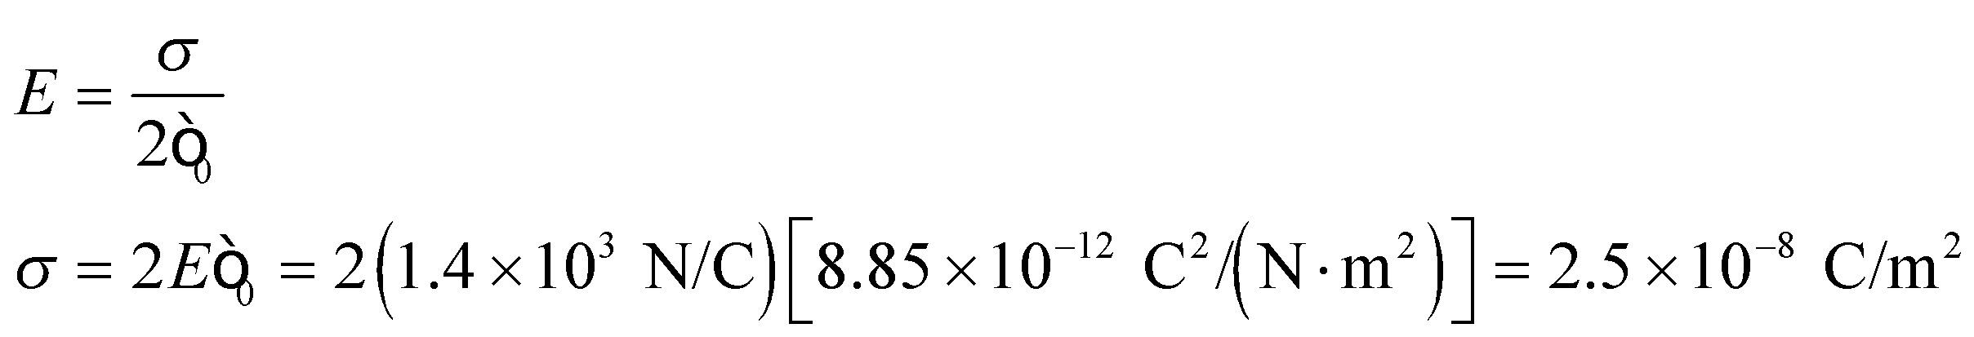

**Assess** This is a small charge density in terms of the Coulomb, but the Coulomb is a relatively large charge.

**Section 21.5 Field of Arbitrary Charge Distribution**

**35. Interpret** We are given a charge distribution with approximate line symmetry, so we can apply Gauss’s law to compute the electric field. We are to consider two cases: the first at a distance that is small compared to the length of the rod and the second at a distance much, much greater than the length of the rod.

**Develop** Close to the rod, but far from either end, the rod appears infinite, so the electric field strength is (see Example 21.4) 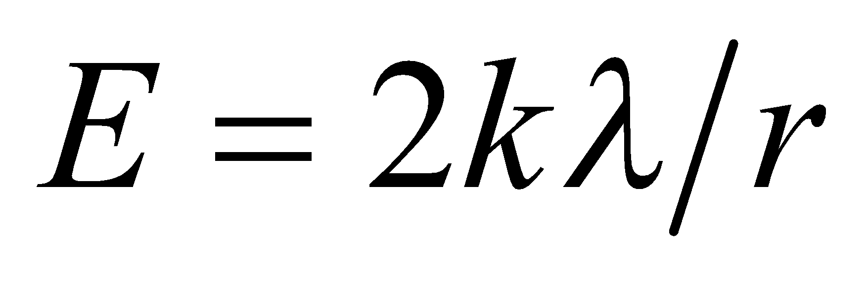. For part (b), we are considering a position *r* = 23 m that is over an order of magnitude larger than the size of the rod (0.50 m). Therefore, the rod may be treated as a point charge, so the electric field will be given by Equation 20.3.

**Evaluate** **(a)** Substituting the values given in the problem statement, we obtain



**(b)** Far away 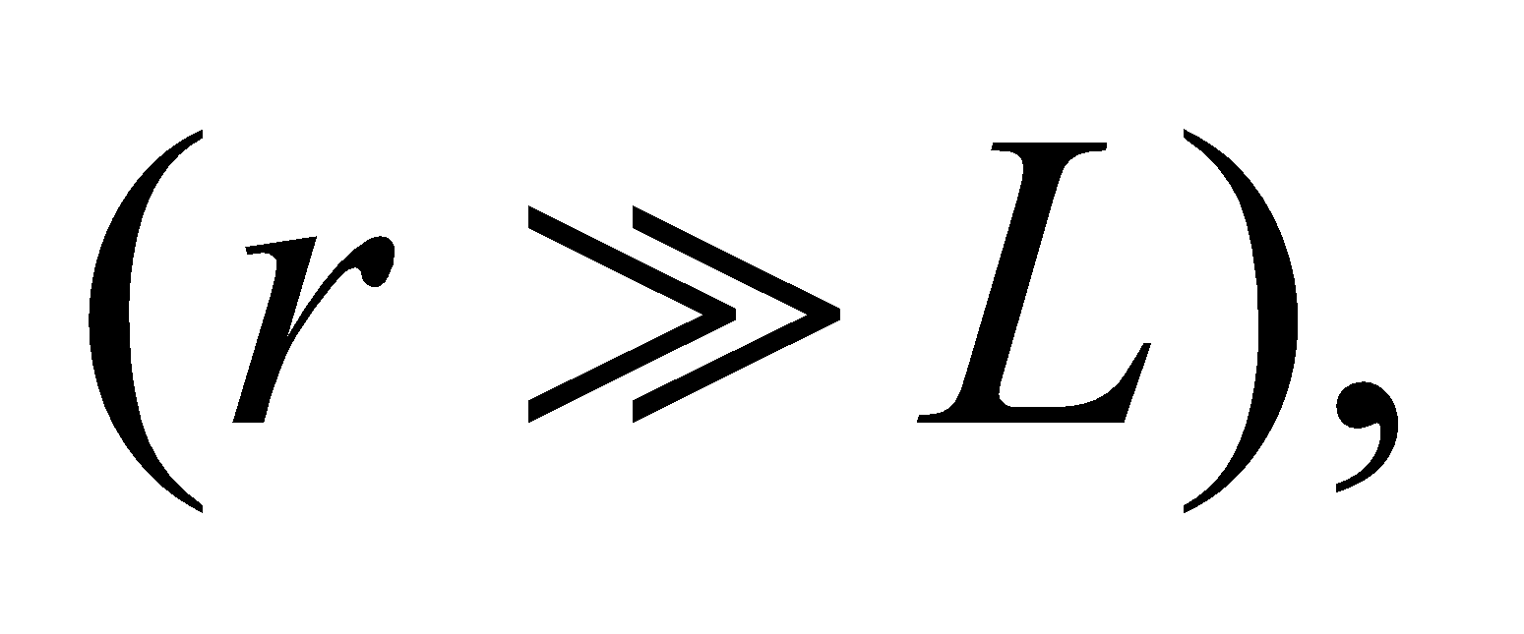 the rod appears like a point charge, so

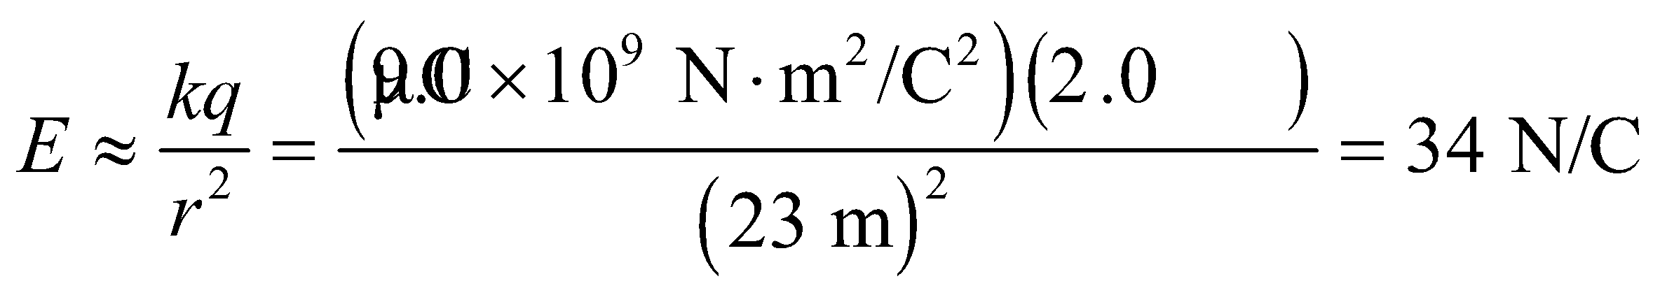

**Assess** At distance much, much greater than the characteristic size of any charge distribution, (line charge in this case), the field always resembles that of a point charge.

**36.** **Interpret** We are to determine the approximate field strength near a charged piece of paper with a given surface charge density. We will assume that the paper is flat and is large compared to the distance involved.

**Develop** As derived in Example 21.6, the electric field due to an infinite sheet of charge is



A piece of paper is not infinite, but the problem states that it is an ordinary piece of paper, so we’ll assume that the paper is large compared to the 1-cm distance from the paper. This approximation allows us to use the equation above for the infinite case. The surface charge density on the paper is 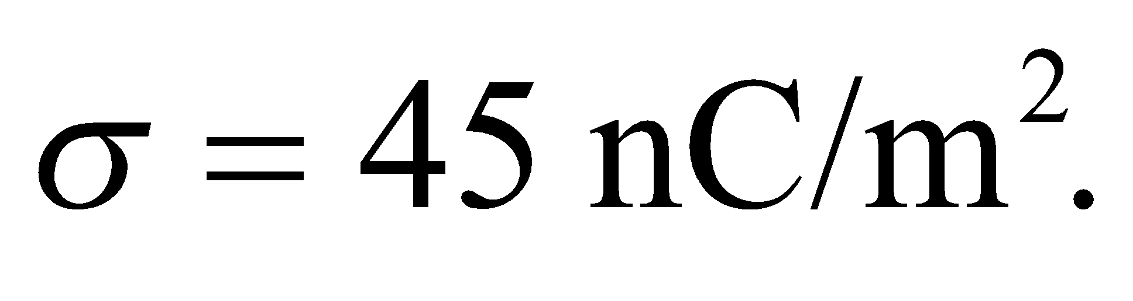

**Evaluate** Inserting the given quantities gives

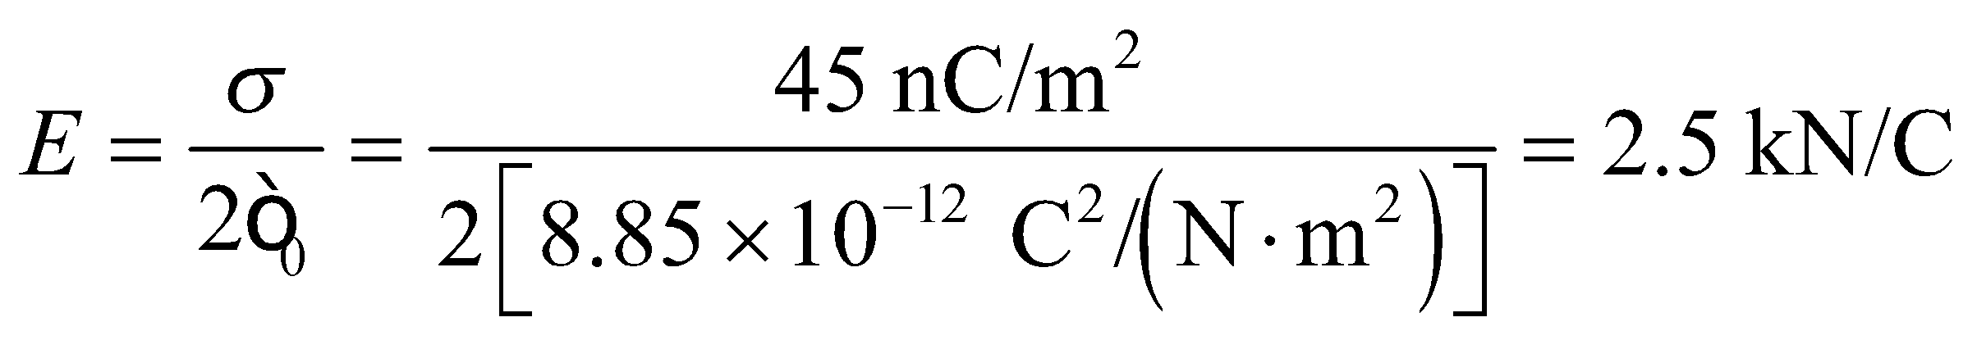

**Assess** The infinite sheet of charge is not a useless construct. If you are close enough to any flat surface, it *looks* infinite, and you can use the infinite case as a very good approximation.

**37.** **Interpret** We are to approximate the electric field strength near the center of a flat, charged disk and far from the charged disk. In both cases, we will choose appropriate approximations.

**Develop** The area of the disk is given as 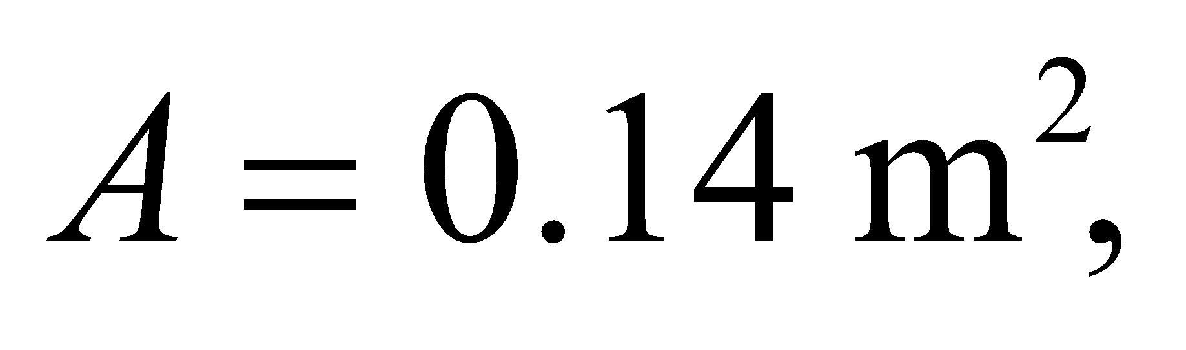 so the radius of the disk must be

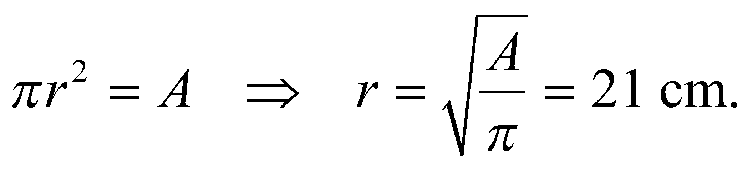

The point *r* = 0.1 cm from the center of the disk is 2 orders of magnitude smaller than the disk radius, so the disk will appear to be an infinite plane. Thus, we can use the result of Example 21.6,



The point *r* = 250 cm from the disk is one order of magnitude larger than the disk radius, so the disk will look more like a point charge and we can use Equation 20.3



The charge on the disk is 

**Evaluate** (**a**) Inserting the given quantities into the expression for a flat plane gives

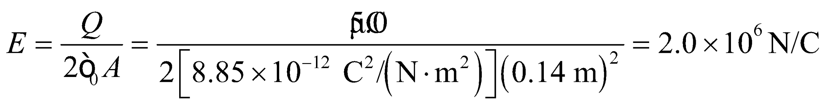

**(b)** Inserting the given quantities into the expression for the point charge gives

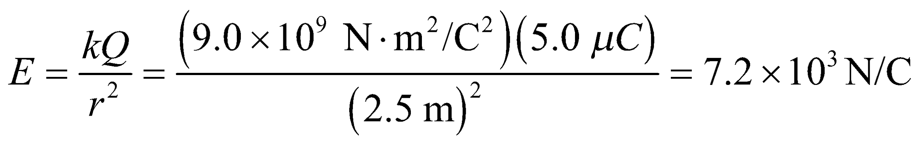

**Assess** If you are far enough from anything, it looks like a point charge; and if you are close enough, it looks like an infinite plane.

**Section 21.6 Gauss’s Law and Conductors**

**38.** **Interpret** This problem requires us to find the electric field strength “just” outside a conducting sphere with a given charge density. Although the problem contains spherical symmetry, we can also consider it to contain planar symmetry, since the surface of the sphere will appear to be an infinite plane for distances from the surface that are much, much less than the sphere’s radius (consider the surface of the Earth as an example of this effect).

**Develop** Because we are not given the sphere’s radius, we cannot calculate the total charge on the sphere, so we are obliged to approximate the electric field by considering the surface of the sphere as an infinite plane. Under these conditions, we can use Equation 21.7 to find the electric field. However, there is one caveat that we must take into consideration that differentiates this problem from that of Example 21.7; namely, that we are considering a conducting sphere here, so the field inside it is zero! This means that the electric field that emanates from both sides of our conducting sheet in Example 21.7 must now emanate only in a single direction away from the surface of the sphere (i.e., away from the center). Thus, we expect the electric field to have twice the strength of that given in Example 21.7, or



To see that this is so, consider a conducting sphere of radius r with surface charge s. The total charge on the sphere is

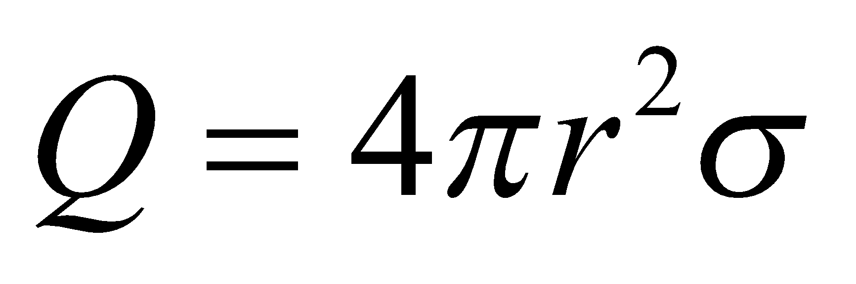

From Example 21.1, we know that the electric field outside a spherical charge distribution is

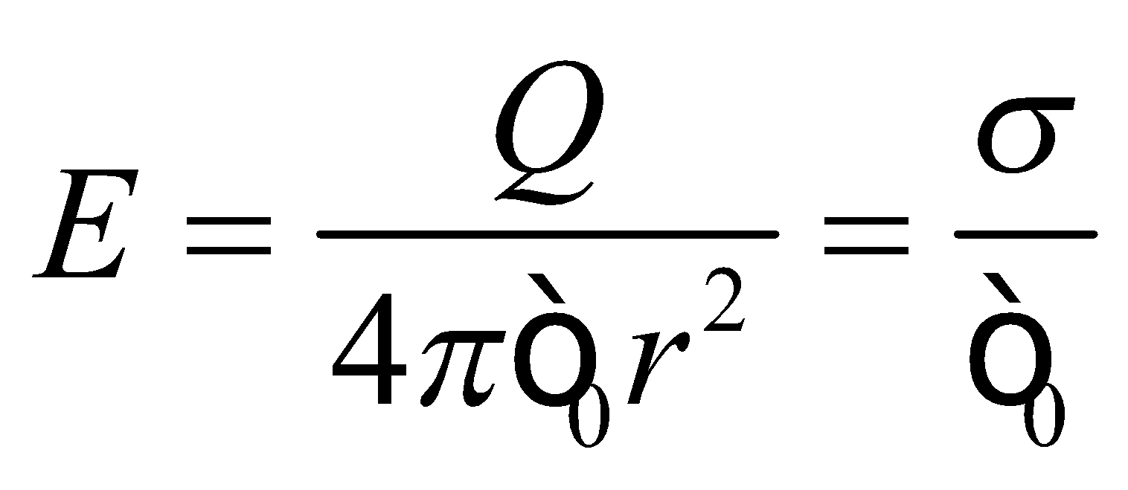

which is what we derived above by considering the physics involved.

**Evaluate** Inserting the surface charge density into the expression above for electric field, we find

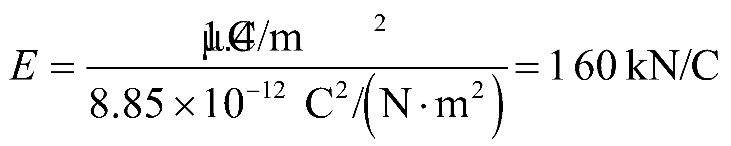

**Assess** Because the charge density is positive, we can also say that the electric field lines point away radially from the center of the sphere.

**39. Interpret** This problem involves finding the charge distribution of a conductor using Gauss’s law. The charge distribution is spherically symmetric.

**Develop** As explained in Section 21.6, the electric field inside a conductor of arbitrary geometry is zero. In addition, the net charge must reside on the conductor surface.

**Evaluate** **(a)** Because the net charge inside the conductor is zero, the volume charge density inside the conductor is also zero.

**(b)** If the sphere is electrically isolated, the charge will be uniformly distributed (i.e., spherically symmetric), so the surface charge density is just the total charge divided by the surface area of the sphere. This gives

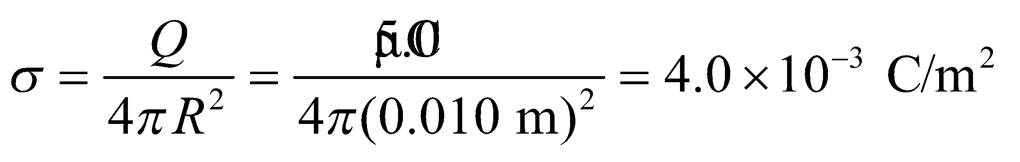

**Assess** Since charges are mobile, the presence of other charges near the conductor will cause the charges on the surface to move, so the equilibrium charge distribution will not be spherically symmetric.

**40.** **Interpret** This problem requires us to sketch the electric field lines for a spherically symmetric charge distribution.

**Develop** The field inside the shell is just due to the point charge (8 electric field lines radiating outward). The field outside the sphere is just that of a point charge , so there are (5/2)×8 = 20 lines of force radiating outward.

**Evaluate** See figure below.



**Assess** There is a charge −*q* spread uniformly over the inner surface of the shell, so the field inside the conducting material that makes up the spherical shell is zero.

**41. Interpret** This problem is about finding the electric field near the surface of a conducting plate. The approximate plane symmetry of the system allows us to make use of Gauss’s law.

**Develop** The net charge of 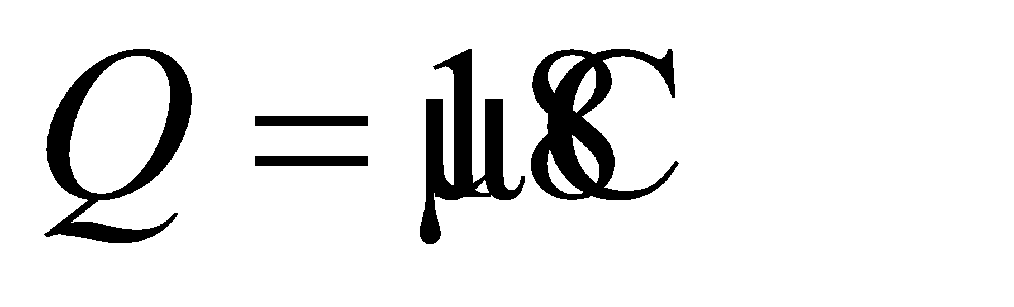 must distribute itself over the outer surface of the plate, in accordance with Gauss’s law for conductors (see Section 21.6). The outer surface of the plate consists of two plane square surfaces on each face, plus the edges and corners. Symmetry arguments imply that for an isolated plate, the charge density on each face is the same, but not necessarily uniform because the edges and corners also have charge. If the thickness of the plate is much, much less than its length and width, we can assume that the edges and corners have negligible charge and that the density on the faces is approximately uniform. With this assumption, the surface charge density is the total charge divided by the area of both faces,



Given this surface charge density, we can apply Equation 21.8 to find the electric field near the surface (but not near an edge) of the conducting plate.

**Evaluate** Inserting the surface charge density into Equation 21.8, we find the field strength near the plate to be

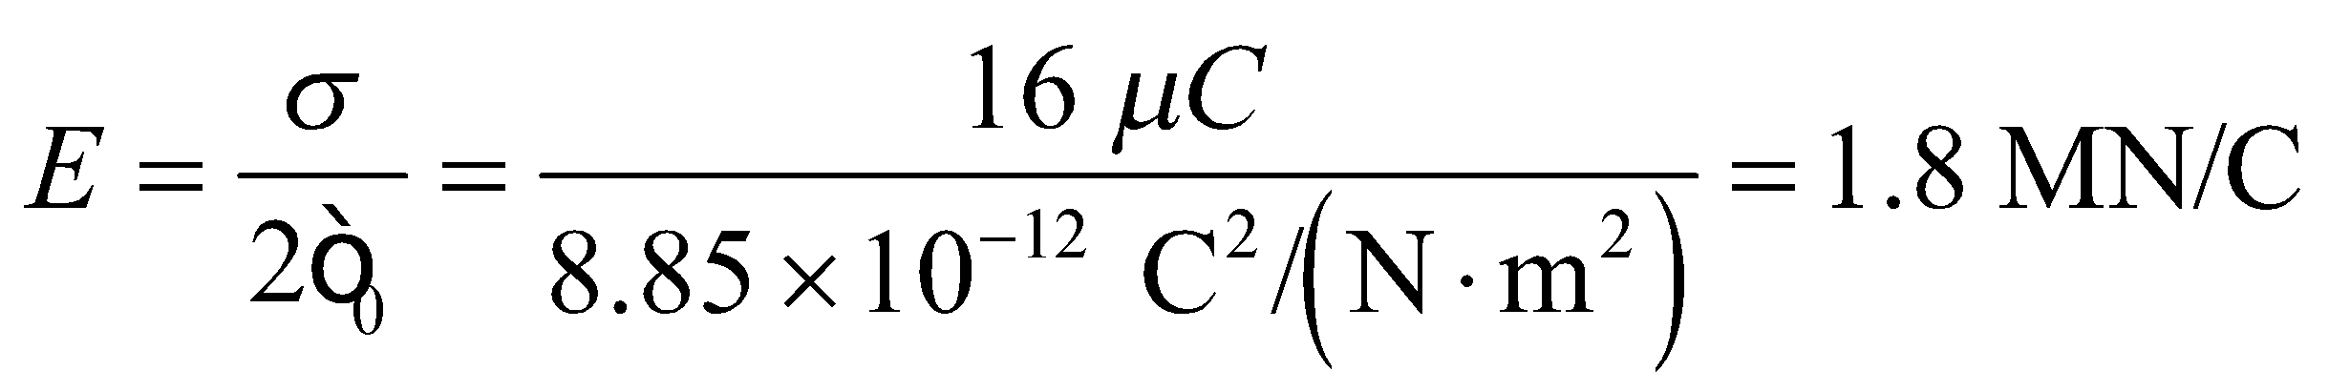

**Assess** Note the distinction between a charged conducting plate and a uniformly charged plate. In the latter, charges are not free to move and the electric field is (see Example 21.6) 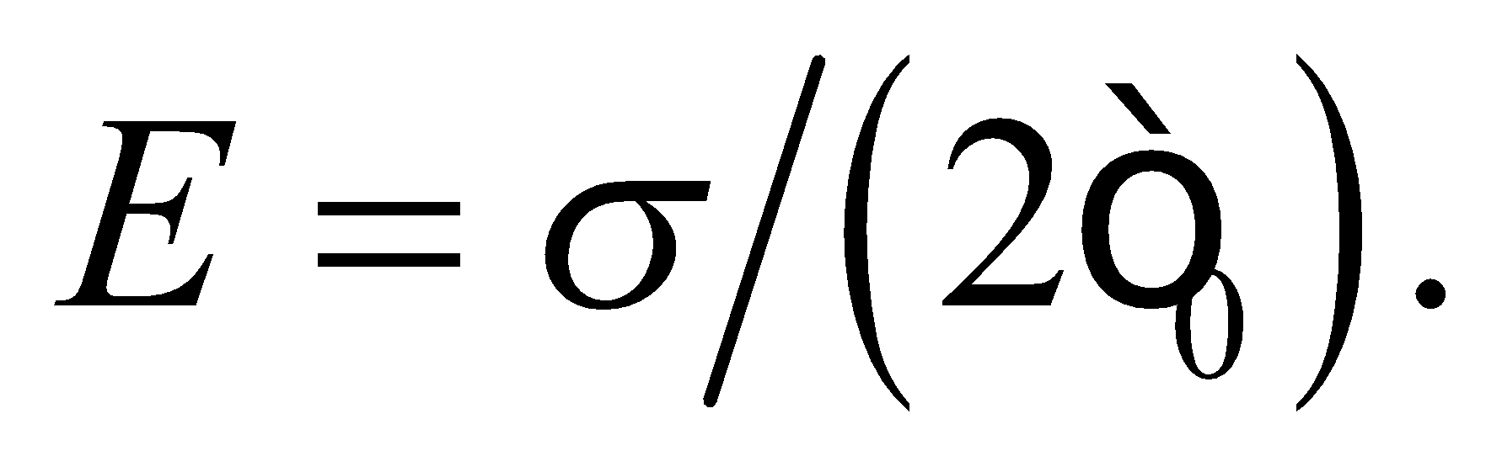

**Problems**

**42.** **Interpret** This problem requires us to consider the geometry of the situation to find the electric flux through the hemispherical surface depicted in Figure 21.33.

**Develop** All of the electric field lines going through the hemisphere also go through an equatorial disk covering its edge (see figure below). Therefore, the flux through the disk (normal in the direction of ) equals the flux through the hemisphere.

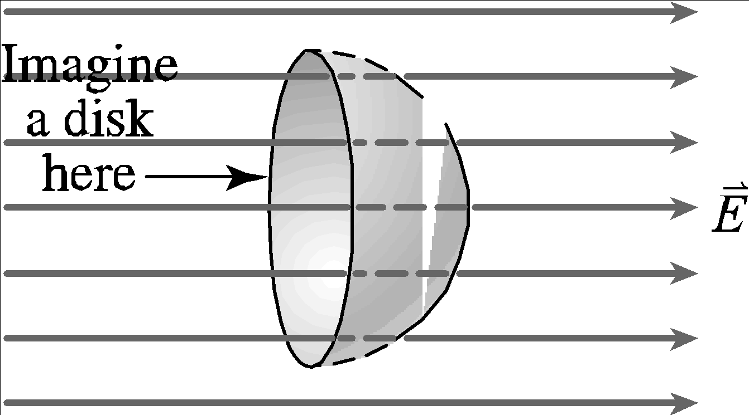

**Evaluate** Sinceis uniform, the flux through the disk is just 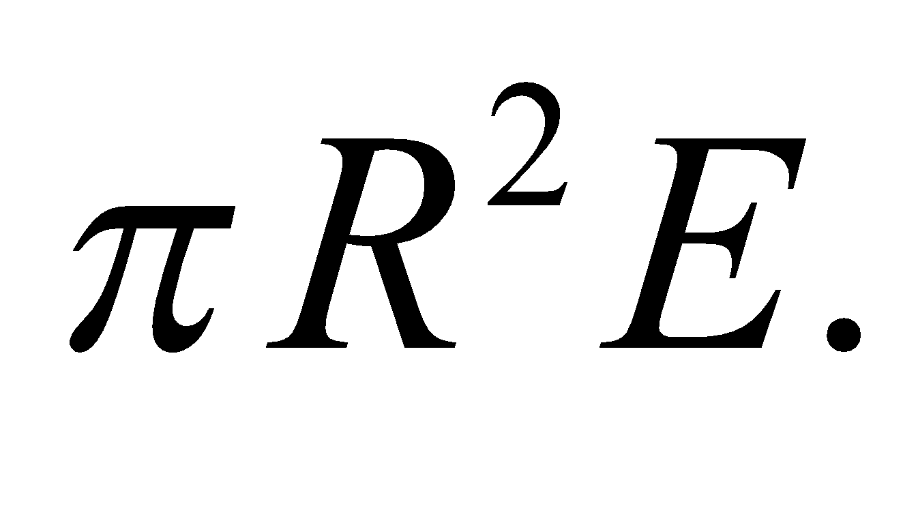

**Assess** Gauss’s law gives the same result, since the flux through the closed surface, consisting of the hemisphere plus the disk, is zero. See Section 21.3.

**43. Interpret** This problem is about finding the electric flux through a given surface.

**Develop** The electric flux through a surface is given by Equation 21.2:

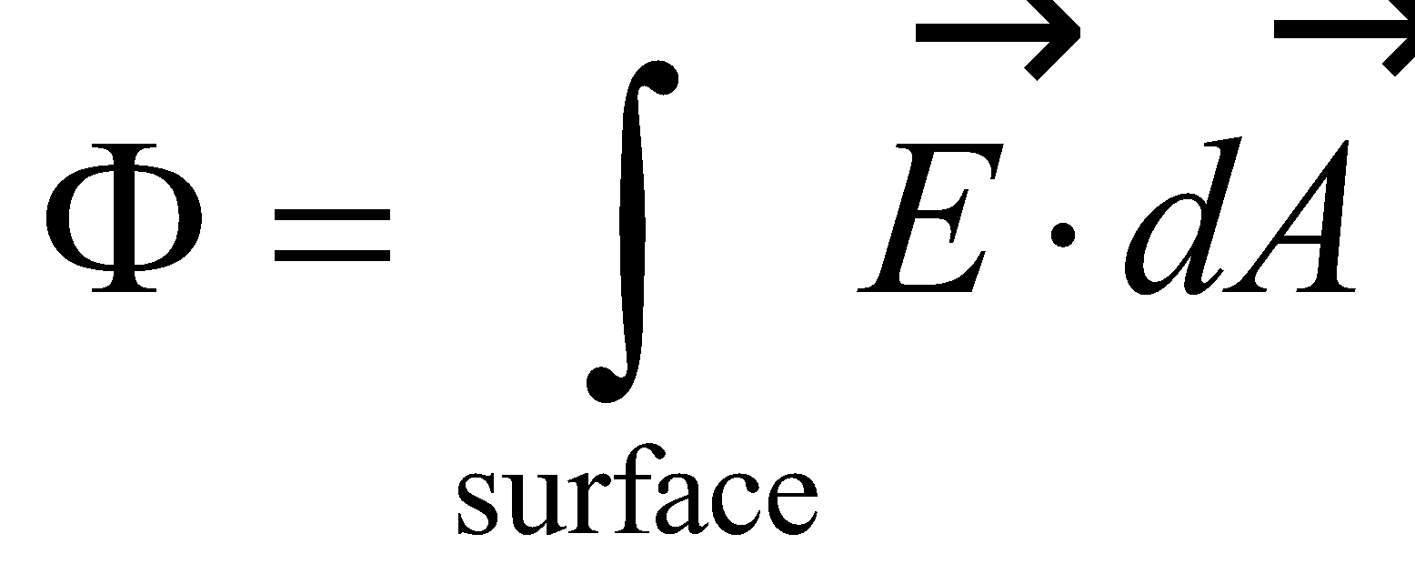

Since the electric field depends only on *y*, we break up the square into strips of area 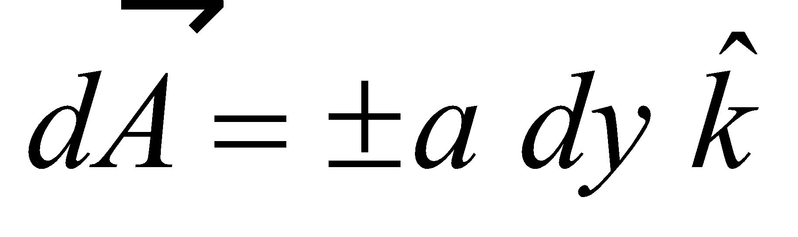 of length *a* parallel to the *x* axis and width *dy* (see figure below). The normal to the surface is 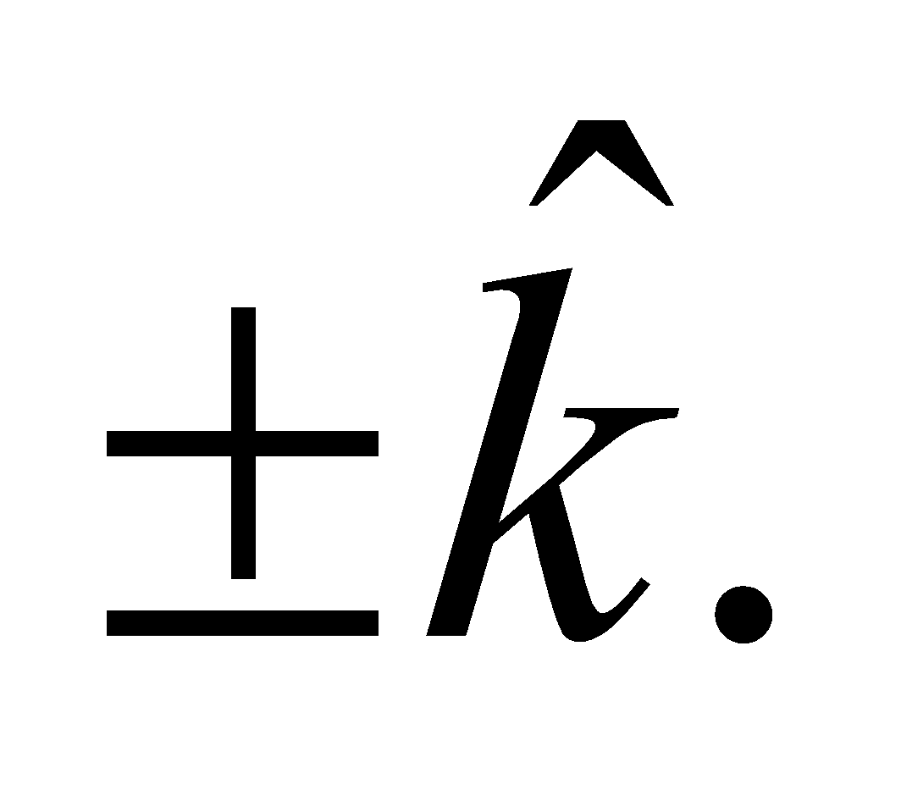



**Evaluate** The integral of Equation 21.2 gives

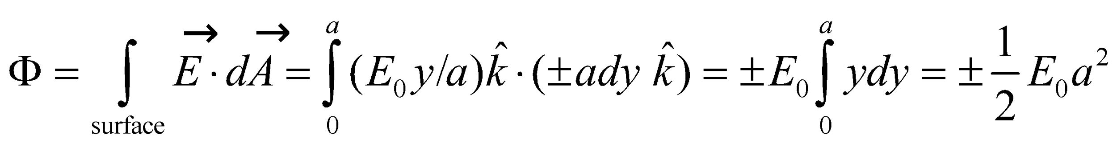

**Assess** Our result can be compared to the case where the field strength is constant. In that case, the flux through the surface would be 

**44. Interpret** From the given electric field, we are to determine the volume charge density in a region, which we can do by applying Gauss’s law.

**Develop** The electric field in the region is given as  where *a* = 40 N/(C·m). Since the field does not depend on *y* or *z*, we must conclude that there is no variation in the *y* or *z* directions. Use a Gaussian surface that is a right prism with a 1-m square base, with the base *A* of the prism at *x* = 0. Gauss’s law states that

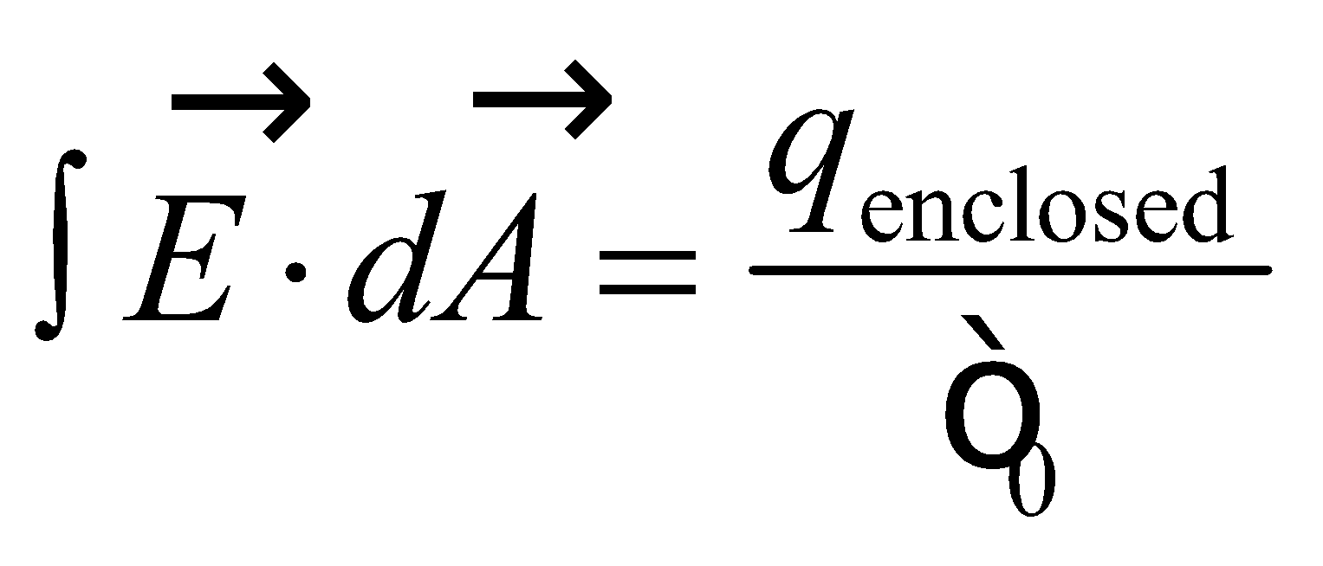

**Evaluate** For this particular electric field, the field is only in the 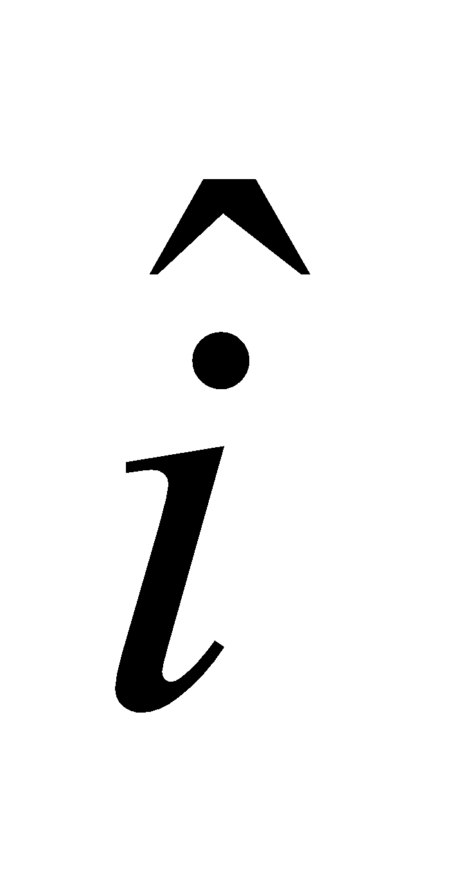 direction so the only surfaces on the prism that have a flux are the surfaces at *x*′ = 0 and *x*′ = *x*. The flux through the surface at *x*′ = 0 is zero, since the field there is zero. The flux through the surface at *x*′ = *x* is

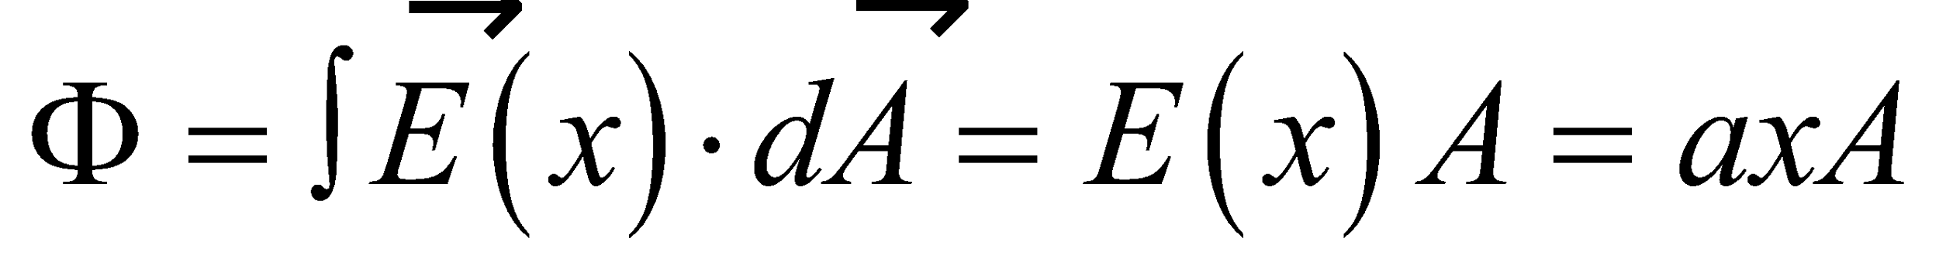

The flux through this surface is also the flux through the entire Gaussian surface, since the rest of the surface has zero flux, so

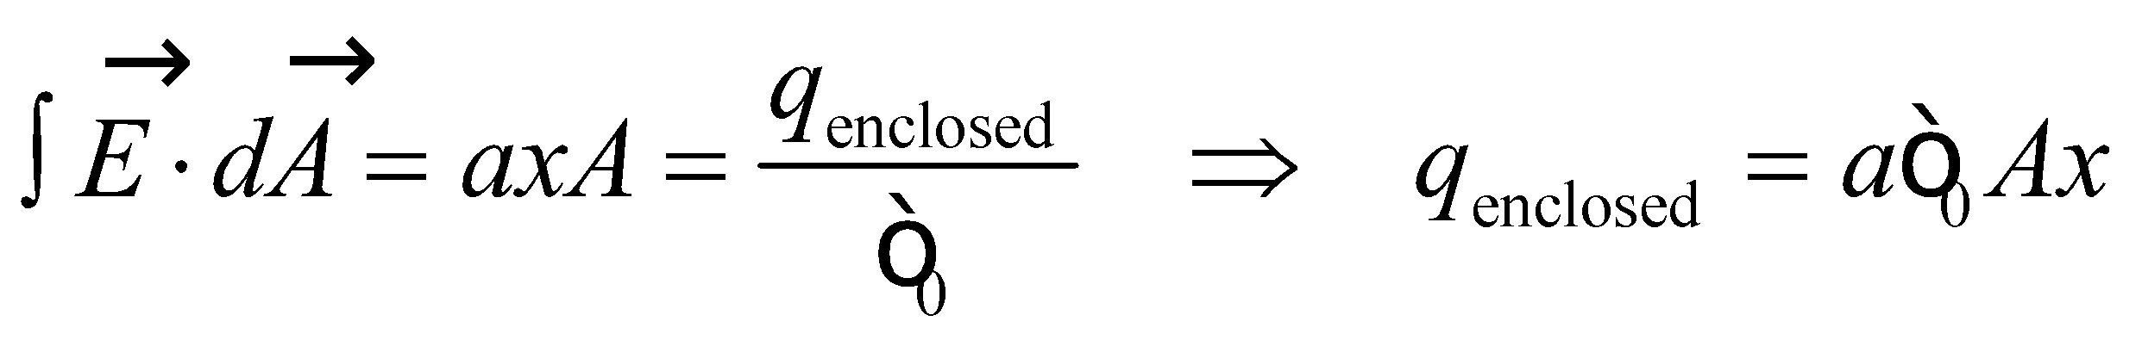

The volume of the prism is *V* = *Ax*, so the charge density is



**Assess** Notice that the units come out to be coulombs per unit volume, as expected. This is the electric field and charge density we would have inside a thick slab of charged material, such as in Figure 21.34.

**45.** **Interpret** We're asked to estimate the electric field outside red blood cells of two different species, given the enclosed charges and the cell radii.

**Develop** We are told to approximate the red blood cells as perfect spheres. The charge from an excess of electrons 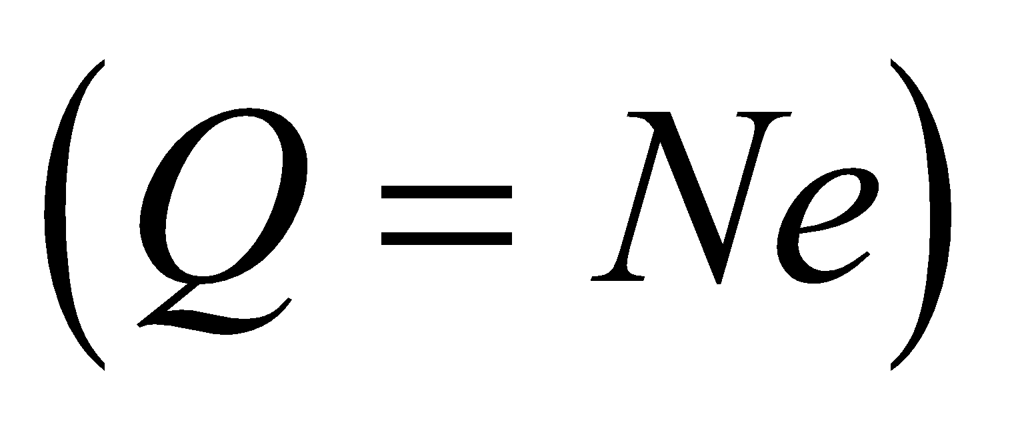is spread uniformly around the surface. The symmetry implies Gauss's law can be used to find the electric field. Outside a charged sphere, the electric field is 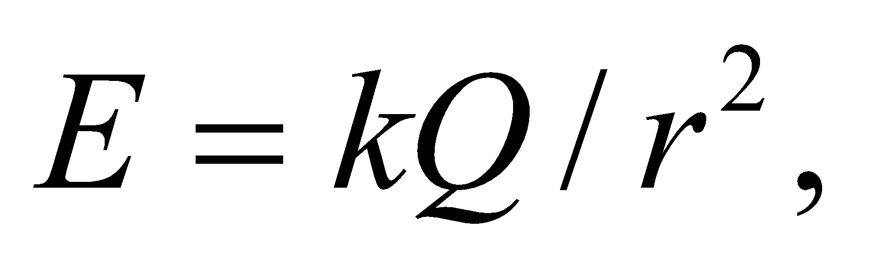which is the same as for a point charge at the origin.

**Evaluate** For rabbit RBCs:

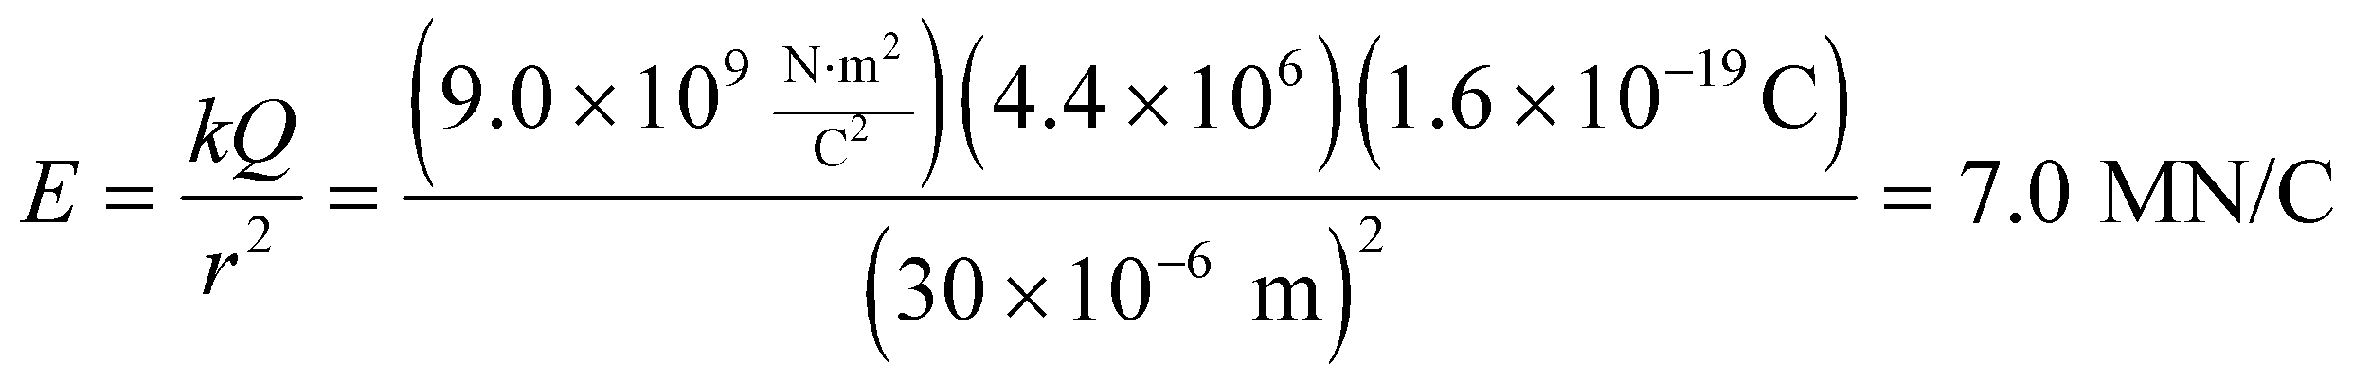

For human RBCs:

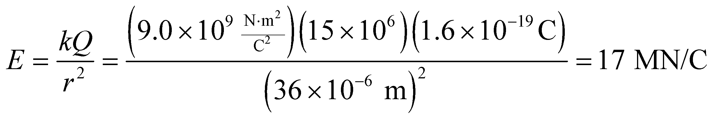

**Assess** Because the charge is from electrons, the electric fields point in towards the center of the cells.

**46. Interpret** We are given a charge distribution with spherical symmetry, so we can apply Gauss’s law to find the electric field.

**Develop** The balloon can be regarded as a spherical shell with charge residing on the outer surface. Gauss’s law (Equation 21.3) is

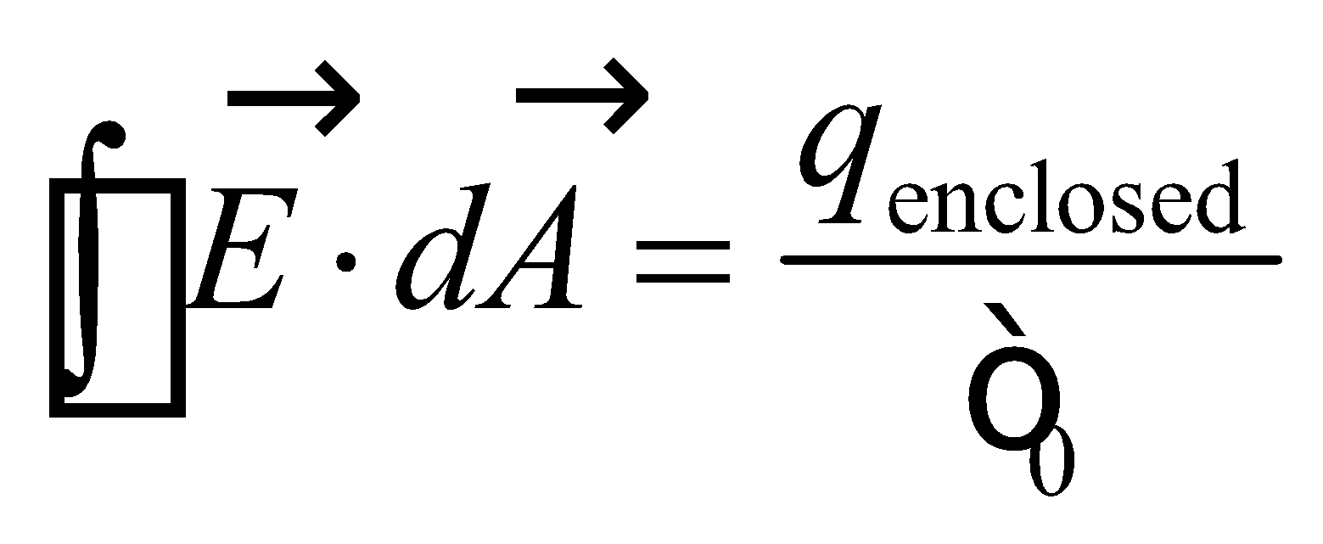

For part (a), the surface over which we perform the integration is inside the balloon (*r* = 50 cm), so *q*enclosed = 0 and Gauss’s law gives

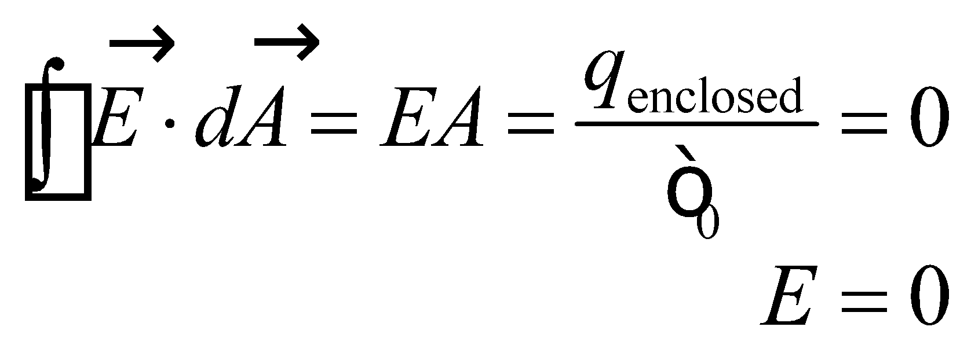

For part **(b)**, we note that outside the balloon, the field is like that of a point charge at the center that carries the total charge. Therefore, the electric field is given by Equation 20.3, which gives

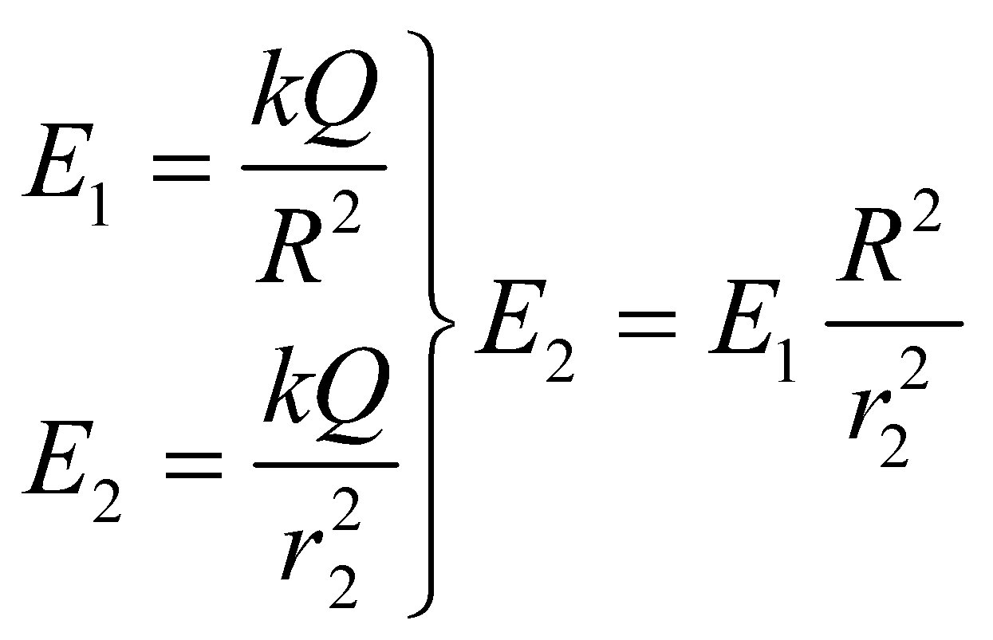

where *R* = 70 cm, *r*2 = 190 cm, and *E*1 = 26 kN/C. Notice that the expression for E1 also allows us to find the total charge *Q* on the balloon for part (**c**).

**Evaluate** **(a)** Inside the balloon, *E* = 0 as discussed above.

**(b)** Inserting the given quantities into the expression for *E*2 gives

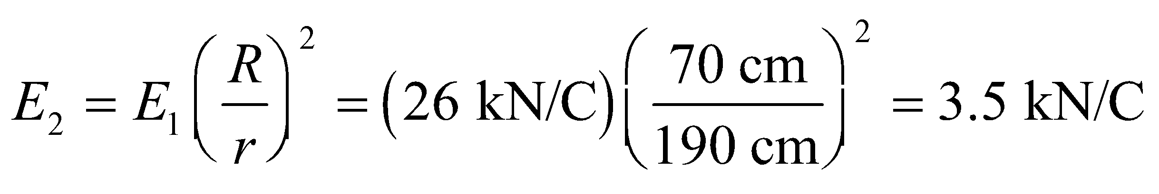

**(c)** Using the given field strength at the surface, we find a net charge

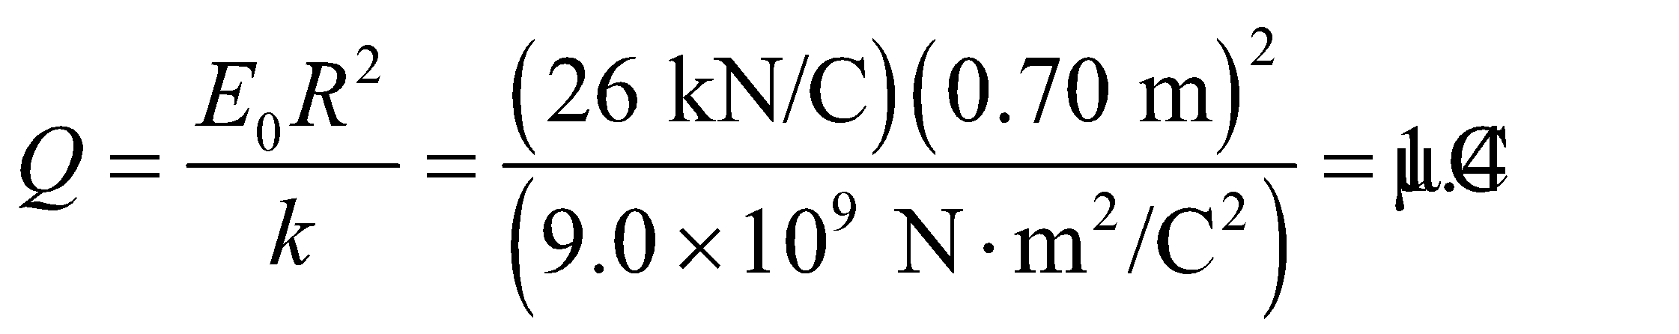

**Assess** The electric field inside a spherical shell is identically zero. Outside the shell, the field decreases as 1/*r*2.

**47.** **Interpret** This problem involves a uniform, spherically symmetric charge distribution. We are to find the second location where the electric field has the given value, and find the net charge on the sphere. Doing so will involve Gauss’s law.

**Develop** Example 21.1 uses Gauss’s law to derive expressions for the electric fields inside and outside a spherical charge distribution. We are given the field strength inside the sphere (at *r*1 = *R*/2), so we can equate it to the field strength outside the sphere at *r*2 and solve for the position. Explicitly, we have



To find the net charge on the sphere, we can use the expression for *E*inside and solve for *Q*.

**Evaluate** (a) Solving the expression above for *r*2 gives 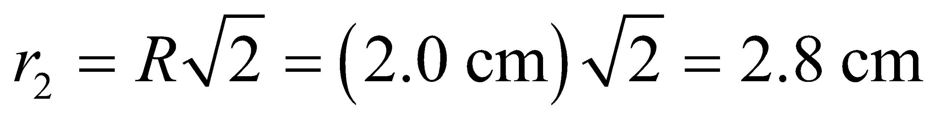

(b) Solving for the total charge *Q* gives



**Assess** For part (a), we assumed that the second location at which the field had the given value was outside the sphere. Were this not true, we would have found an unphysical answer (i.e., an imaginary field).

**48. Interpret** The given charge distribution has spherical symmetry, so we can apply Gauss’s law to find the electric field. In addition, because the charge distribution consists of two distinct charge distributions, we can apply the principle of superposition to find the net electric field.

**Develop** The total electric field is the superposition of the fields due to the point charge and the spherical shell.

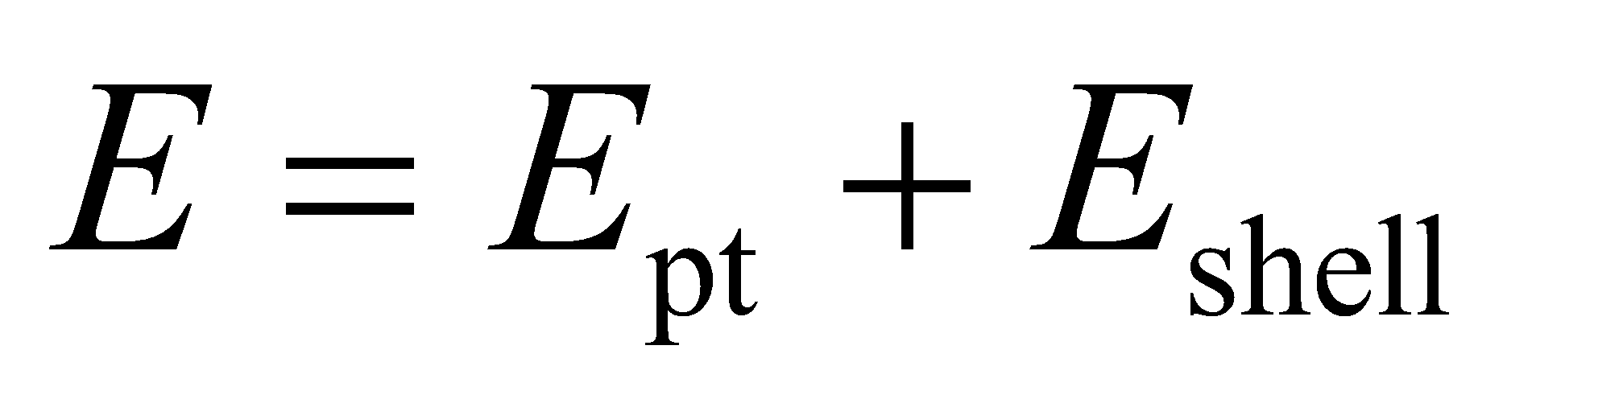

The field is spherically symmetric about the center. Inside the shell, the contribution *E*shell to the electric field is zero because there is no charge enclosed (remember, this is just for the shell with no point charge inside). Outside the shell, the contribution *E*shell is like that of a point with charge *Q* located at the center of the sphere of the shell. Both inside and outside the shell, the contribution *E*pt is that of a point charge with charge −2*Q*.

**Evaluate** **(a)** At 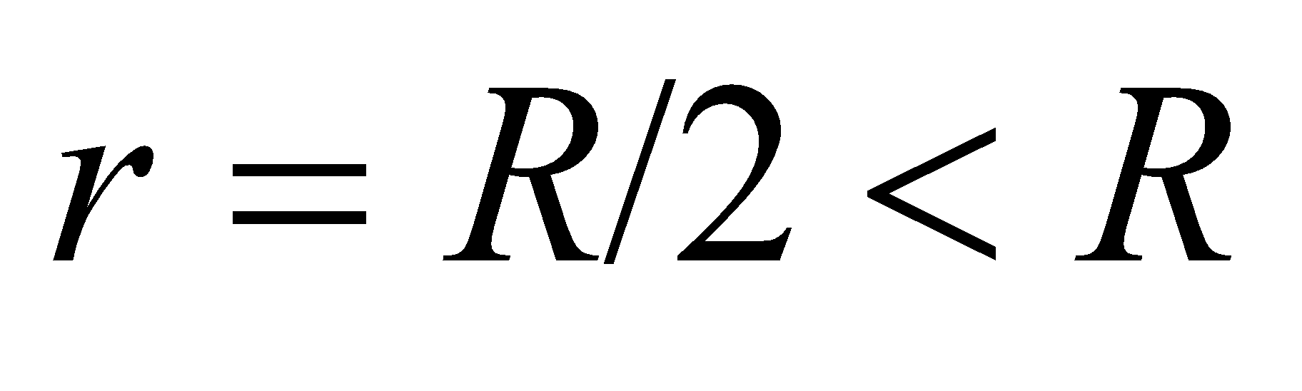 (inside the shell), the electric field is

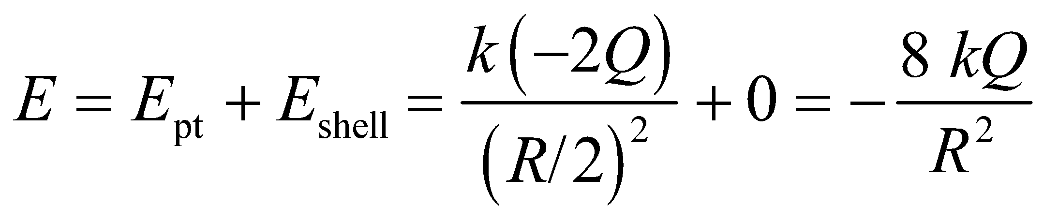

Note that the minus sign means the direction is radially inward.

**(b)** At 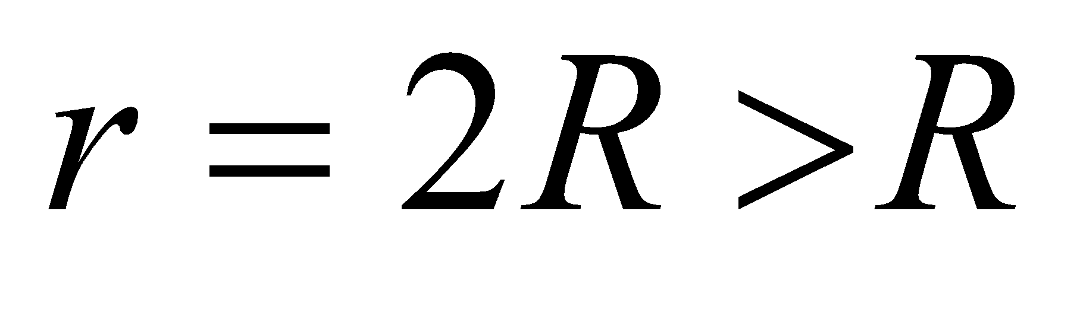 (outside shell), the field strength is



Again the direction of the field is radially inward.

**(c)** If 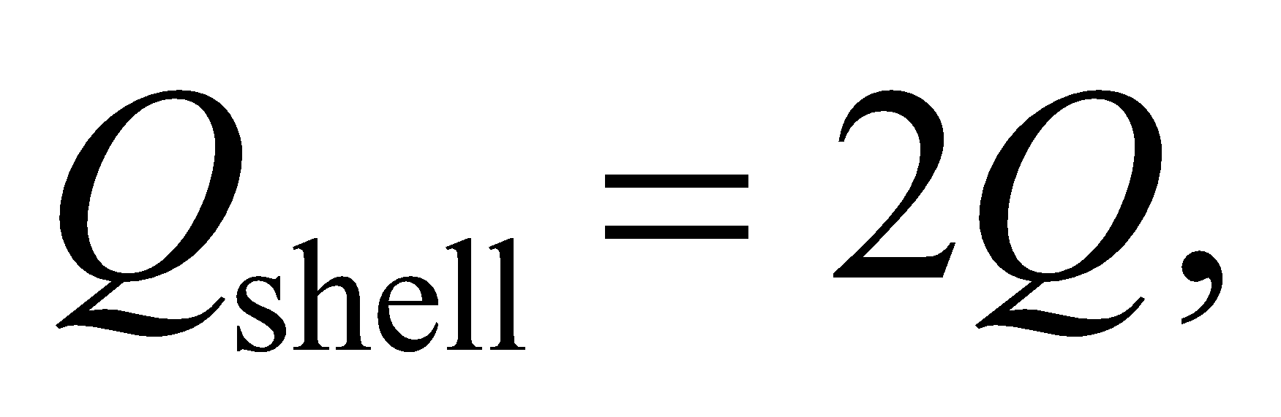 the field inside would be unchanged, but the field outside would be zero by Gauss’s law (Equation 21.3) since 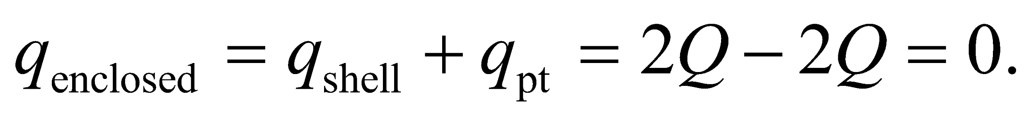

**Assess** By Gauss’s law, the shell produces no electric field in its interior. The field outside a spherically symmetric distribution is the same as if all the charges were concentrated at the center of the sphere.

**49.** **Interpret** You're helping your friend determine what charge is needed on a square plate to obtain the desired field at a point near the plate's center. The situation has planar symmetry.

**Develop** The field strength is specified at a distance from the plate, 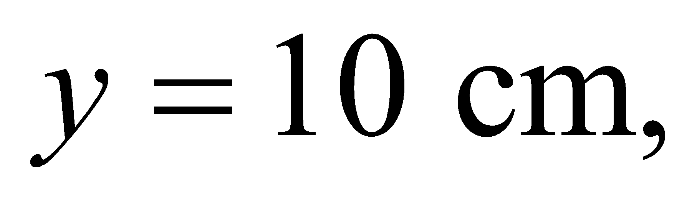which is considerably less than the size of the square plate, 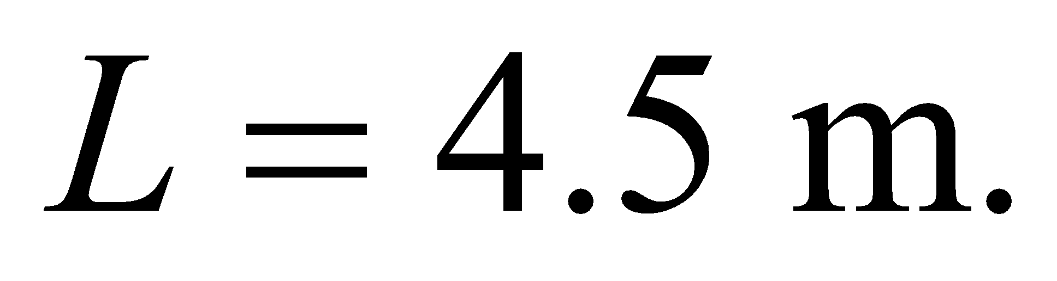 Therefore, we can assume that the field lines are essentially perpendicular to the plate, which means the electric field strength is given by Gauss's law: 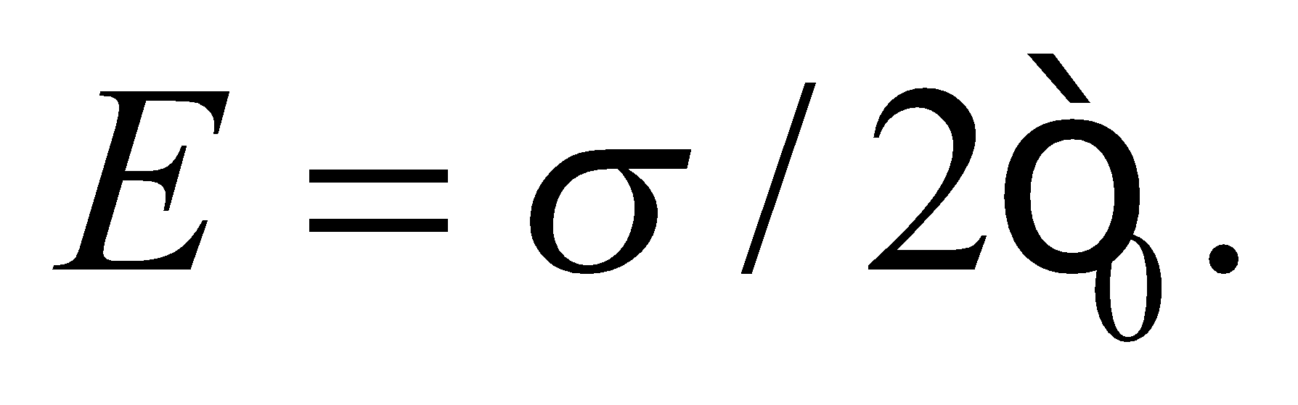The total charge on the plate will be 

**Evaluate** Solving for the total charge:



**Assess** The answer doesn't depend on the distance *y*, but as one moves farther from the plate, the assumption that the field lines are all pointing in the direction perpendicular to the sheet will no longer be true. In fact, for 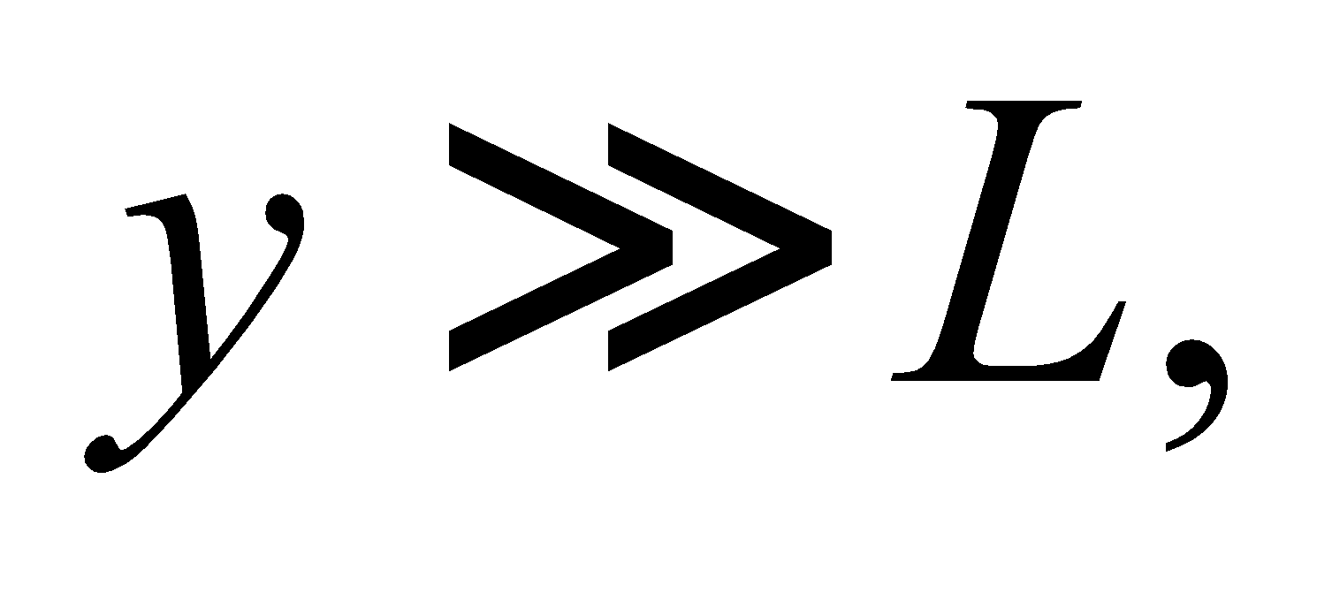 the plate will seem like a point and the field will go as 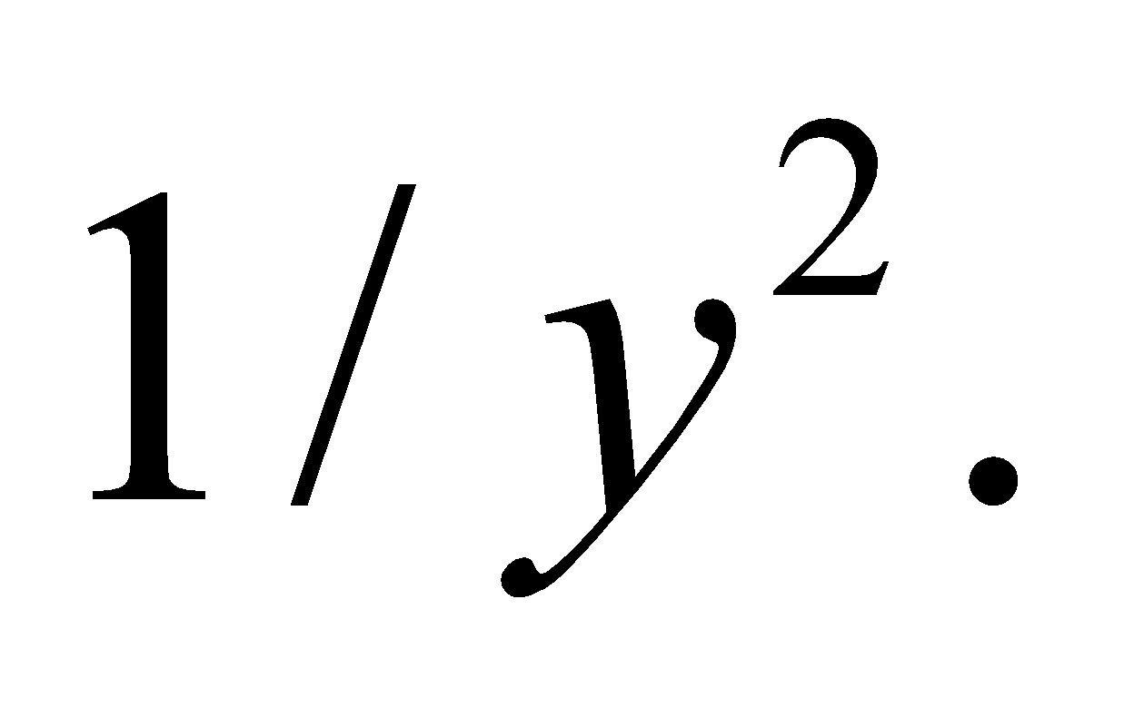

**50.** **Interpret** The geometry of this problem is similar to that of Problem 21.48. We again have a spherically symmetric charge distribution that we can separate into two pieces (shell + point charge) to apply the superposition principle. This and Gauss’s law allows us to find the point charge and the field just outside the shell.

**Develop** As in the solution to Problem 21.48, we use the superposition principle to find the field outside the shell. The result, evaluated at the spheres surface (*r* = *R*) is



By Gauss’s law, the field inside the shell is due to the point charge only, so Equation 20.3 (or by again using Gauss’s law) gives

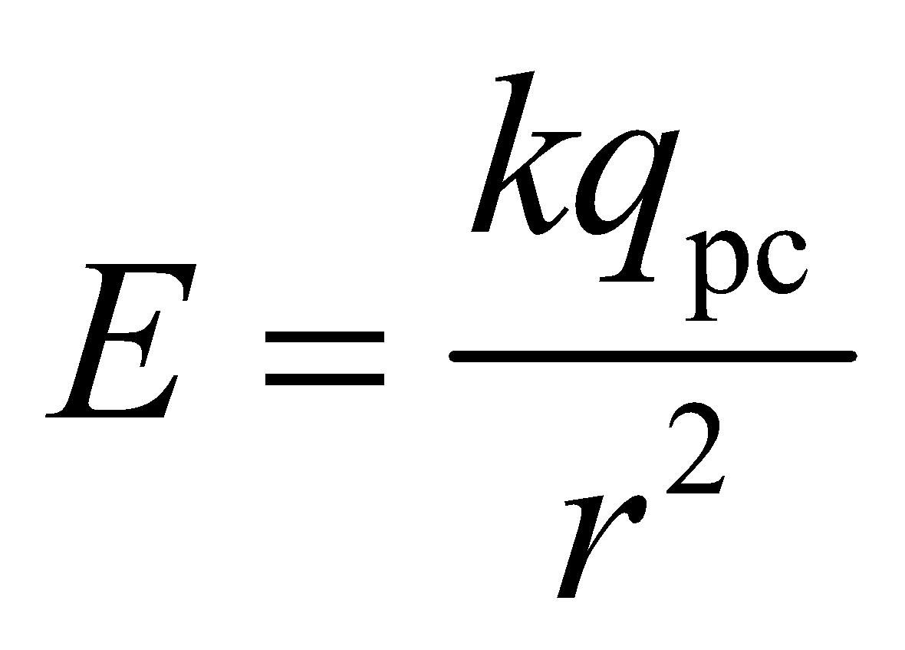

**Evaluate** (a) Solving the first expression or *q*pc gives

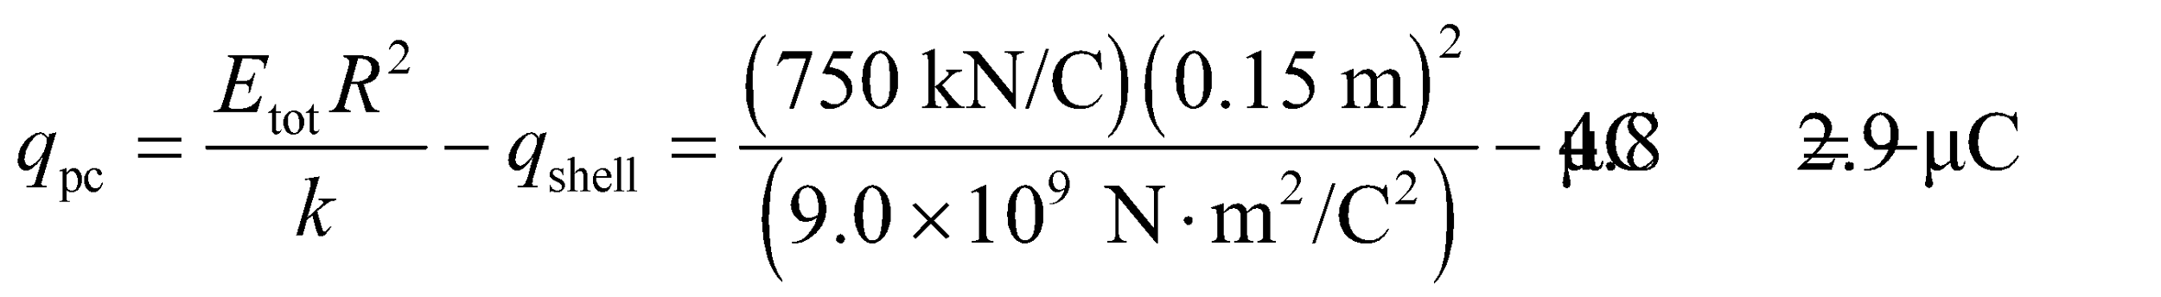

(b) Just inside the sphere, *r* = 15 cm − *δ*, where *δ*  15 cm. Inserting this and the result from part (a) into the expression for the electric field inside the sphere gives

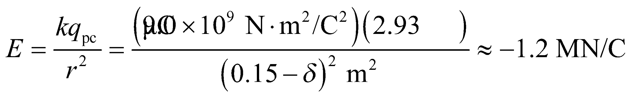

directed radially inward.

**Assess** The field just inside the sphere is larger than the field just outside the sphere because the positive charge on the sphere cancels some of the field due to the negative point charge at the center of the sphere.

**51. Interpret** The charge distribution has spherical symmetry, so we can apply Gauss’s law to find the electric field. In addition, it is composed of two distinct charge distributions, so we can consider each one separately and use the superposition principle to construct the net electric field. Note that this problem is exactly the same as Problem 21.50, so we will defer here to that solution.

**Develop** See the solution to Problem 21.50 for the derivation. The total electric field is the superposition of the fields due to the point charge and the spherical shell. The field is spherically symmetric about the center.

**Evaluate** **(a)** The field due to the shell is zero inside, so at *r* = 5 cm, the field is due to the point charge only. Thus,

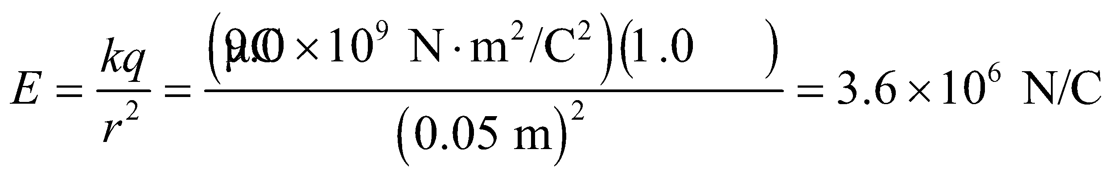

The field points radially outward.

**(b)** Outside the shell, its field is like that of a point charge with a total charge equal to the sum of the charge on the sphere and the point charge, so atthe field strength is



The direction of the field is radially outward.

**(c)** If the charge on the shell were doubled, the charge enclosed inside the sphere would not change, so Gauss’s law (Equation 21.3) tells us that the electric field inside the sphere would not change. However, the field outside would be

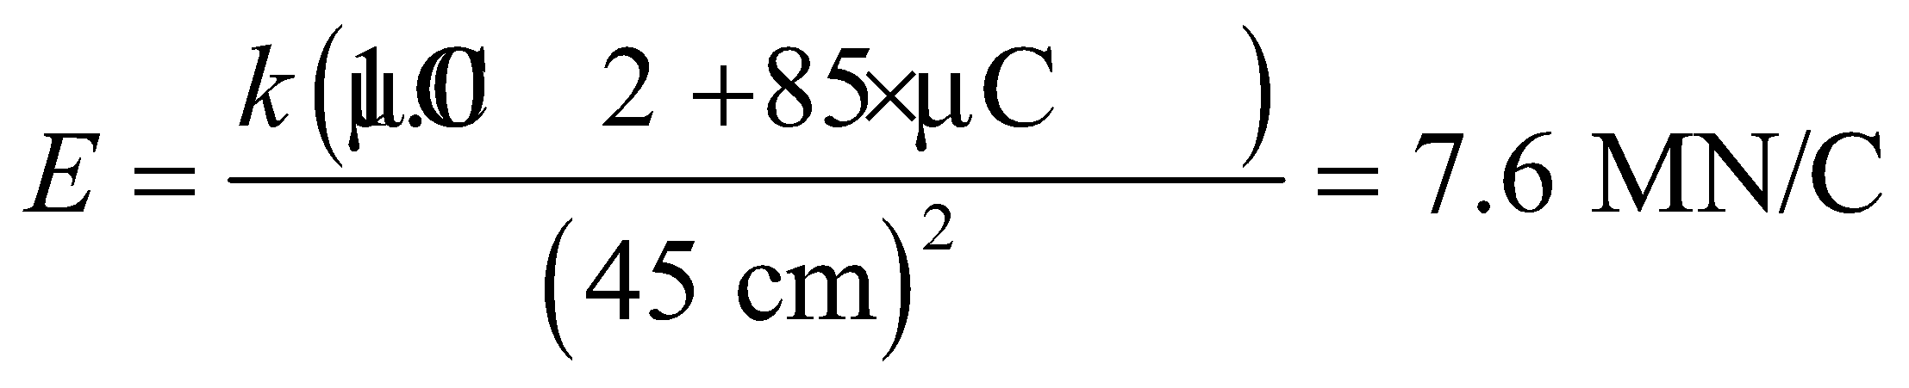

which is essentially doubled (to two significant figures).

**Assess** By Gauss’s law, the shell produces no electric field in its interior. The field outside a spherically symmetric distribution is the same as if all the charges were concentrated at the center of the sphere.

**52.** **Interpret** This problem involves a spherically symmetric, uniform charge distribution, so we can apply Gauss’s law to find an expression for the electric field.

**Develop** Make a sketch of the situation (see figure below). Consider a sphere with radius *r*, where *a* < *r* < *b*. Gauss’s law tells us that the electric field at this surface is



which is Equation 20.3 for the field of a point charge with charge *q*enclosed. The charge *q*enclosed is given by the charge density *ρ* times the charged volume enclosed by the sphere or radius *r*, or

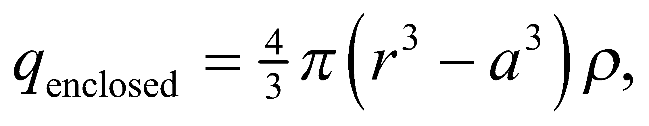

We can combine these two expressions to express the electric field inside the charged volume.

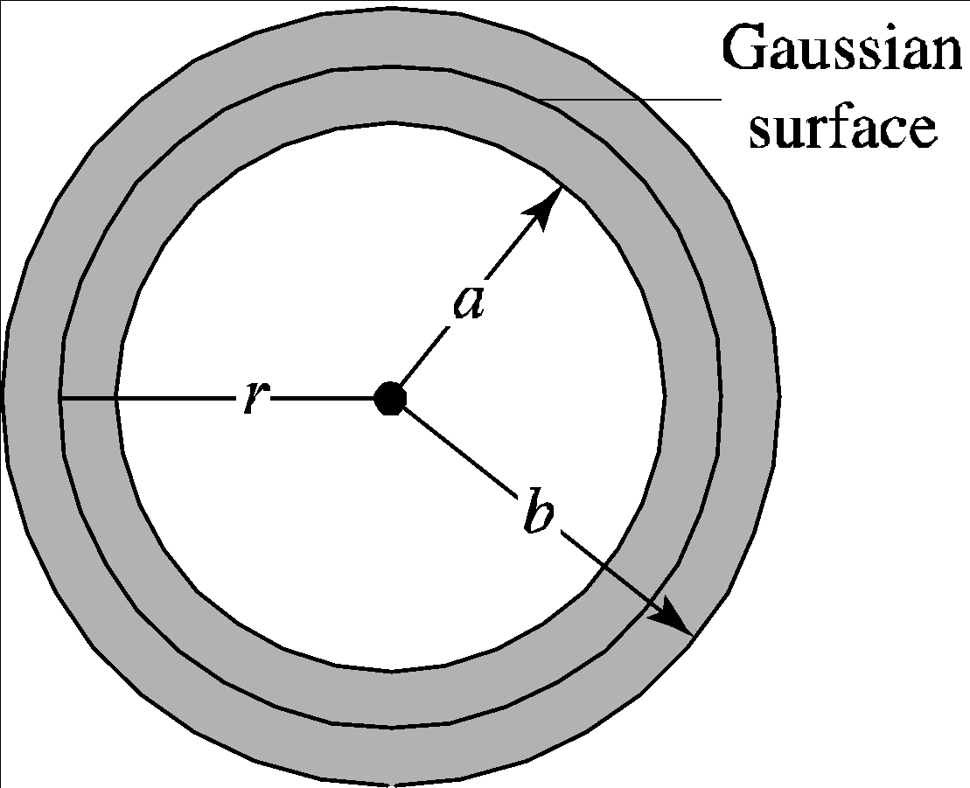

**Evaluate** Inserting *q*enclosed into the expression for the electric field gives



If we let 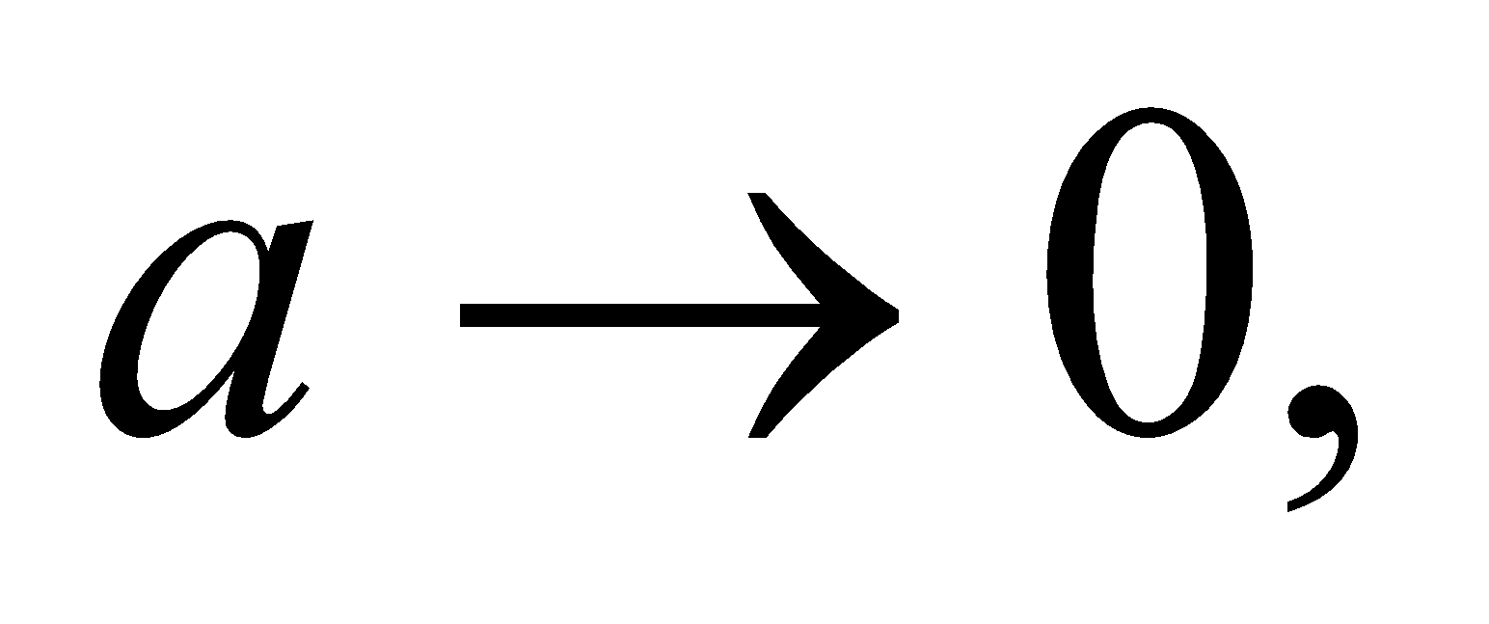and recall that *Q* = *ρV* = *ρ*(4*πR*3/3), we get

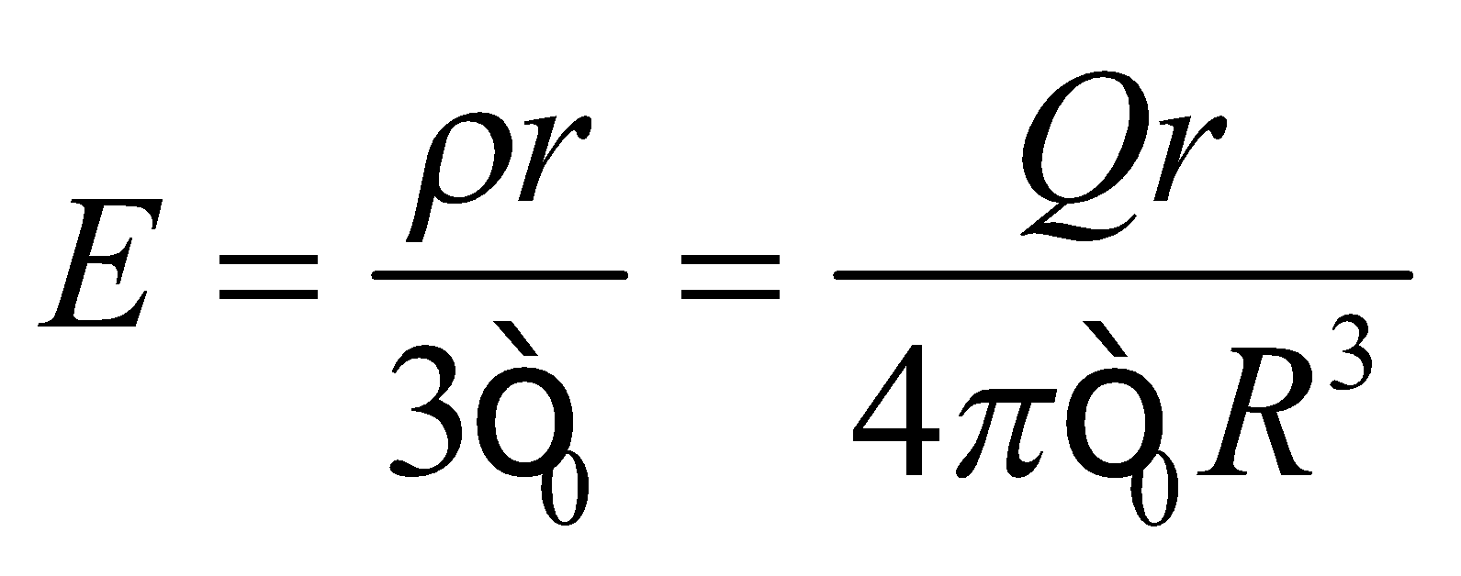

which is Equation 21.5 for the electric field inside a uniformly charged sphere of radius R.

**Assess**  Equation 21.5 for a uniformly charged spherical volume is recovered.

**53. Interpret** We are given a charge distribution with approximate line symmetry (provided we consider distances from the wire that are much, much smaller than the length of the wire, and provided we are not near the end of the wire). We can use this symmetry and Gauss’s law to compute the electric field.

**Develop**With the assumption that the electric field is approximately that from an infinitely long, line symmetric charge distribution, we can use the result of Example 21.4 (i.e., Equation 21.6) to express the electric field near the wire:

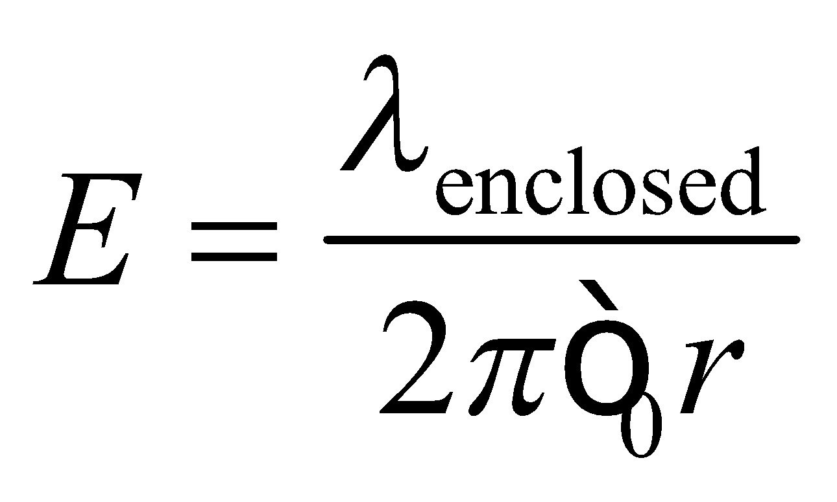

where 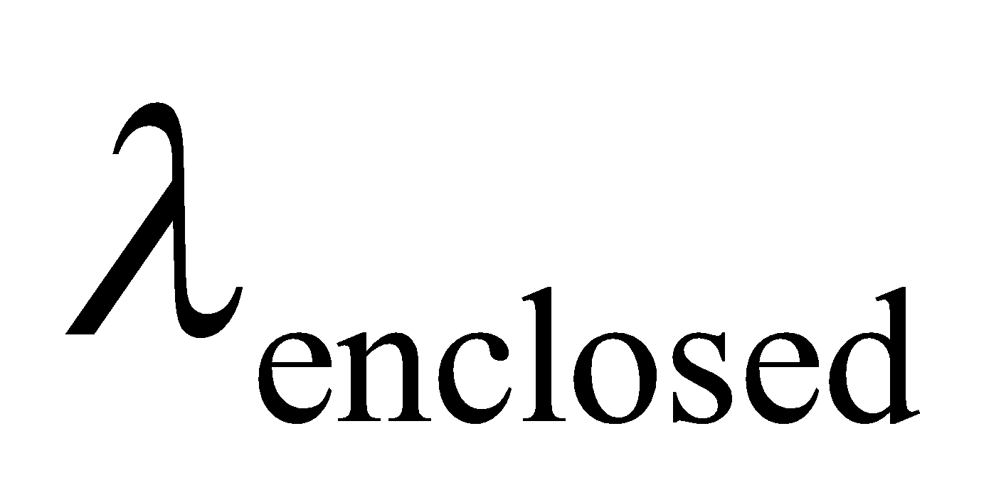 is the charge per unit length enclosed by a cylinder of radius *r*. We can evaluate this expression to find the electric field at different distances *r* from the wire.

**Evaluate** **(a)** For r = 0.50 cm = 0.0050 m, which is between the wire and the pipe, the enclosed charge per unit length is 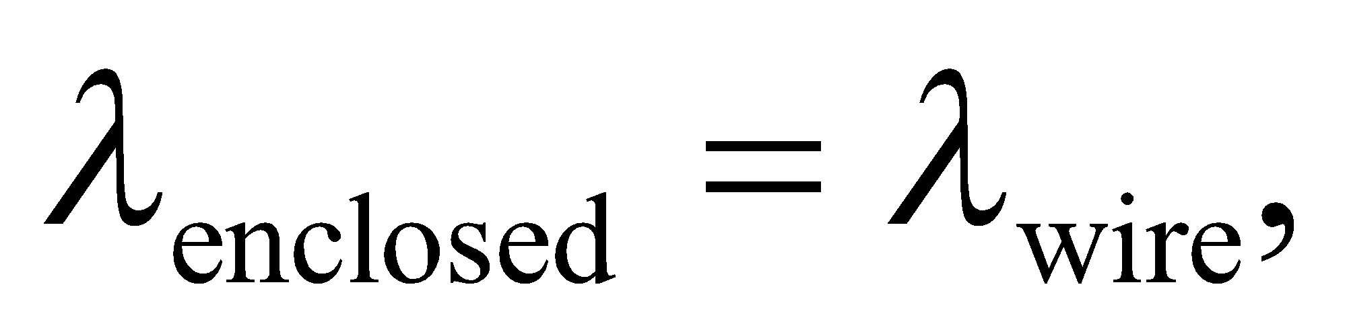and

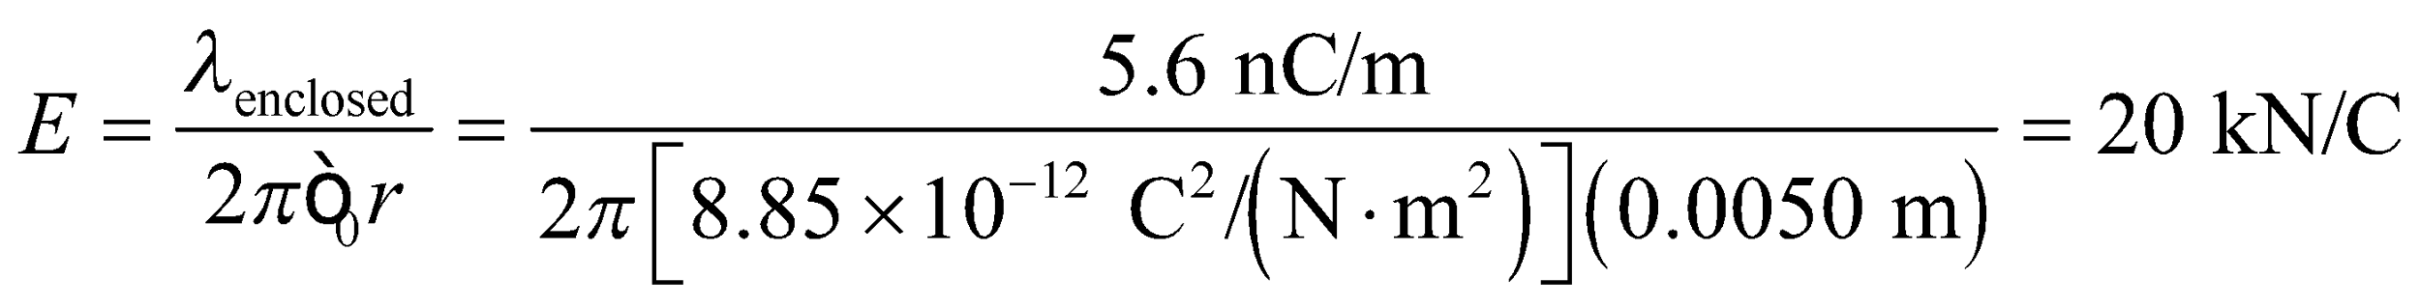

The field is (positive) radially away from the axis of symmetry (i.e., from the wire).

**(b)** For r = 1.5 cm = 0.015 m, the enclosed charge per unit length is 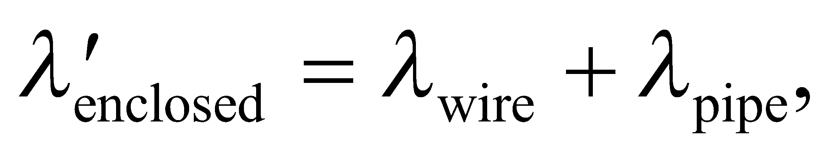 and

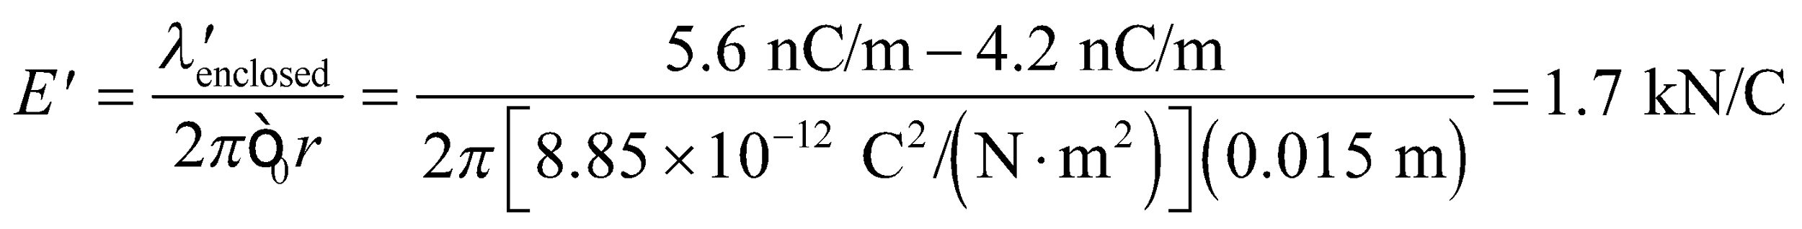

The field is in the same direction as the field in part **(a)**.

**Assess** Between the wire and the pipe, the enclosed charge per unit length is  whereas outside the pipe, the enclosed charge is 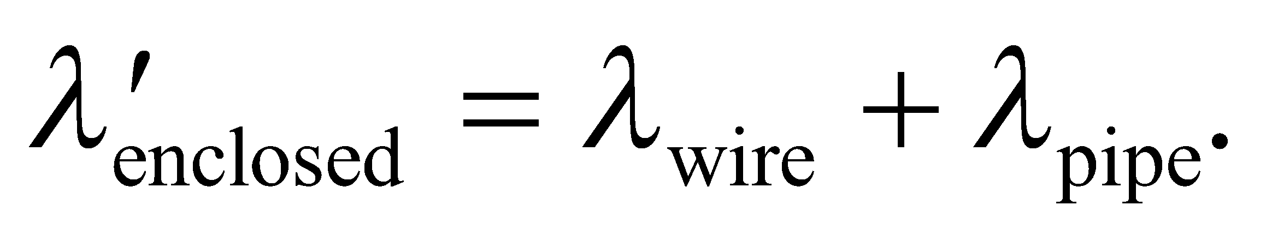 Since the pipe and the wire carry opposite charges, 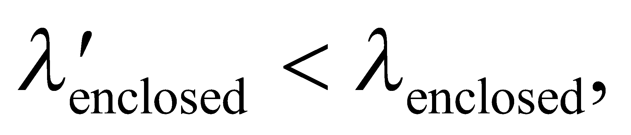 so 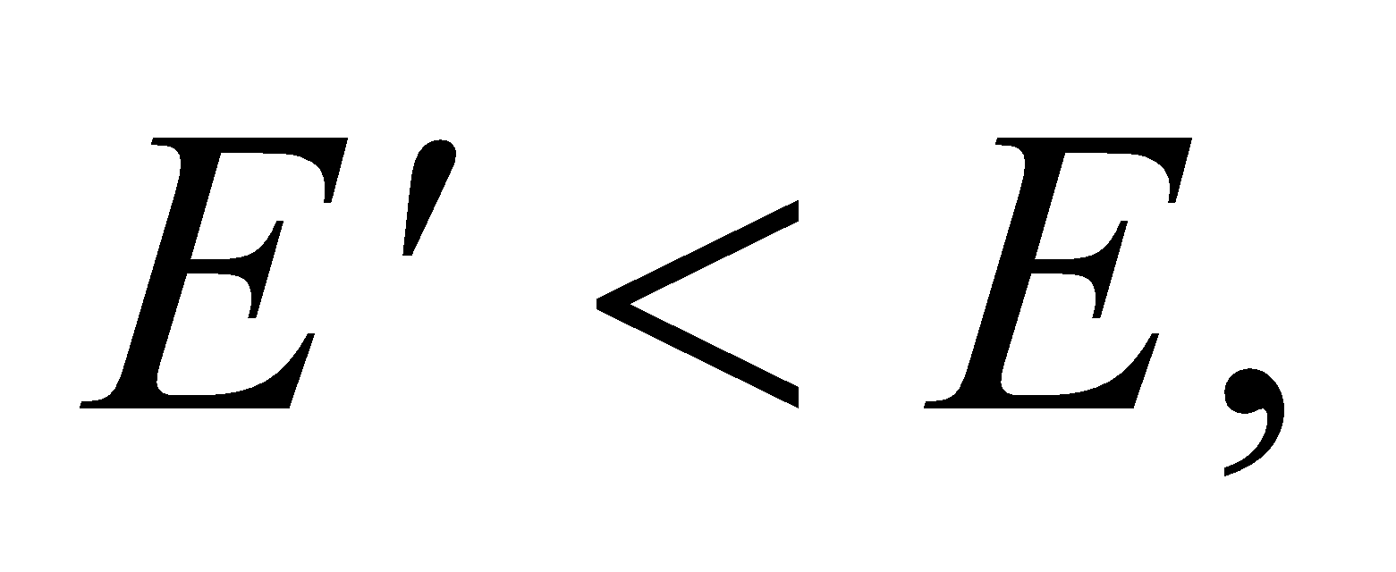 as we have shown.

**54.** **Interpret** We're asked to find the electric field from an infinite rod. The line symmetry implies we should use Gauss's law.

**Develop** Imagine a Gaussian surface in the shape of a cylinder with radius *r* and length *L*, see Figure 21.15. The electric field is radial; i.e. it will be perpendicular to the curved outer surface, and parallel to the two flat ends. Therefore, the electric flux through the cylinder is

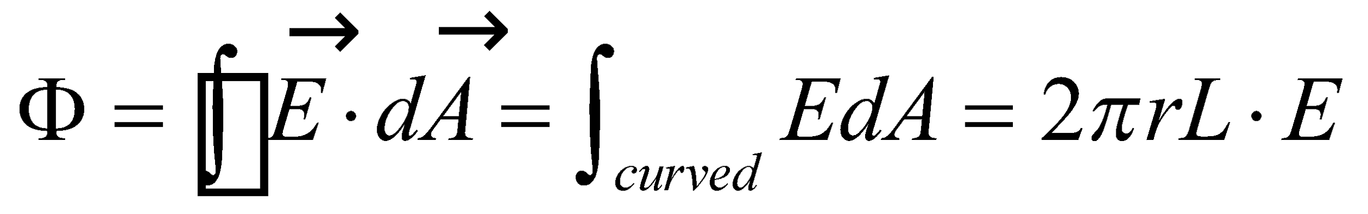

Where we have used the fact that *E* should be constant at a given radius and the fact that the curved outer surface of the cylinder has area of 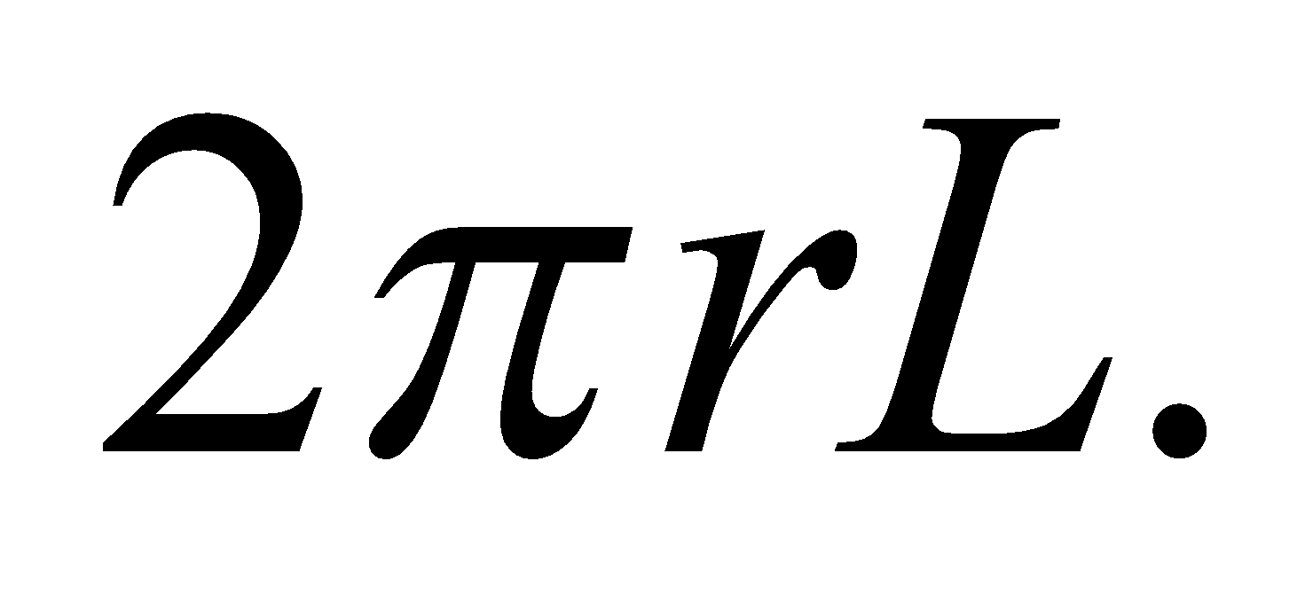

**Evaluate** Outside the rod for 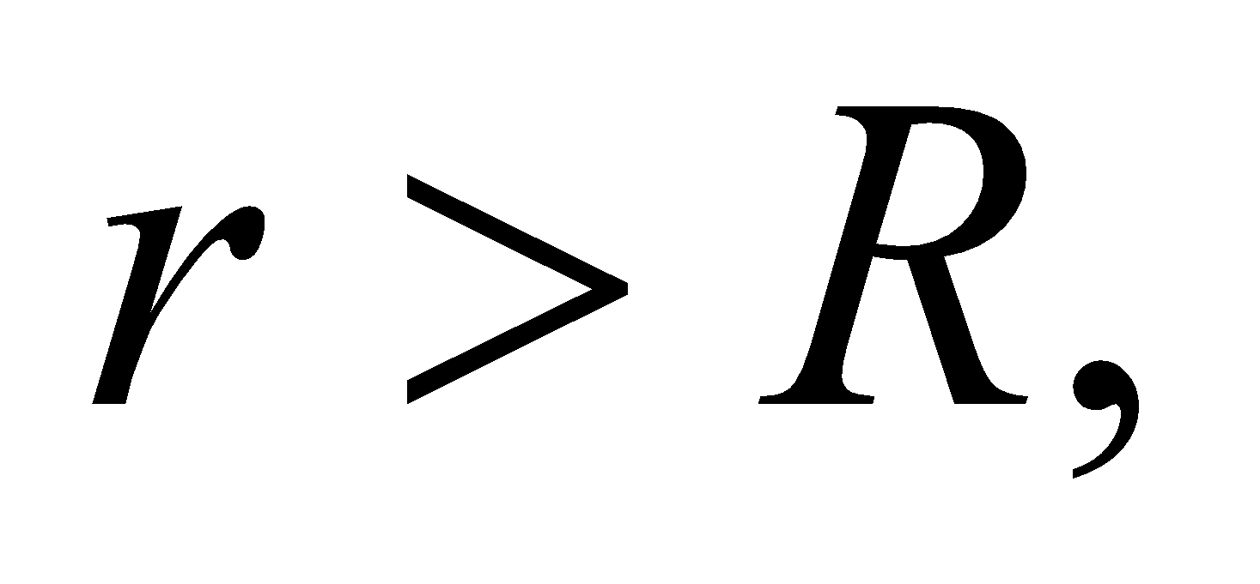the enclosed charge is that contained in a cylinder with radius *R*. Applying Gauss's law, the electric field is

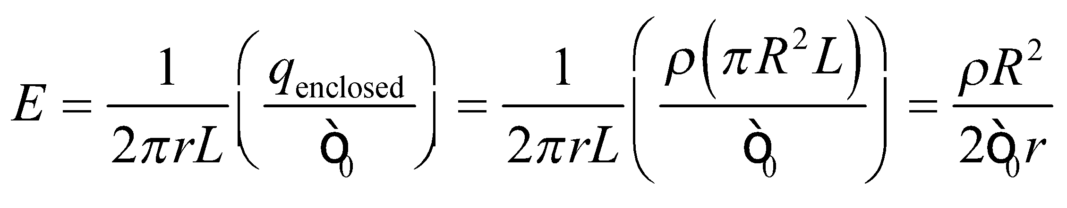

Inside the rod for 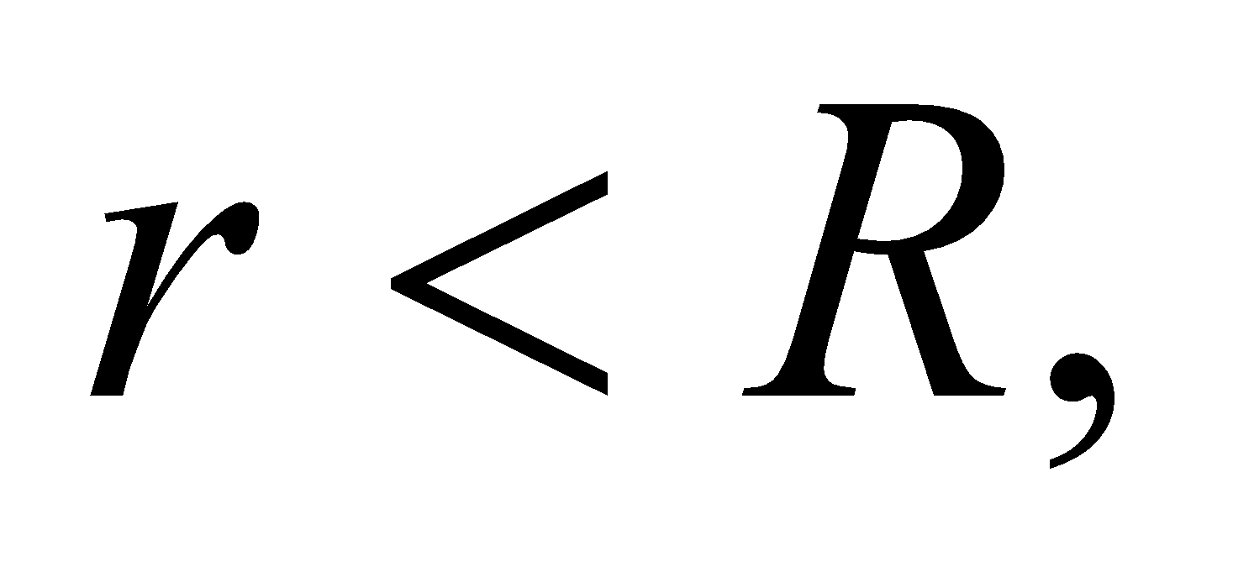the enclosed charge is that contained in a cylinder with radius *r*. Applying Gauss's law, the electric field is

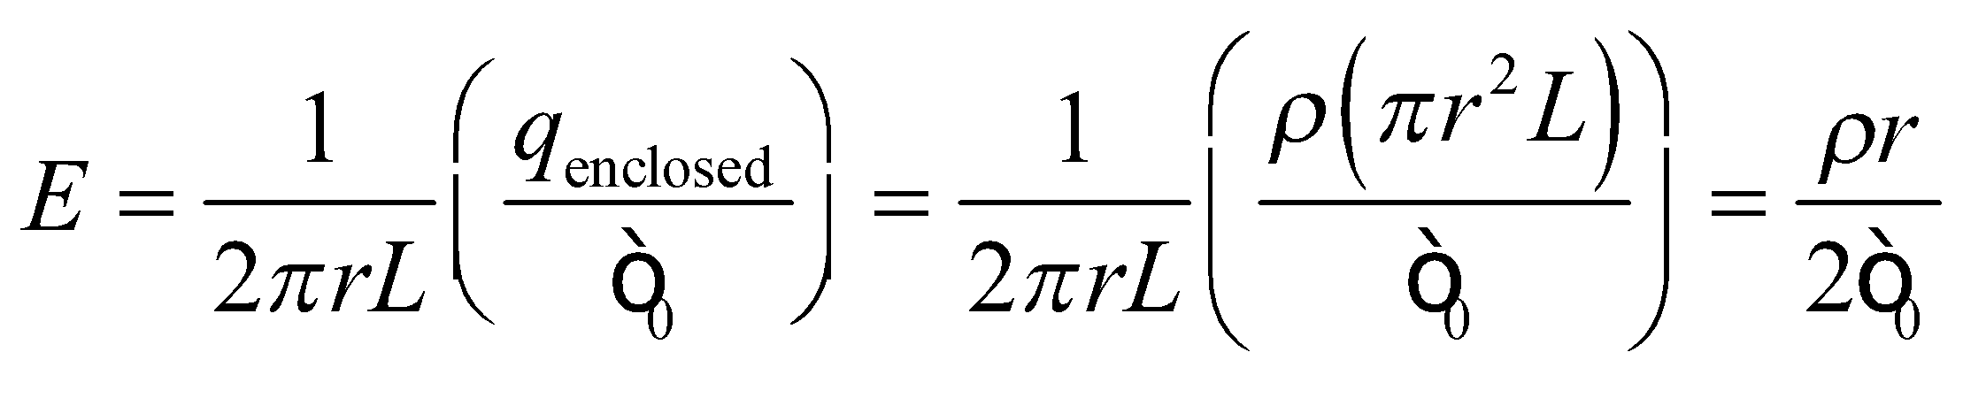

**Assess** Compare this result to a uniformly charged sphere, Example 21.1. In both cases, the electric field inside the charged material is proportional to the radius *r*. But outside the material, the electric field drops faster for a sphere 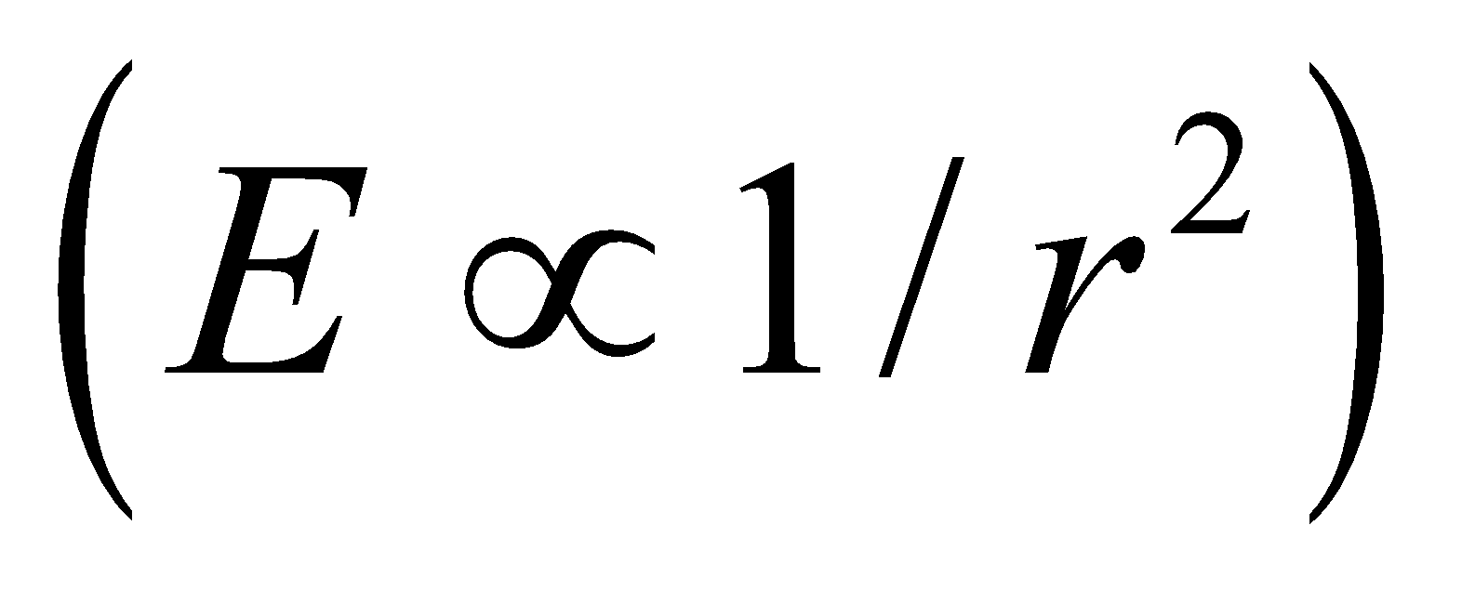 than for an infinite rod 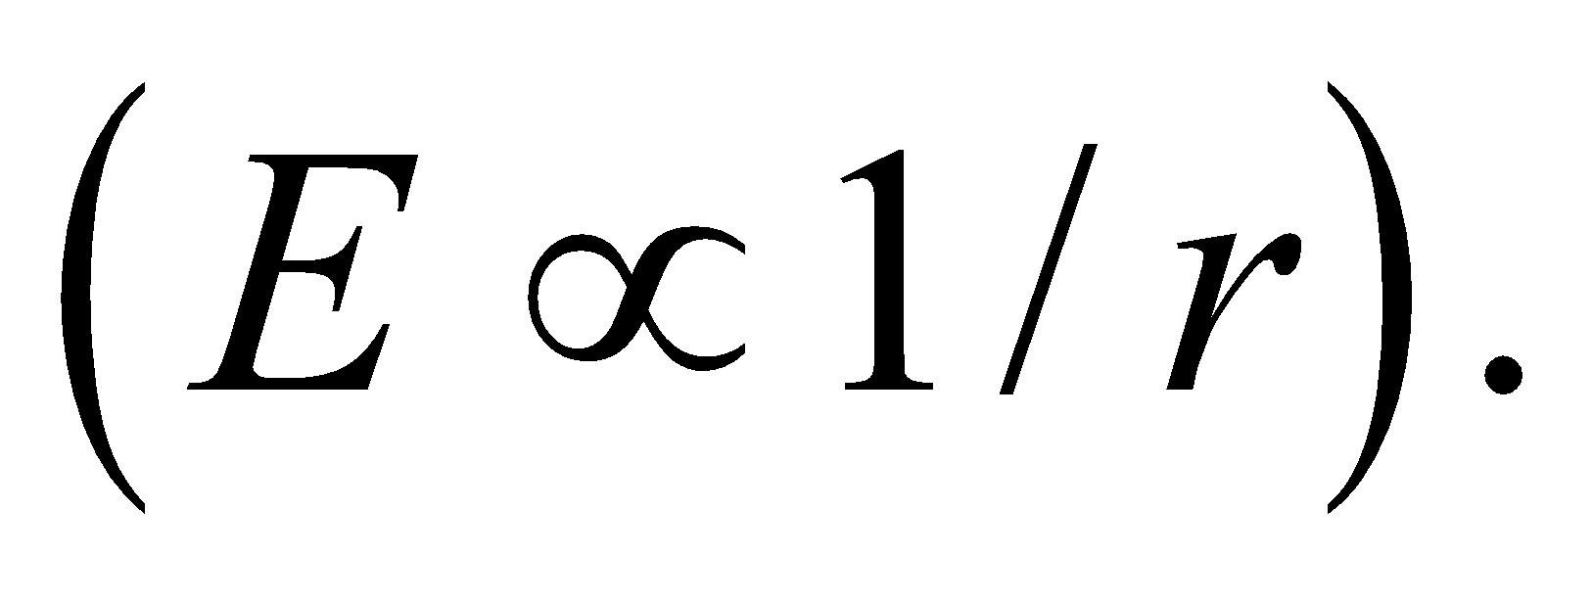

**55. Interpret** Because we are not concerned with the electric field near the end of the wire, but only with the field in the central part of the wire, we can consider that the given charge distribution has line symmetry (and this is true only for distances r that are much, much less than the length of the wire). Thus, we will apply Gauss’s law to compute the electric field near the wire.

**Develop** We assume that the rod is long enough and approximate its field using line symmetry. This is the situation dealt with in Example 21.4, so we use that result:



where  is the charge per unit length inside a cylindrical Gaussian surface of radius *r* about the symmetry axis. Since the charge is uniformly distributed throughout the solid rod, the line charge density is simply equal to the volume charge density times the cross-sectional area of the rod: 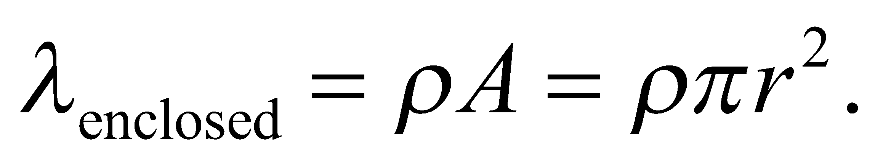 Combining the two equations yields

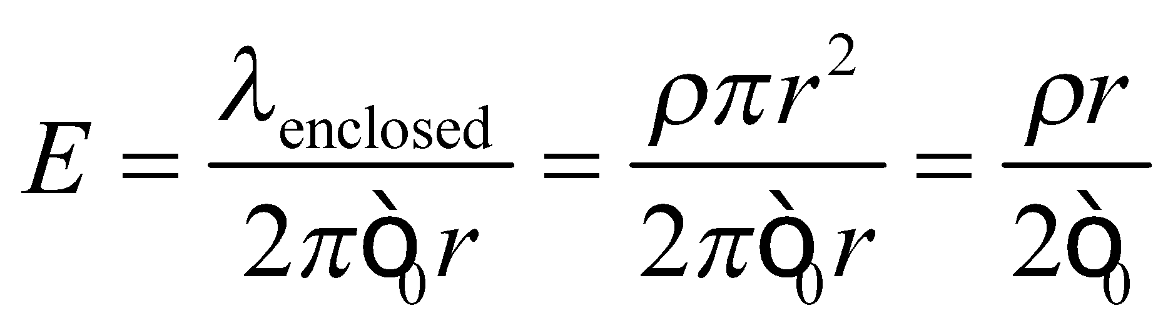

This equation (valid for 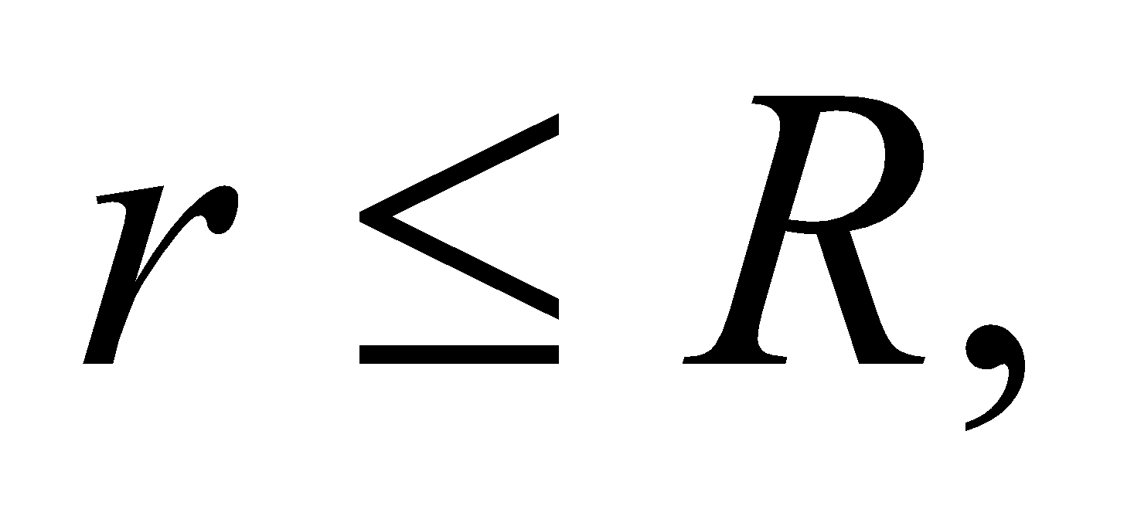 where *R* is the radius of the rod) allows us to solve for *ρ*.

**Evaluate** With the electric field at *r* = *R* given, we find the volume charge density to be

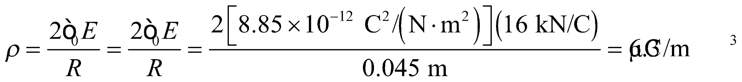

This is the magnitude of *ρ*, since the direction of the field at the surface (i.e., radially inward or outward) was not specified.

**Assess** If we were given the field strength at a point  then

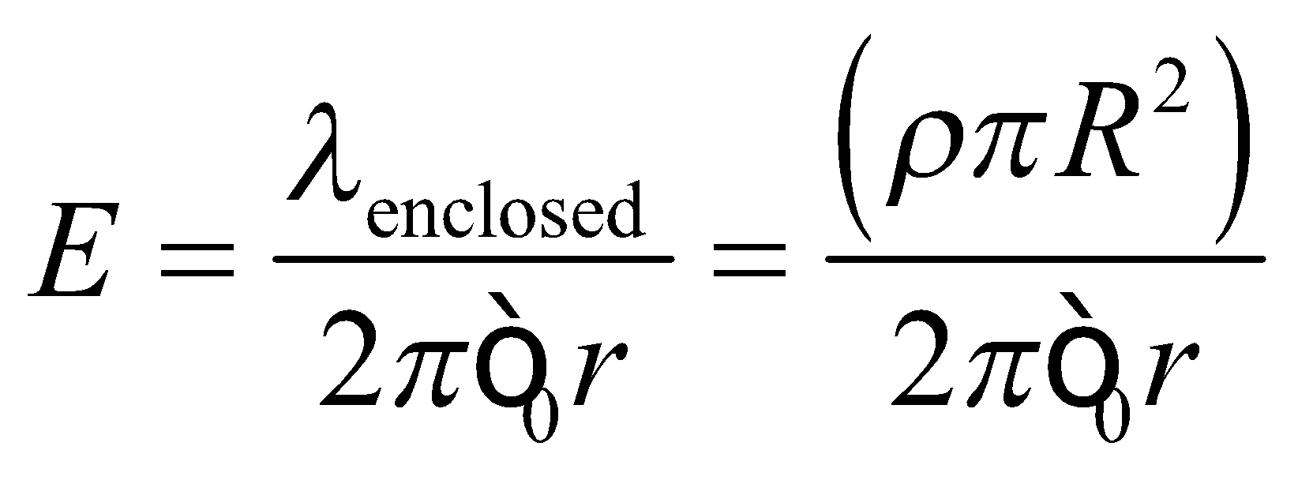

and the volume charge density would be

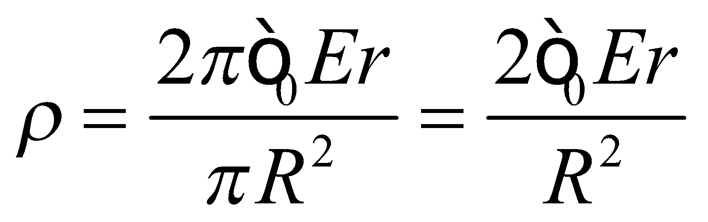

**56.** **Interpret** To suspend a particle above the "charged" floor, the electric force has to counter the gravitational force.

**Develop** If the floor is painted with charge, then it will have the same field as the sheet of charge in Example 21.6: This is constant, so theoretically it shouldn't matter the height that the particle is placed.

**Evaluate** For the electric force, 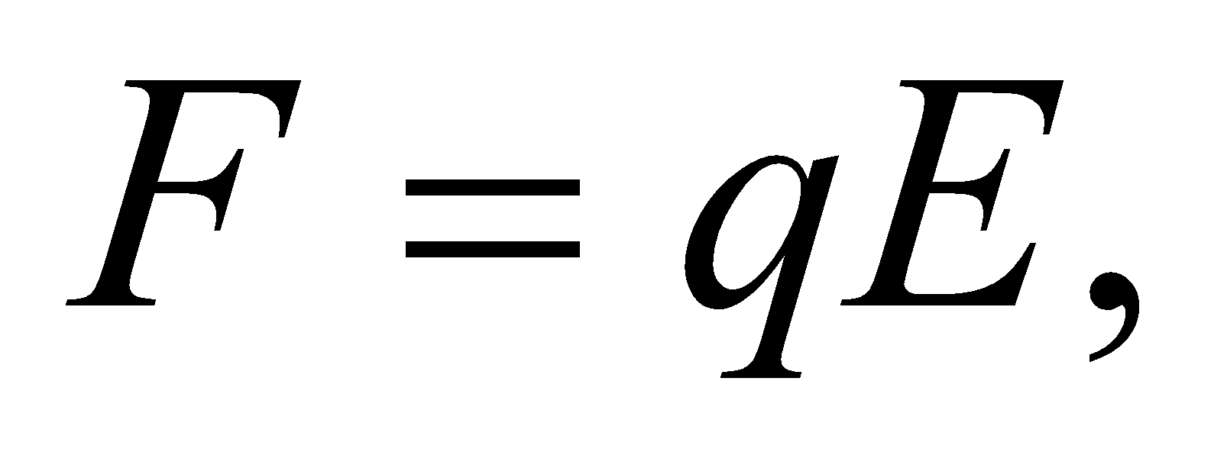to counter the gravitational force, 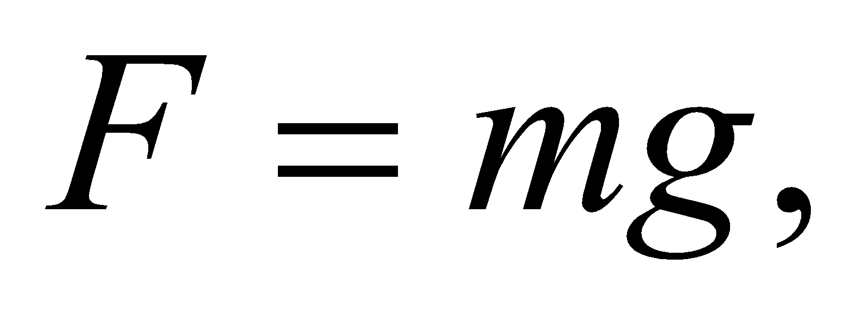the surface charge density on the painted floor must be

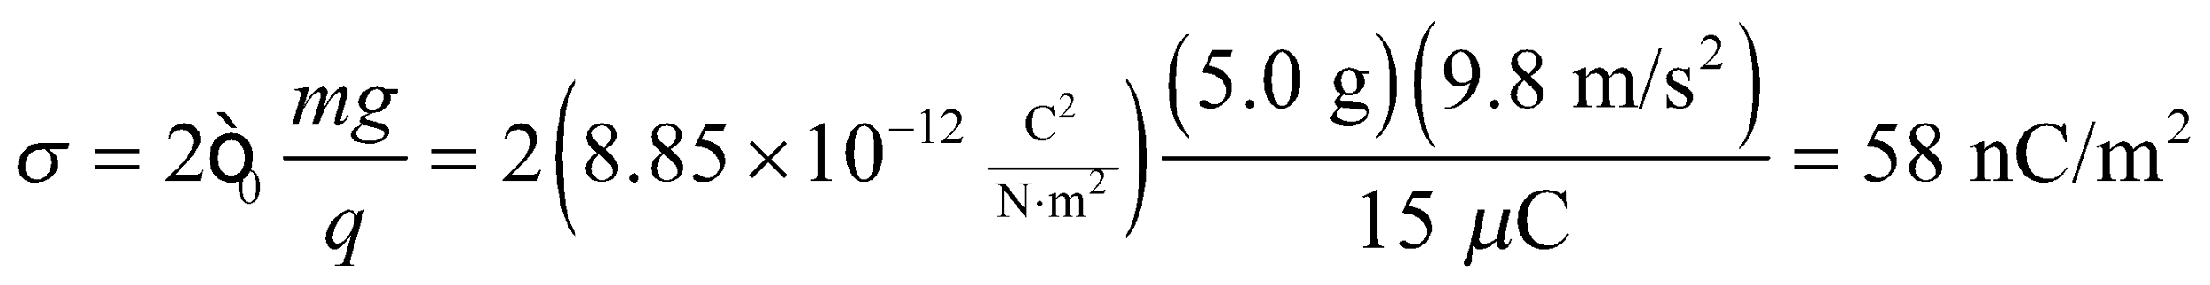

**Assess** Since the particle's charge is positive, the charge on the floor should be positive as well so that the electric force is repulsive. This will be in the opposite direction of the gravitational attraction.

**57.** **Interpret** The infinitely large slab has plane symmetry, and we can apply Gauss’s law to compute the electric field.

**Develop** When we take the slab to be infinitely large, the electric field is everywhere normal to the slab's surface and symmetrical about the center plane. We follow the approach outlined in Example 21.6 to compute the electric field. As the Gaussian surface, we choose a box that has area A on its top and bottom and that extends a distance x both up and down from the center of the slab. See figure below.

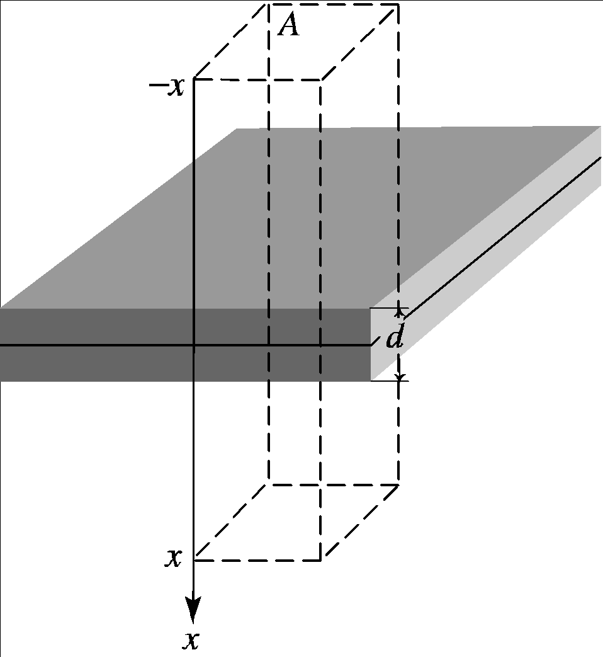

**Evaluate**  (a) For points inside the slab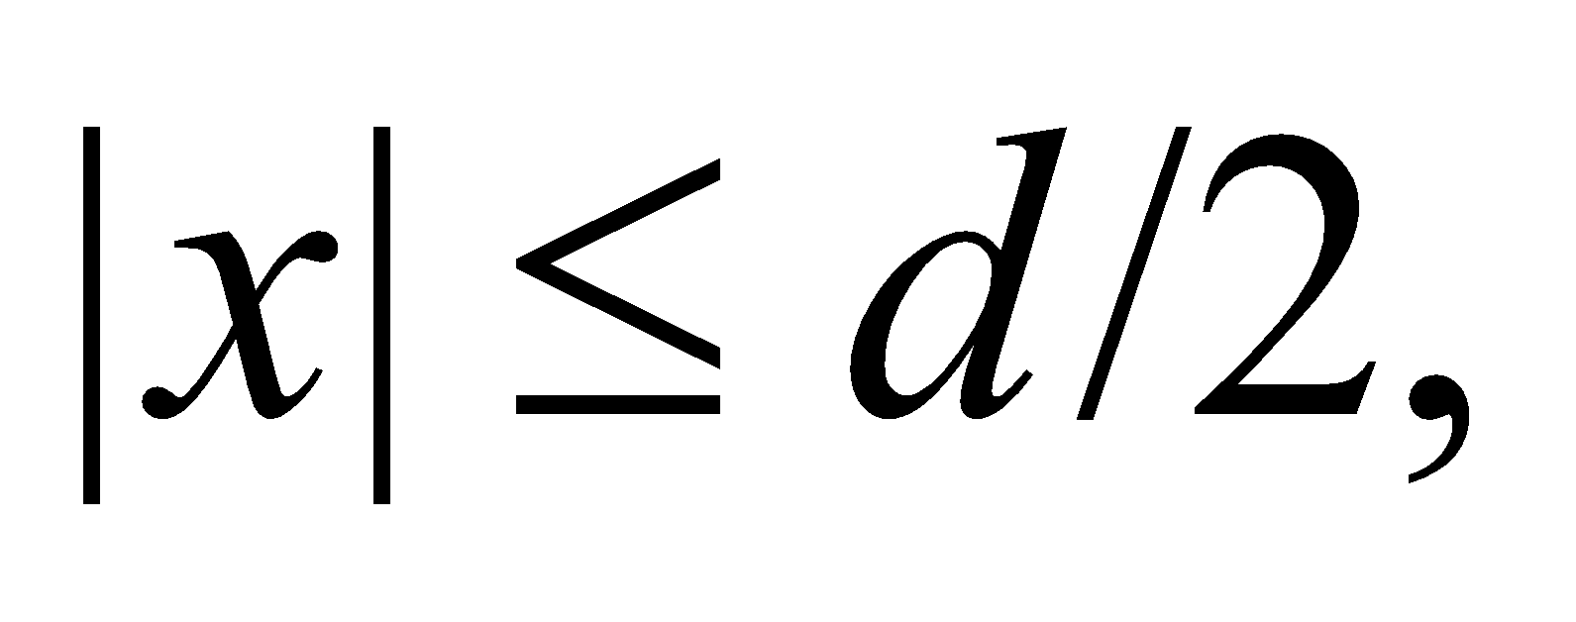the charge enclosed by our Gaussian box is

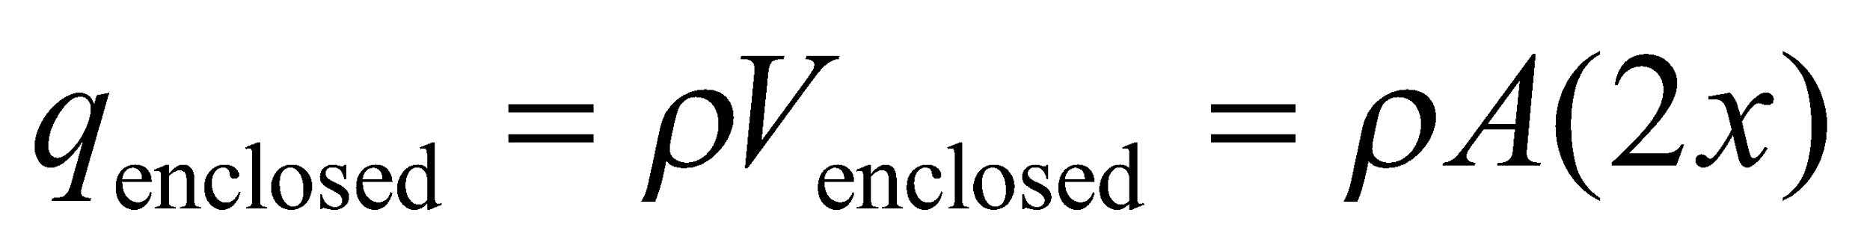

Thus, Gauss’s law gives

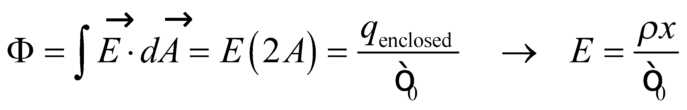

The direction ofis away from (toward) the central plane for positive (negative) charge density.

(b) For points outside the slab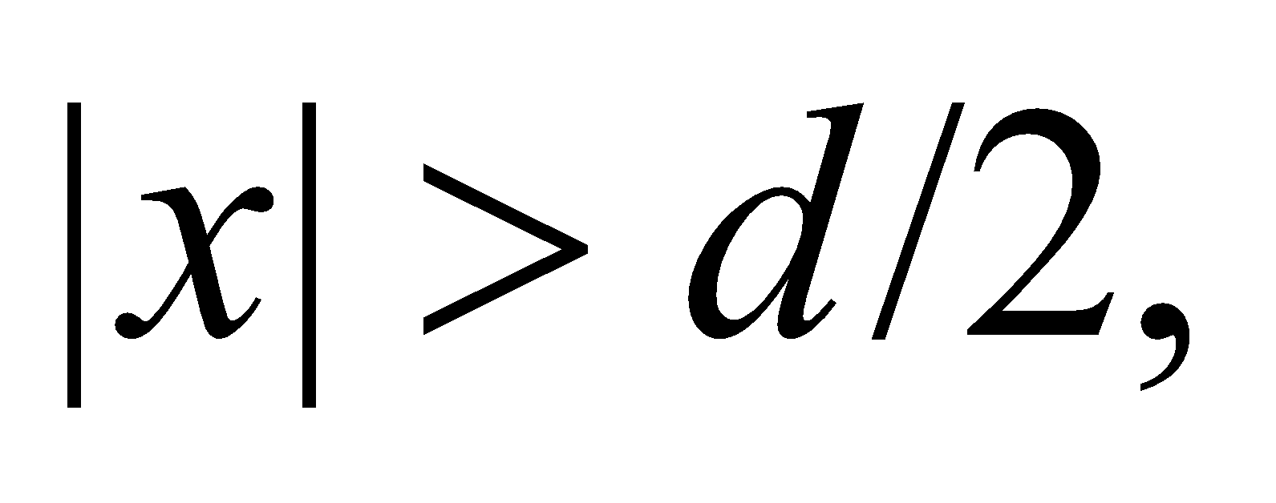the enclosed charge is

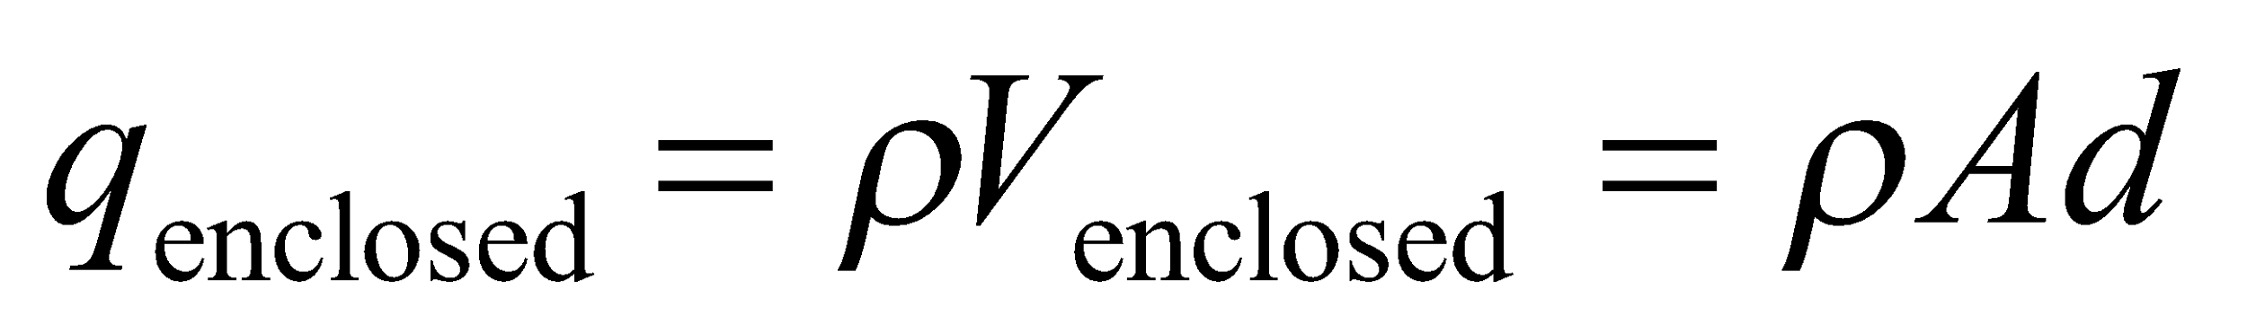

Applying Gauss’s law again gives

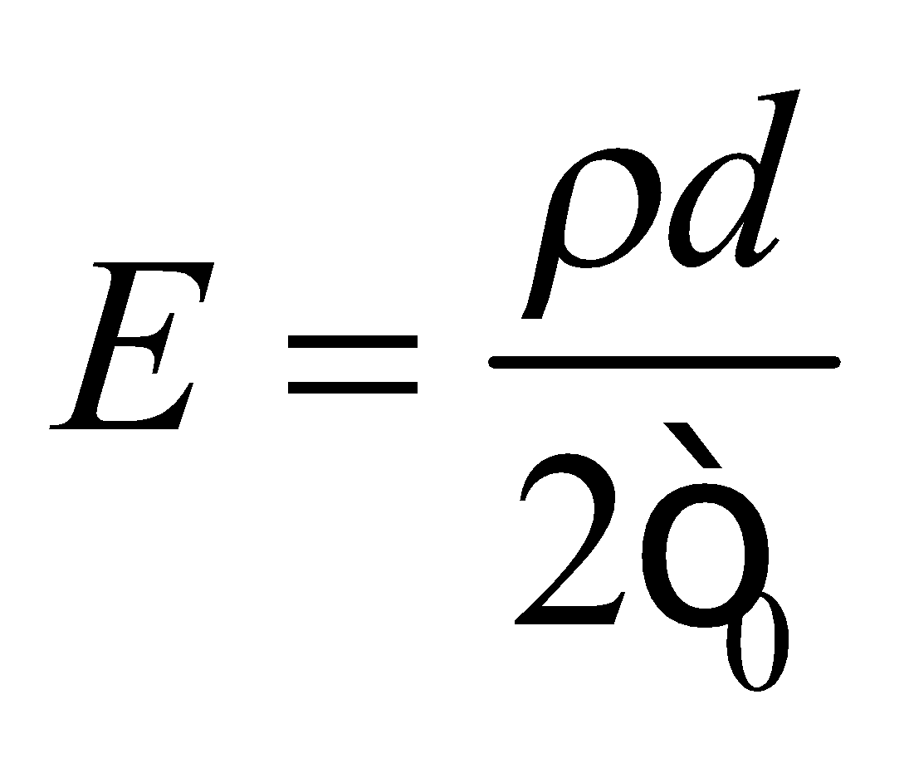

**Assess** Inside the slab, the charge distribution is equivalent to a sheet with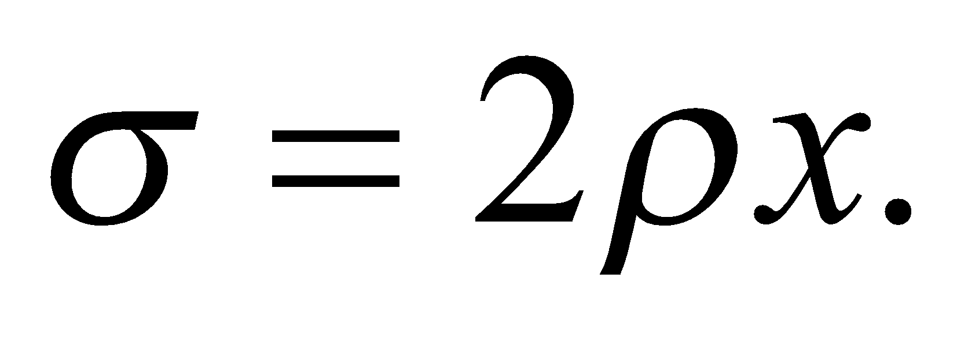On the other hand, outside the slab, it is equivalent to a sheet with 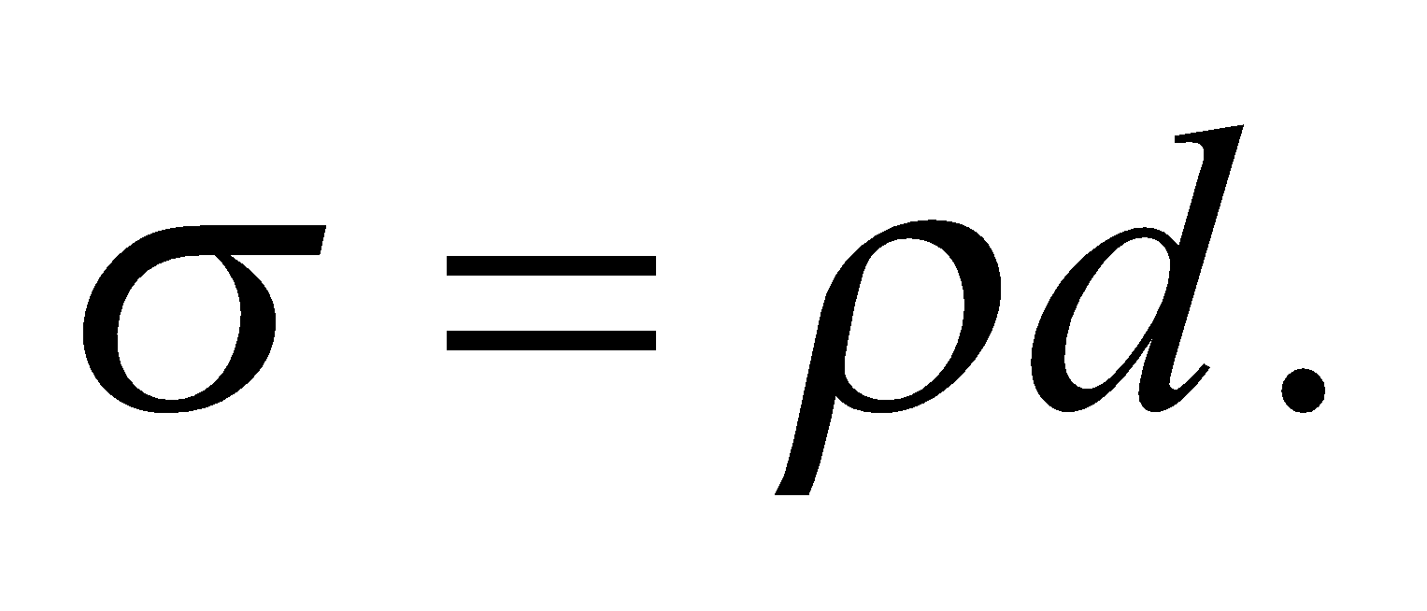

**58. Interpret** We are given some charged concentric spheres, and are asked to find the electric field at various distances from the center. This charge distribution is spherically symmetric and is made of two distinct charge distributions (the inner and outer spheres). We will use Gauss’s law and the principle of superposition to find the electric field at the various points.

**Develop** The central solid sphere has radius *R* = 10 cm and has a uniformly distributed charge *Q* = 40 mC. The outer shell has radius R2 = 20 cm, and holds the same charge, again uniformly distributed. Gauss’s law tells us that the field outside a spherical charge distribution is

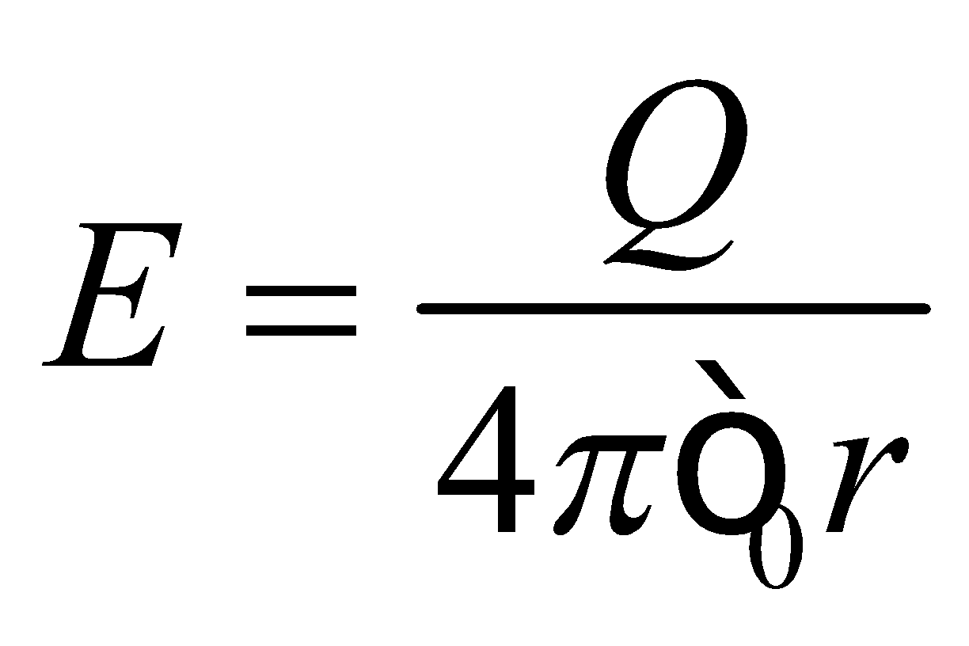

inside a spherical shell is *E* = 0, and inside a uniformly charged sphere the field is

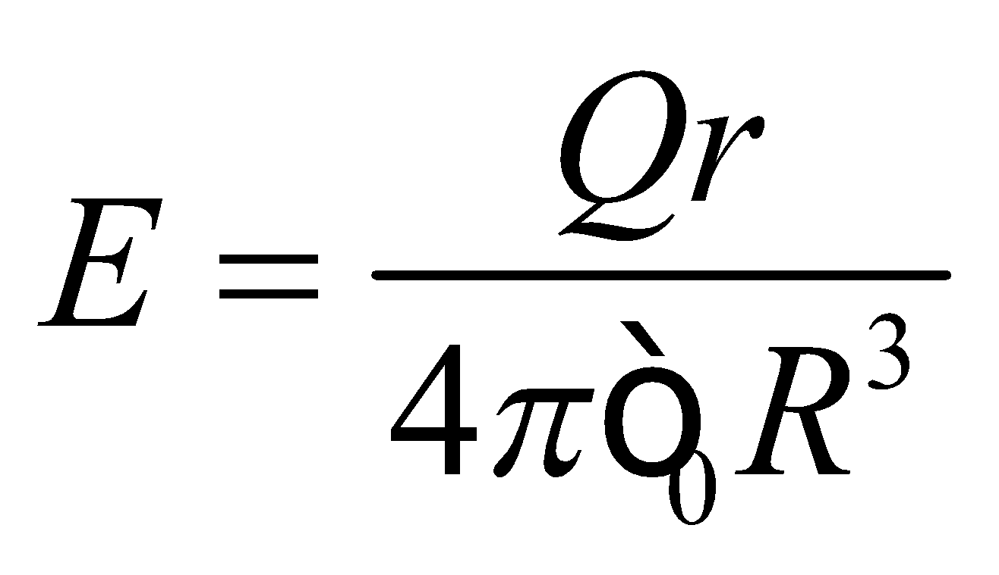

**Evaluate** **(a)** At *r* = 5.0 cm, we are inside of the inner sphere, so

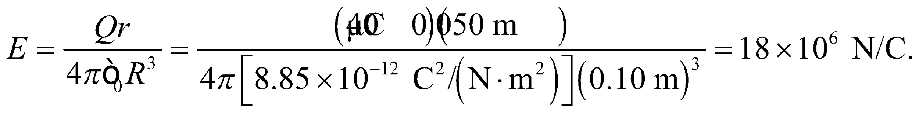

**(b)** At *r* = 15 cm, we are outside the inner sphere but inside the outer sphere, so the outer sphere does not contribute to the field.

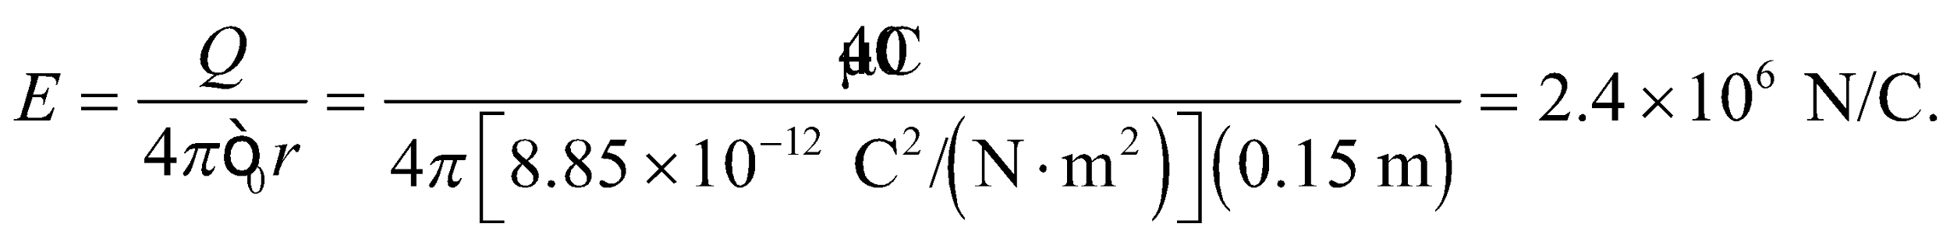

**(c)** At *r* = 30 cm, we are outside both spheres. The total charge within our spherical Gaussian surface is now 2*Q*, so and the electric field is

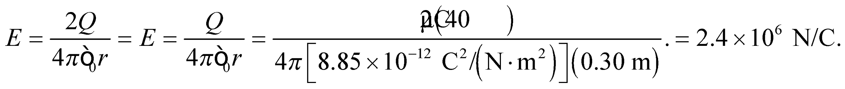

**Assess** The answers to **(b)** and **(c)** are the same! The charge in **(c)** is twice as much, but we are also twice as far away.



**59. Interpret** At distances much, much less than 75 cm from the plate, and not near the edges of the plate, it can be approximated by an infinite plane, so we can apply Gauss’s law for plane symmetry. For distances much, much greater than 75 cm, the plate looks like a point charge. We can use these limiting cases to find the electric field strength 15 m from the plate.

**Develop** Close to the nonconducting plate 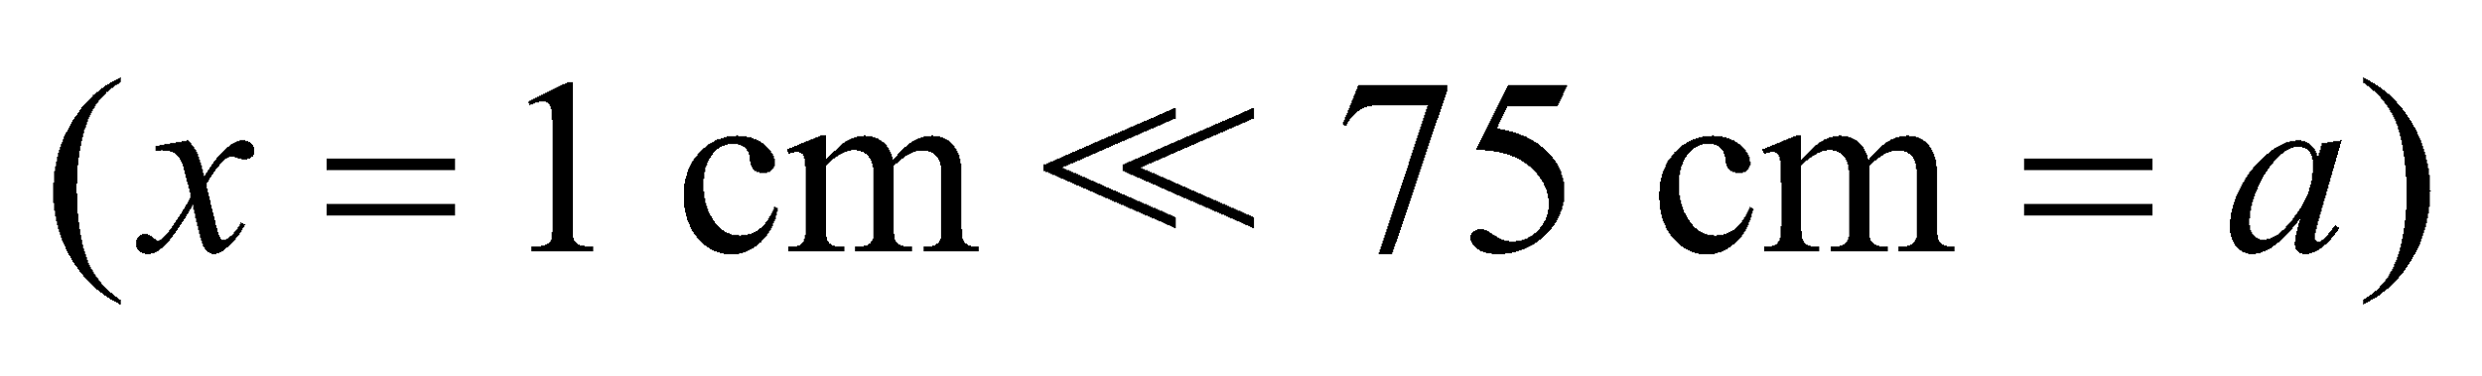, the charge distribution has approximate plane symmetry, so the electric field is given by (see Equation 21.7)

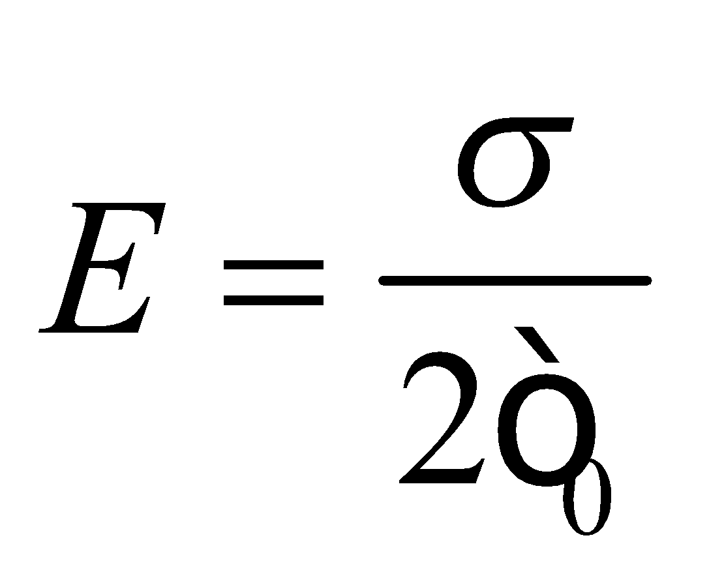

Therefore, the charge on the plate is 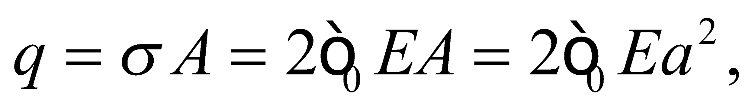 where *a* is the length of a side of the square plate. At a point sufficiently far from the plate 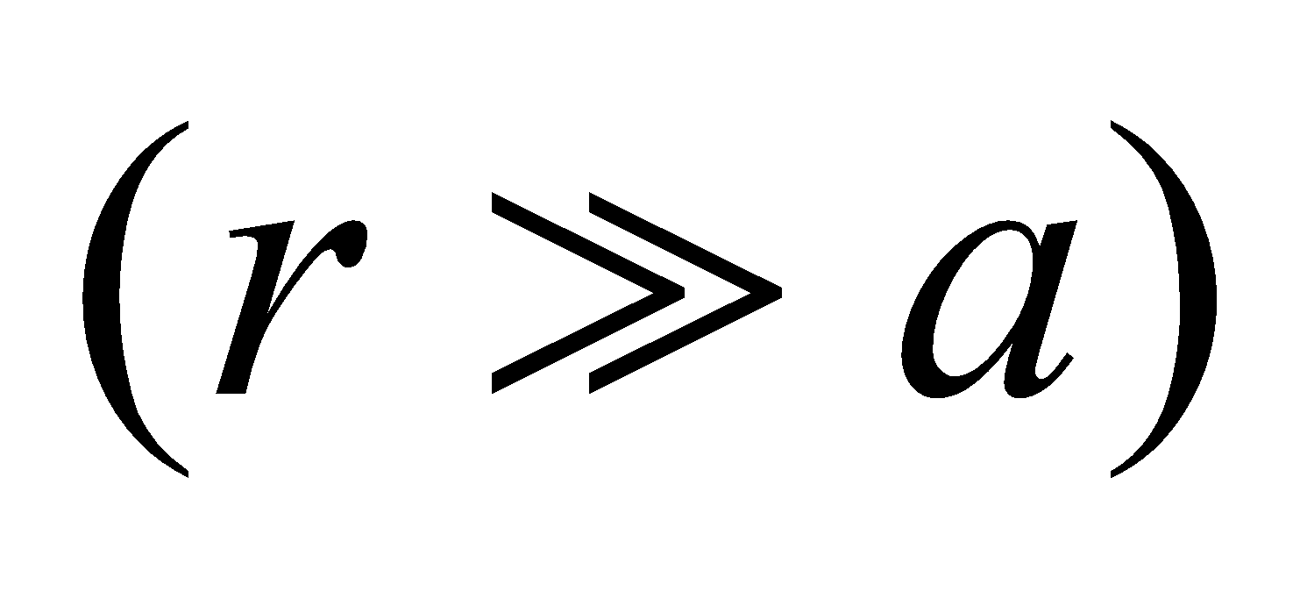 the field strength will resemble that from a point charge, 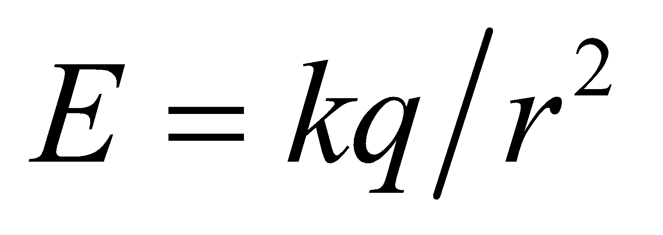.

**Evaluate** Inserting the values given, we find the charge on the plate is



The field strength at 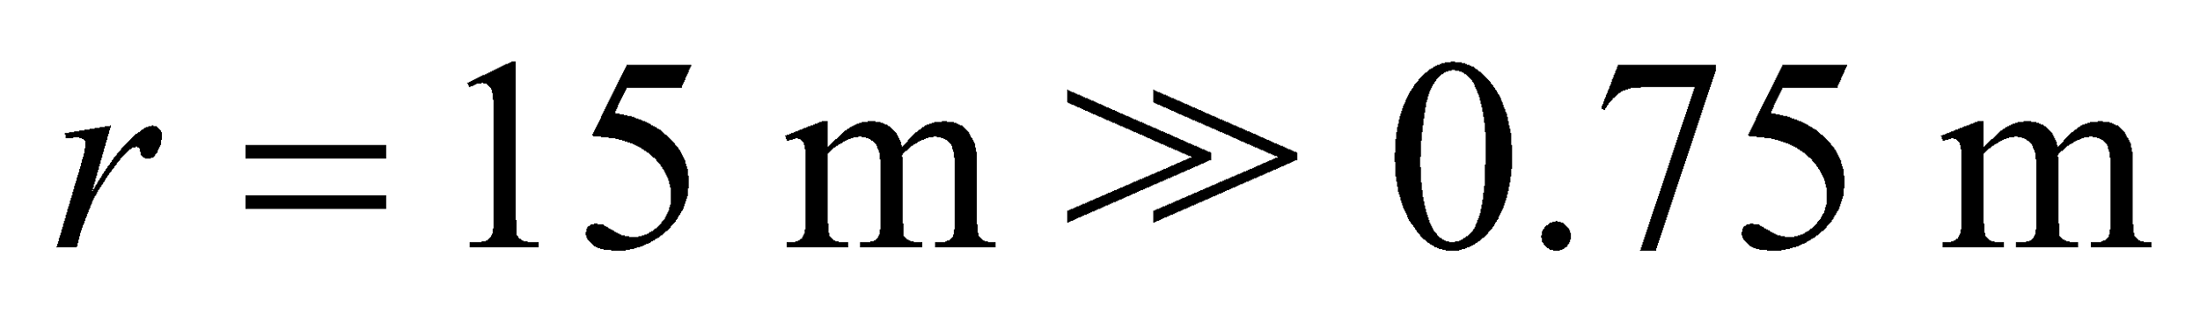 is like that from a point charge:

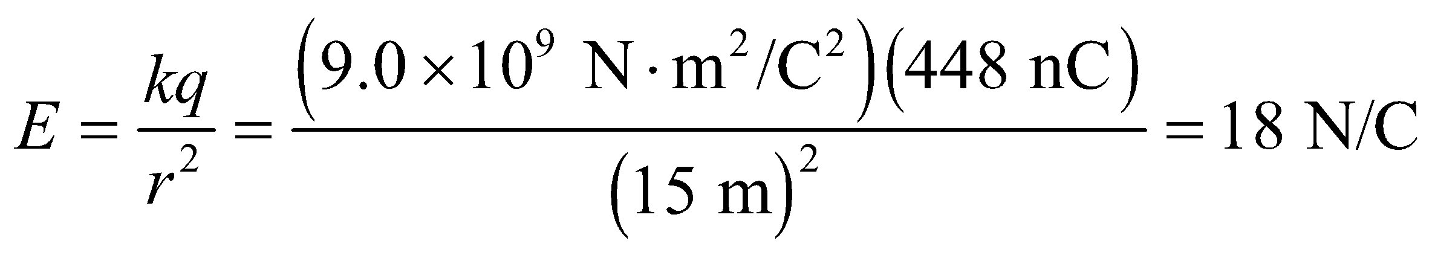

**Assess** Far from the finite charge distribution (plane charge in this case), the field always resembles that of a point charge.

**60.** **Interpret** This problem involves a uniform charge distribution with spherical symmetry. Close to the surface of the sphere (a distance much, much less than the radius of the sphere), the electric field will resemble that from a uniformly charged conducting plate.

**Develop** There is a non-zero field outside the shell, because the net charge within is not zero. Therefore, from Equation 21.8, there is a surface charge density 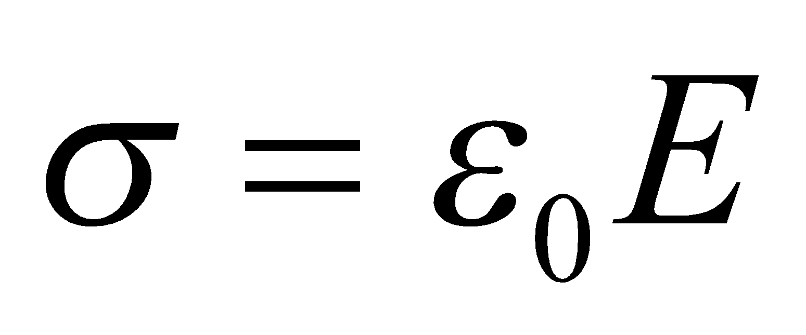 on the outer surface of the shell, which is uniform if we ignore the possible presence of other charges and conducting surfaces outside the shell. Gauss’s law (with reasoning similar to Example 21.7) requires that the charge on the shell’s outer surface equal the point charge within, so

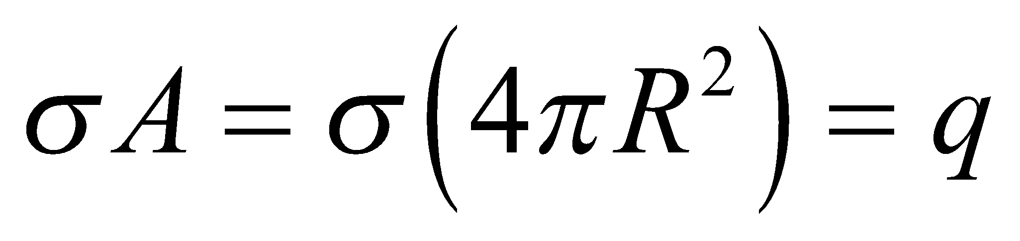

**Evaluate** (a) The surface charge density is

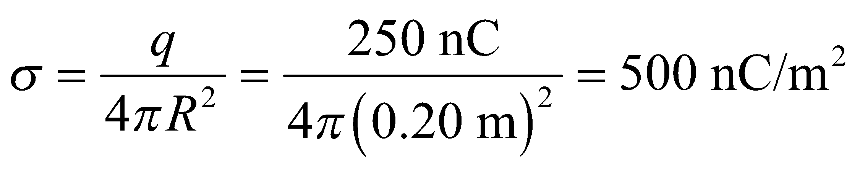

(b) The field strength at the outer surface of the sphere is

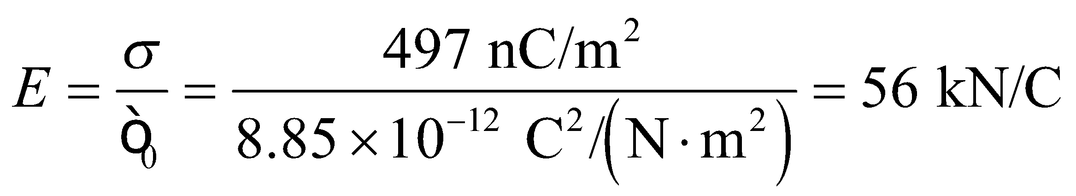

**Assess** Notice that the units for part (b) cancel correctly to give N/C.

**61. Interpret** This problem involves a irregular-shaped conductor in electrostatic equilibrium. The conductor is hollow and we are to show there is zero field in the cavity. This geometry is nonsymmetric, so we cannot apply the formulas developed for circular, plane, or line charge distributions.

**Develop** Review Section 21.6 to see why the electric field within a conducting medium, in electrostatic equilibrium, is always zero. In addition, the net charge must reside on the conductor surface.

**Evaluate** **(a)** When there is no charge inside the cavity, the flux through any closed surface within the cavity

(see *S*1 in figure below) is zero, so the electric field is also zero. If it were not, there would be a nonzero electric field acting on the surface charges, which would therefore move and the conductor would not be in equilibrium.

**(b)** If the surface charge density on the outer surface (and also the electric field there) is to vanish, then the net charge inside a Gaussian surface *S*2 containing the conductor must be zero. Thus, the point charge in the cavity must be −*Q*, so that 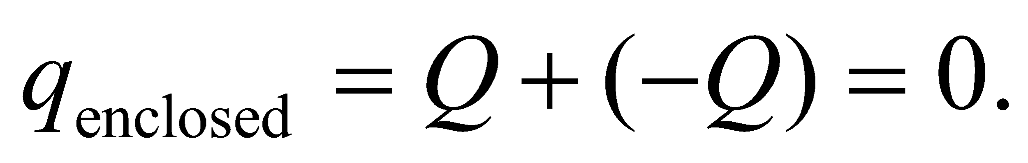



**Assess** An alternative approach is to say that the total charge on the conductor is 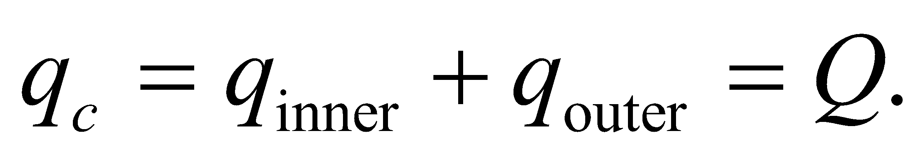 Requiring 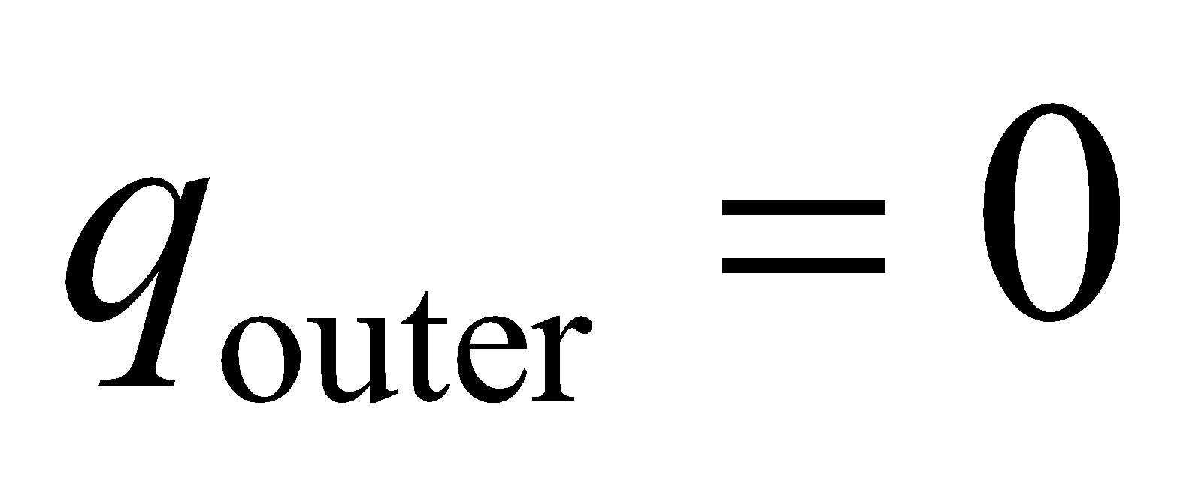 means that 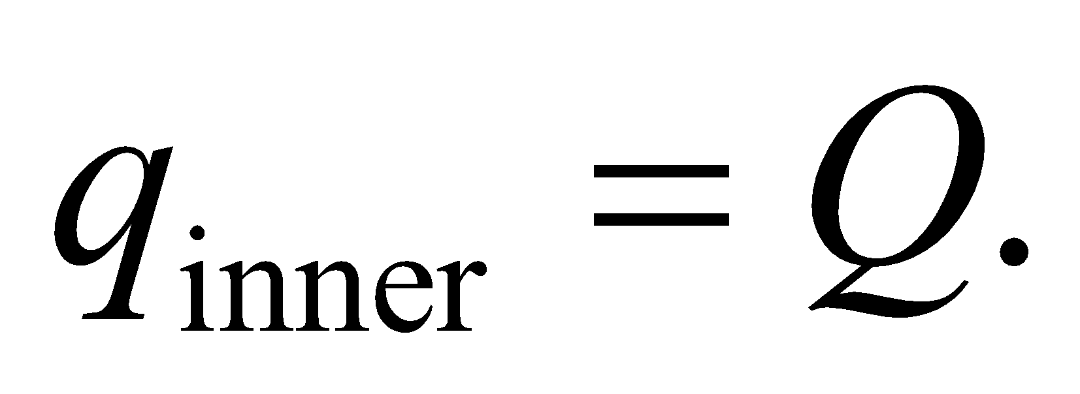 Since electric field inside the cavity vanishes, the point charge placed inside must be 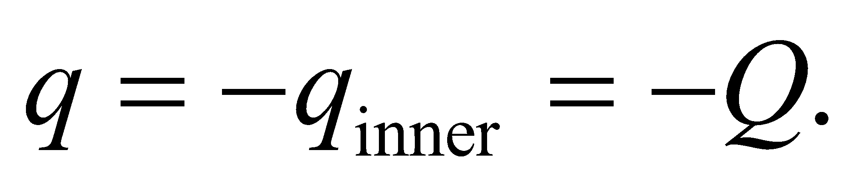

**62.** **Interpret** This problem involves using Gauss’s law for a charge distribution with line symmetry. We are to show that the net electric field is zero outside a coaxial cable carrying equal but opposite charge on each conductor.

**Develop** As a Gaussian surface, consider a concentric cylinder that encloses the coaxial cable. As shown in Example 21.5, the electric field is given by

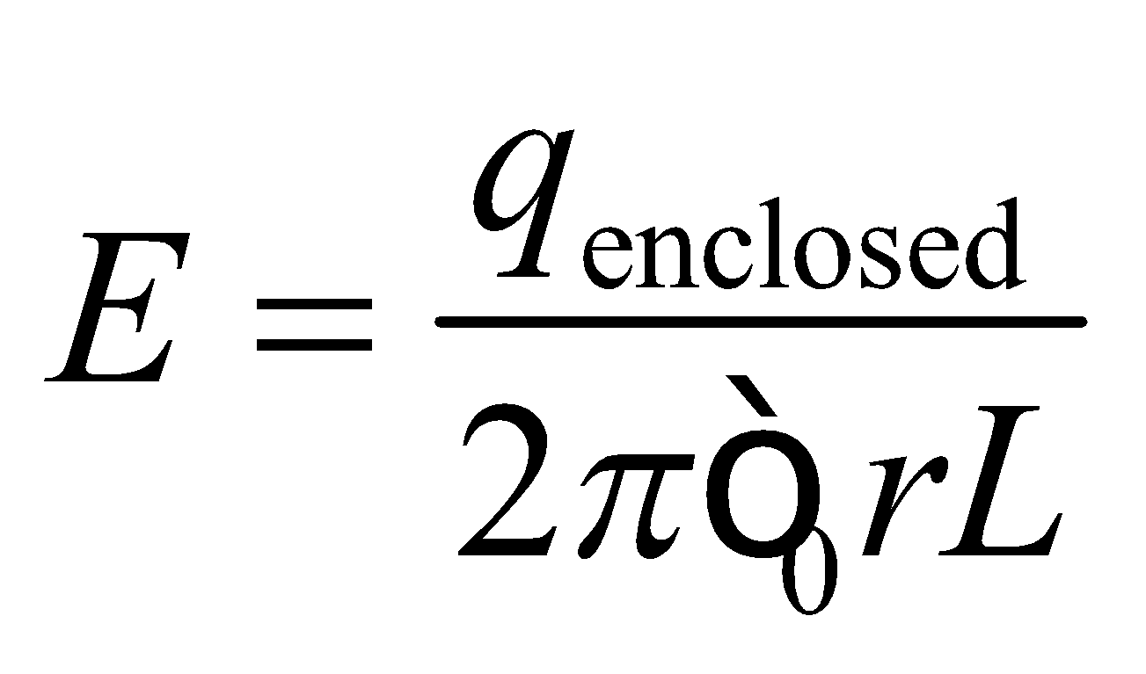

**Evaluate** The total charge enclosed is zero because each conductor in the coaxial cable carries an equal magnitude charge, but with opposite sign. Therefore, the field outside the cable is zero.

**Assess** Note that this argument holds independently of the specific Gaussian surface we choose, provided it encloses the coaxial cable.

**63. Interpret** We are given a spherically symmetric charge distribution, so Gauss’s law can be applied in this problem.

**Develop** The field from the given charges is spherically symmetric, so (from Gauss’s law) is like that of a point charge located at the center with magnitude equal to the net charge enclosed by a sphere of radius equal to the distance to the field point.

**Evaluate** Thus, the electric field is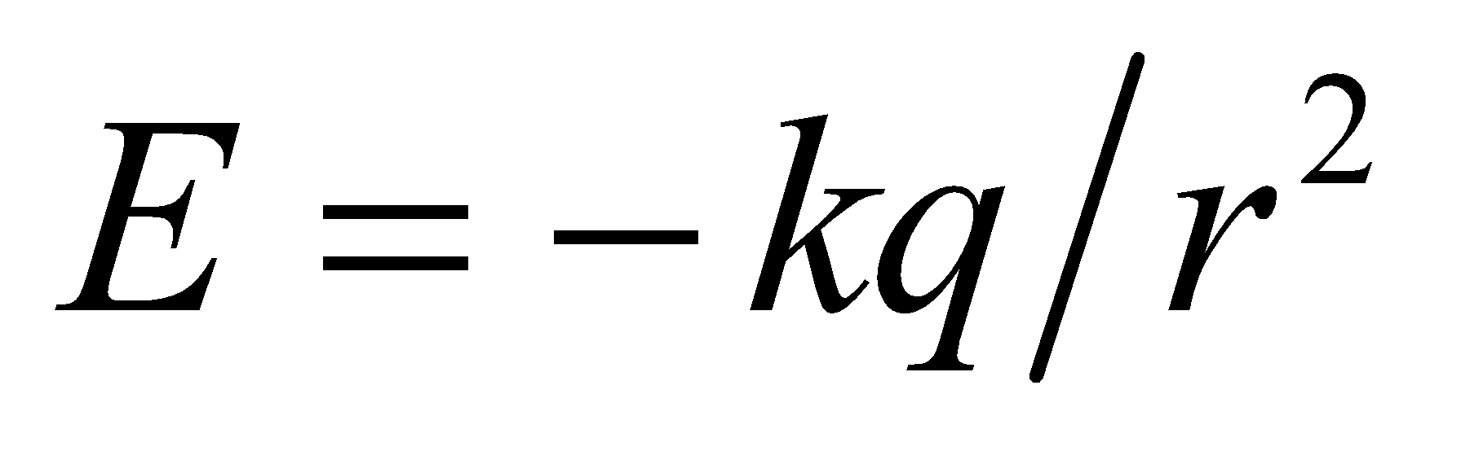 inside the first shell (8 lines radially inward, see figure below), 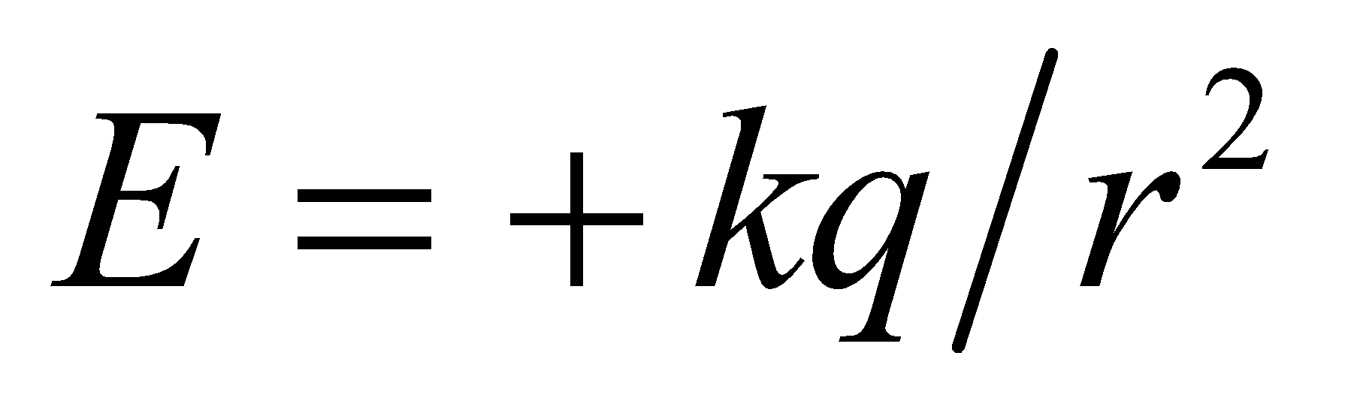 between the first and second shells (8 lines radially outward), and 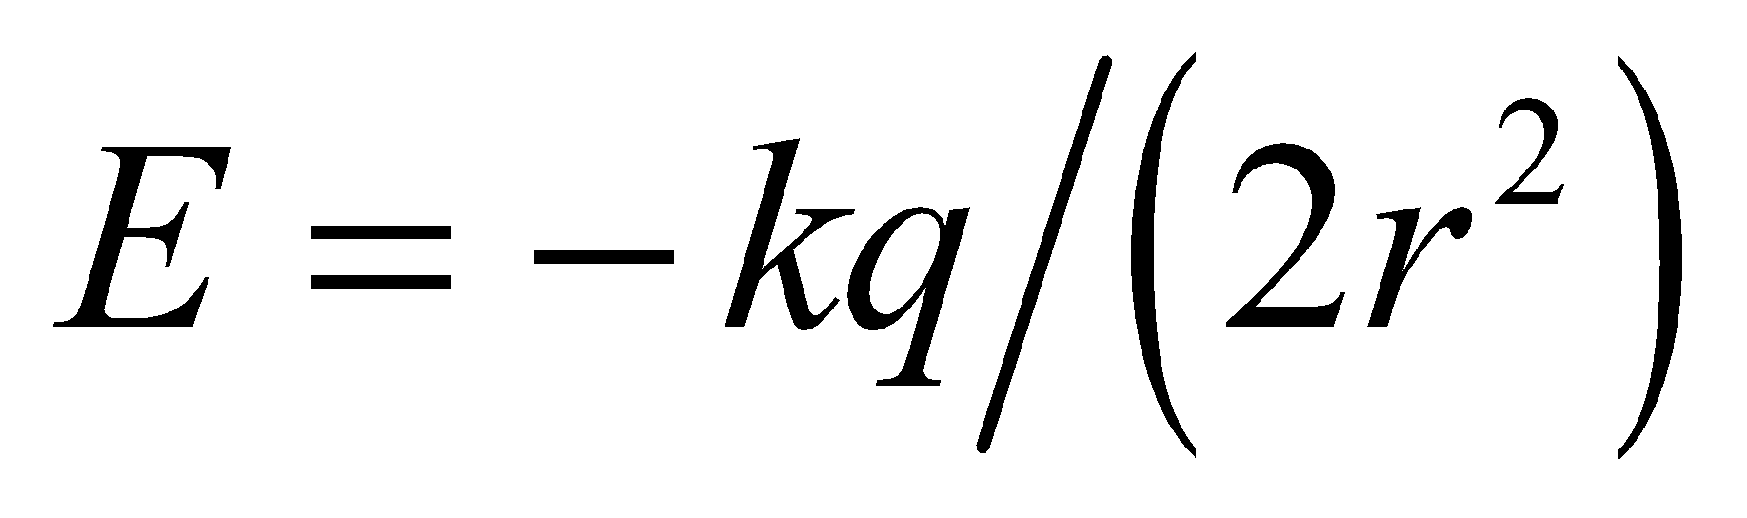 outside the second shell (4 lines radially inward).



**Assess** The direction of the electric field depends on the net charge enclosed. When   is radially outward. On the other hand,  is radially inward when 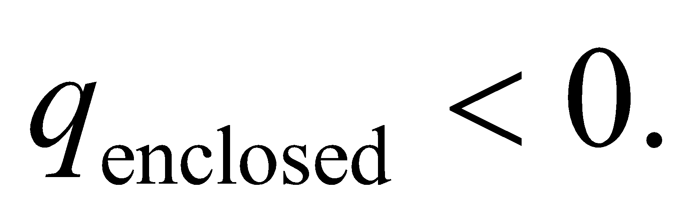 The discontinuity in electric field across the shell is due to a net surface charge density on the shell.

**64.** **Interpret** The charge distribution is spherically symmetric and may be treated as two distinct charge distributions, so we can apply Gauss’s law and the principle of superposition to find the electric field at the various points.

**Develop** Separate the charge distribution into the point charge at the center of the sphere with *q*pc = *q* and the charge distributed over the surface of the spherical shell with charge *q*shell = 2*q*. Using the superposition principle, the total electric field *E*tot is the sum of the electric field from each charge distribution:

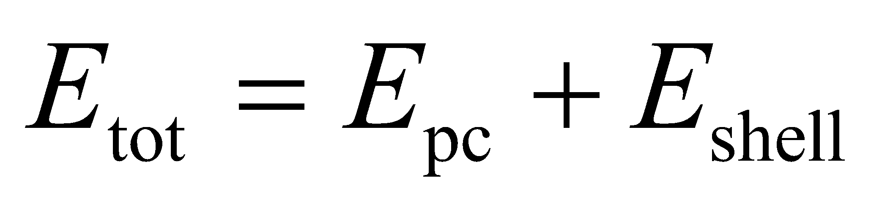

Inside the sphere, the charge enclosed by a concentric Gaussian surface is just the point charge, so the electric field will simply be that due to a point charge (see Equation 20.3), 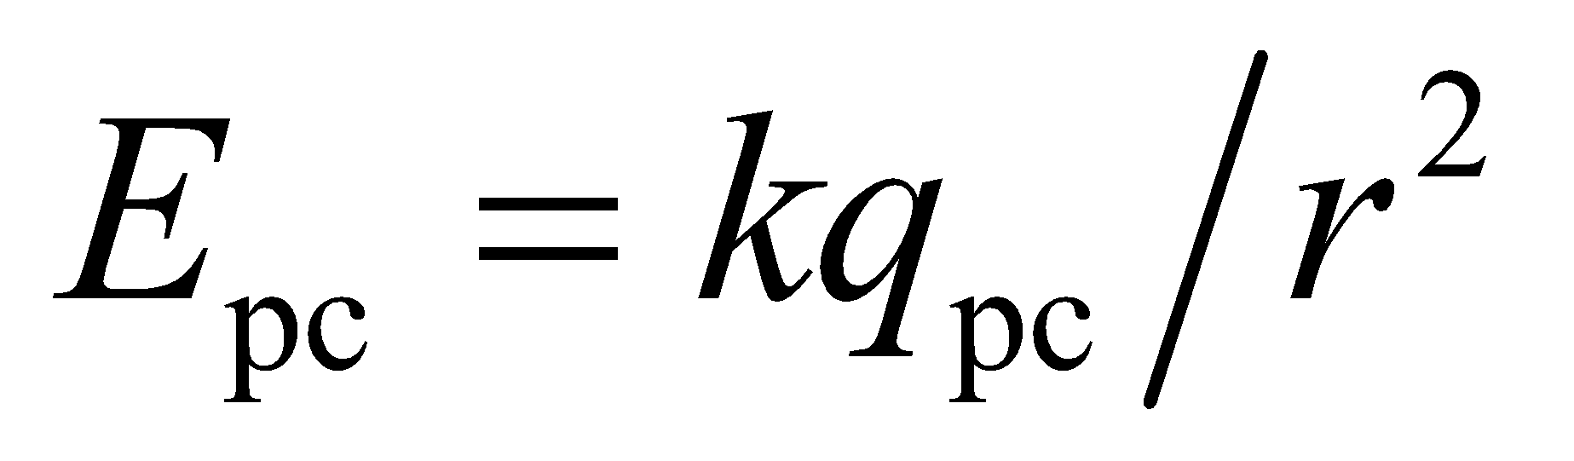. Outside the sphere, a concentric Gaussian surface will enclose the point charge and the spherical charge distribution. As shown in Example 21.1, the field outside any spherically symmetric charge distribution is that due to a point charge at the center that carries the entire charge (see Equation 21.4): 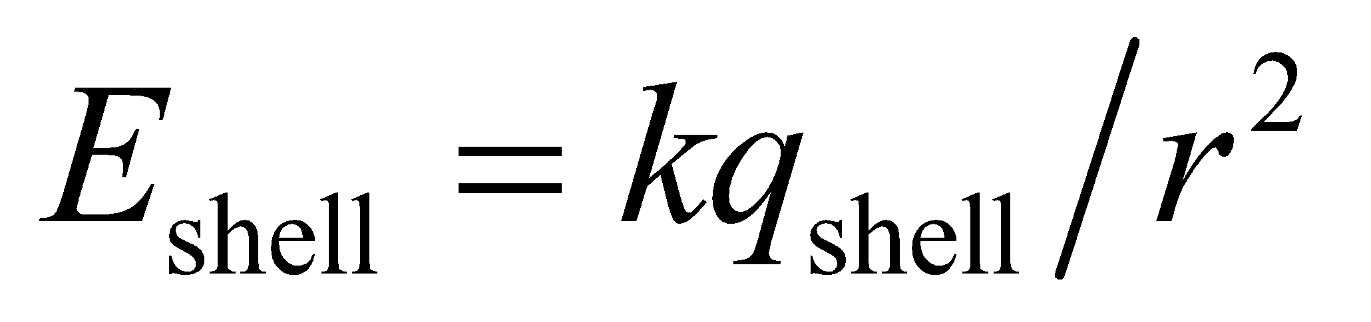.

**Evaluate** (a) For *r* = *R*/2, we are inside the sphere, so the electric field is given by

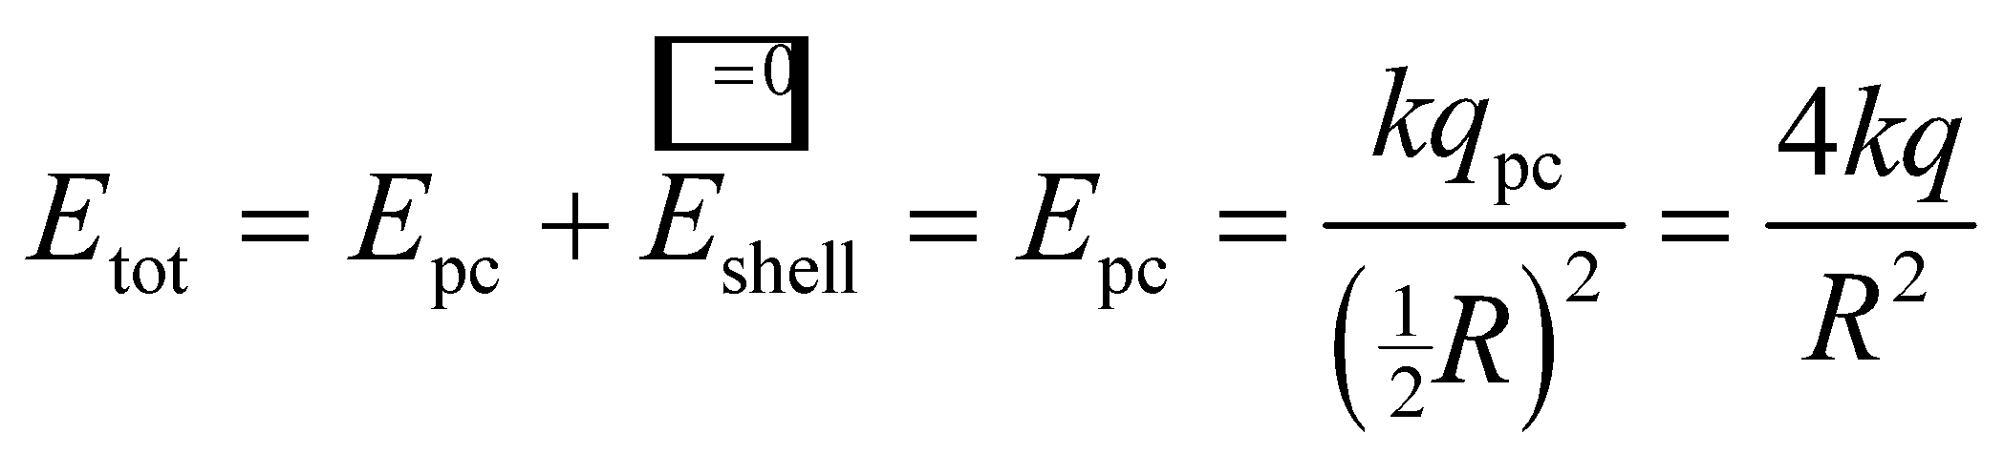

(b) For *r* = 2*R*, we are outside the sphere, so the electric field is given by

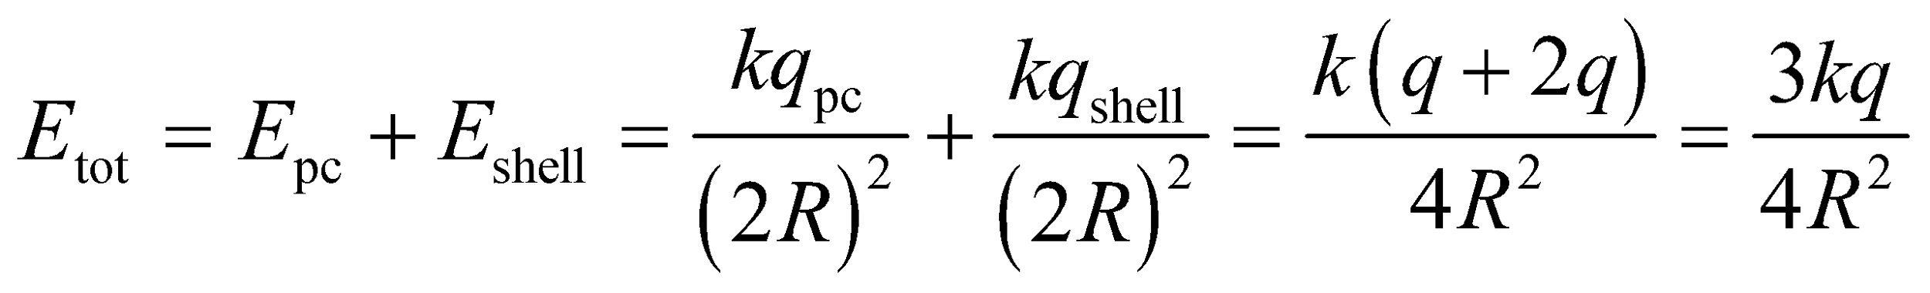

**Assess** Instead of using the superposition principle in this way, you can consider the entire charge distribution. For part (a), a concentric Gaussian surface encloses only the point charge, so

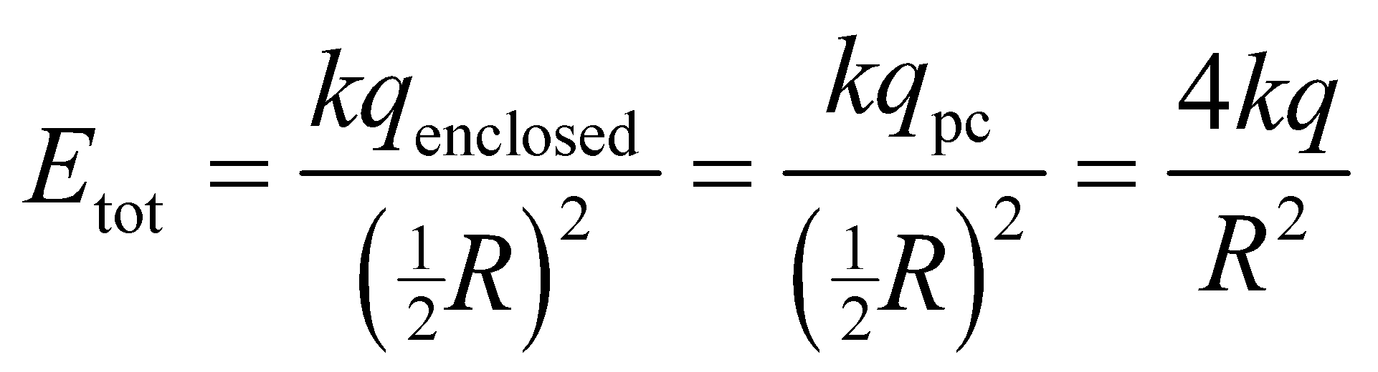

For part (b), a concentric Gaussian surface encloses the central point charge and the sphercial charge (which may be considered as a point charge at the center), so the electric field is



which agrees with the results above.

**65. Interpret** The charge distribution has spherical symmetry, so we can apply Gauss’s law. Also, since the charge distribution is non-uniform, integration is needed to find the electric field.

**Develop** The charge inside a sphere of radius 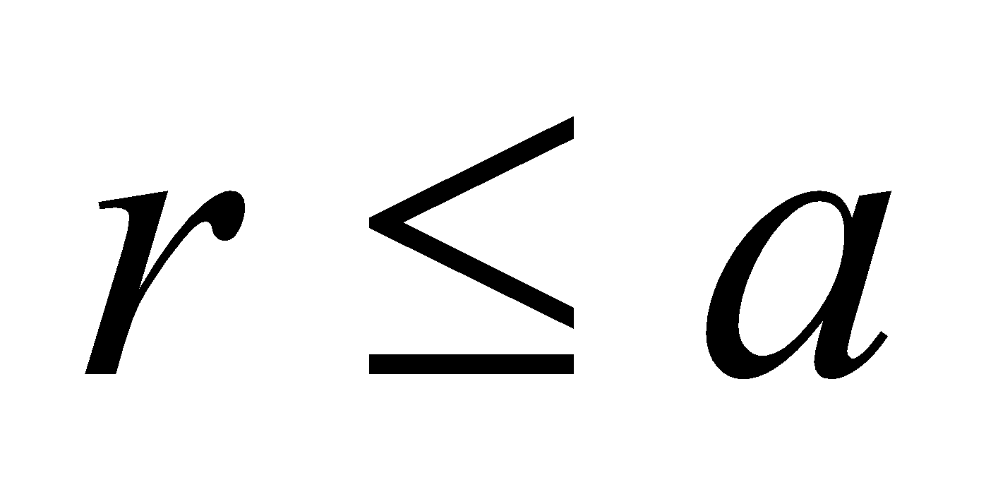 is 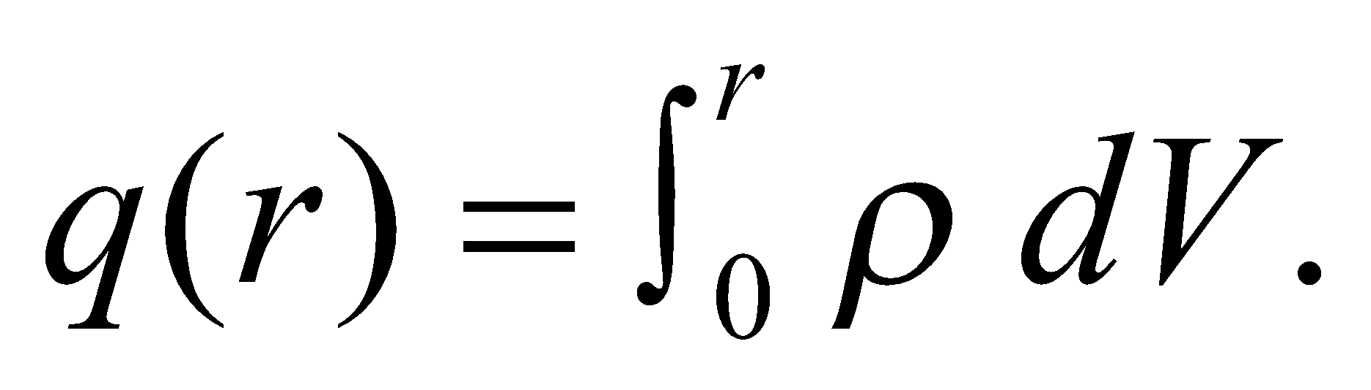 For volume elements, take concentric shells of radius *r* and thickness *dr*, so 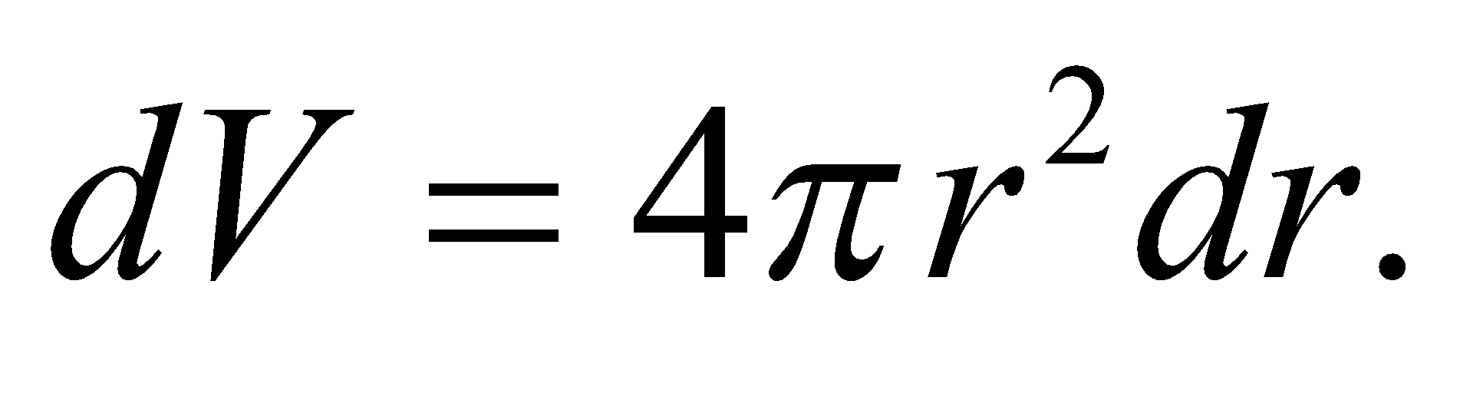

**Evaluate** **(a)** Integrating over *r*, the charge enclosed by a Gaussian sphere of radius *r* is

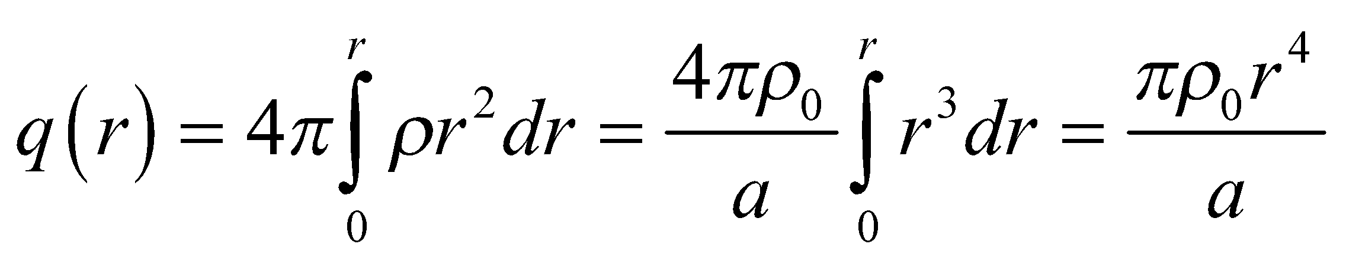

For *r* = *a*, the total charge is 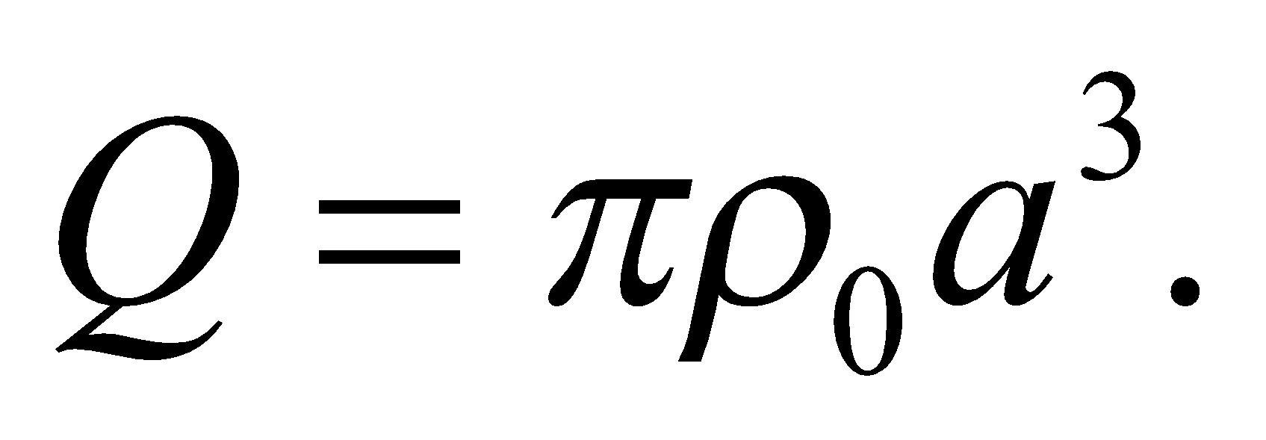

**(b)** Inside the sphere, Gauss’s law and Equation 21.5 give

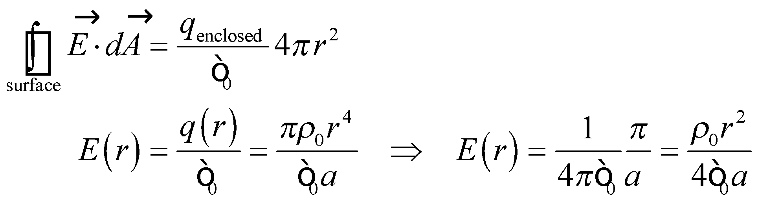

**Assess** The *r*2 dependence of *E* inside the sphere can be contrasted with the *r* dependence in the case (see Example 21.1) where the charge distribution is uniform.

**66.** **Interpret** We are given a charge density with line symmetry, which we will not exploit. Instead, we are to integrate over a planar surface of a rectangular cube transpierced on its axis by the wire.

**Develop** Draw a coordinate system on the box, as shown in the figure below. From Equation 21.6, we know that the electric field on the top surface of the box has magnitude  and is direction radially away from the line of charge. The flux through a strip of width *dx* at position *x* is 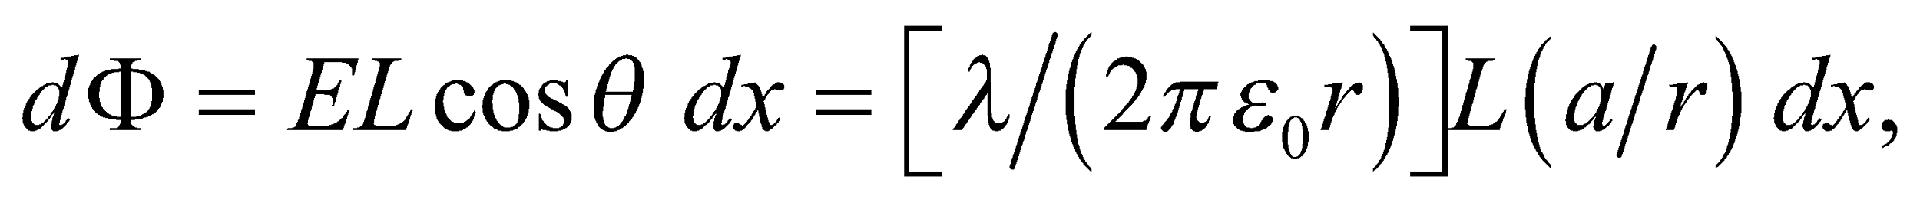 where

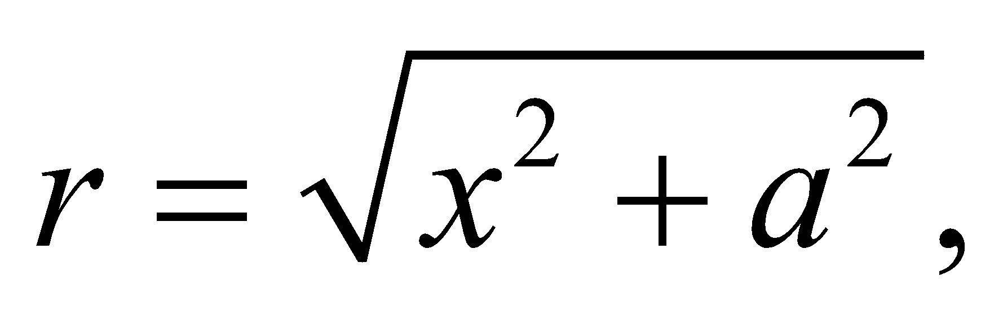

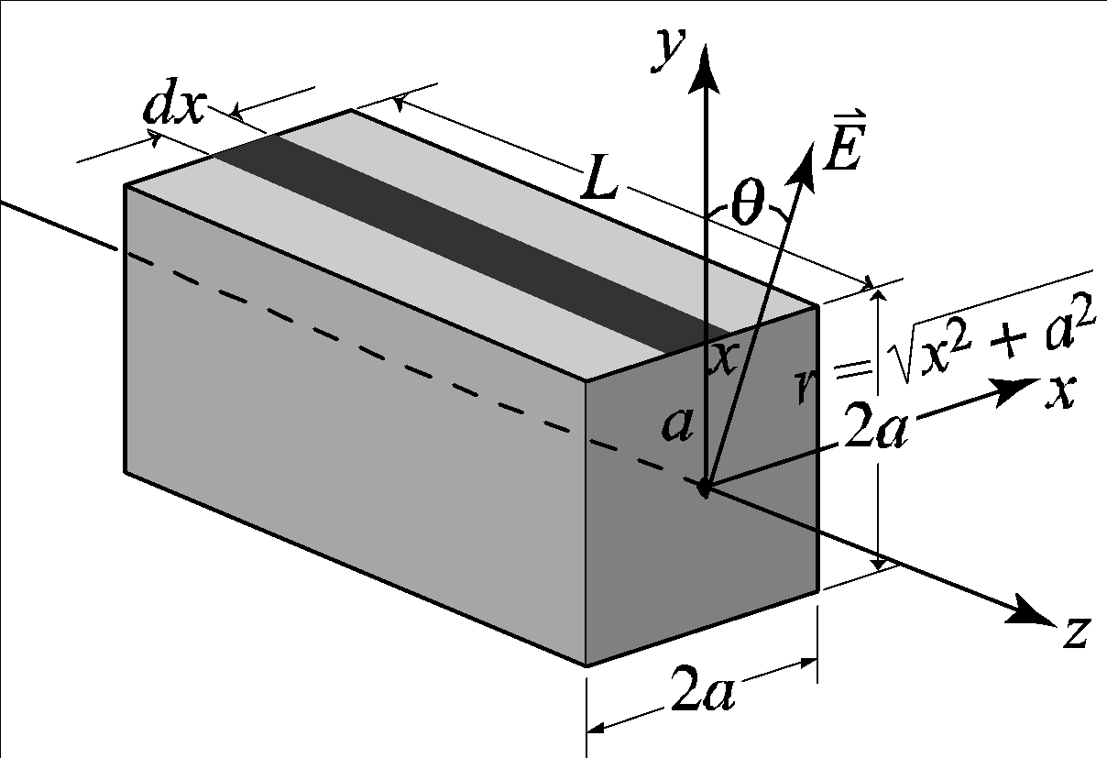

**Evaluate** Integrating from −*a* (the left edge of the box) to *a* (the right edge of the box) gives

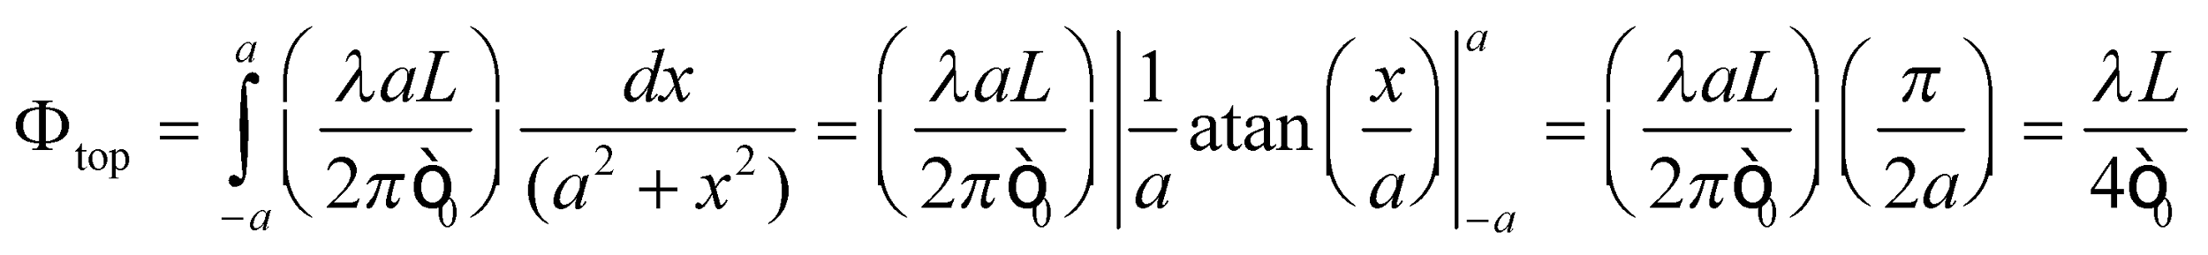

By symmetry, the flux through the entire box is four times this, or 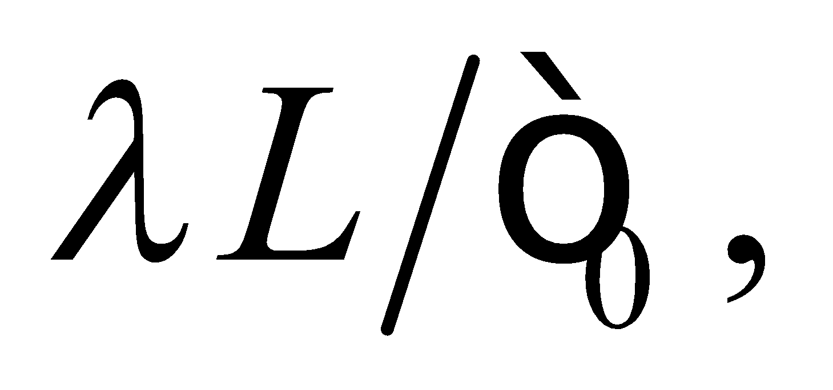 which agrees with Gauss’s law because *λL* = *q*enclosed.

**Assess** Notice that this result is independent of the length *L* of the box, provided the box does not approach the ends of the wire.

**67. Interpret** We are given a charge distribution with spherical symmetry, which we can exploit with Gauss’s law. Also, since the charge distribution is non-uniform, integration is needed to find the condition which gives zero electric field outside the sphere.

**Develop**  Gauss’s law tells us that the field outside the sphere will be zero if the total charge within the Gaussian surface is zero. Thus, using concentric shells of thickness *dr* and volume 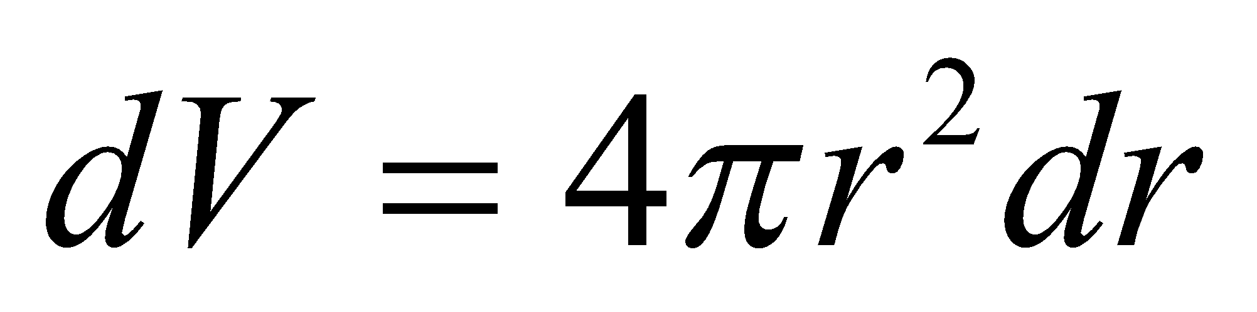 as our charge elements, we require that

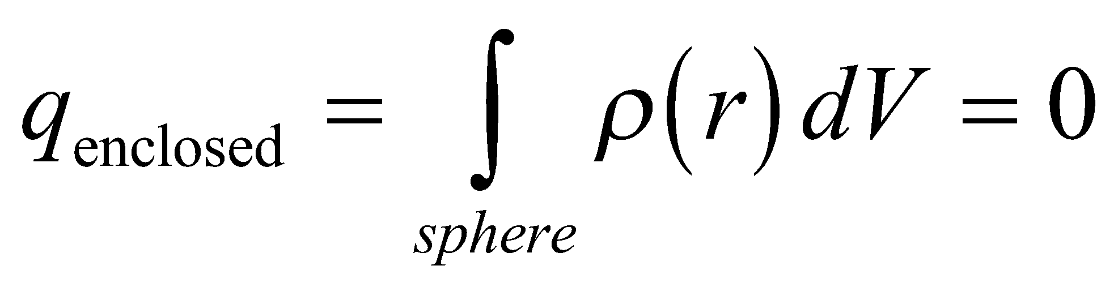

**Evaluate** Inserting the expression for *ρ*(*r*) into the integrand and integrating gives



**Assess** The charge density starts out from the center of the sphere as 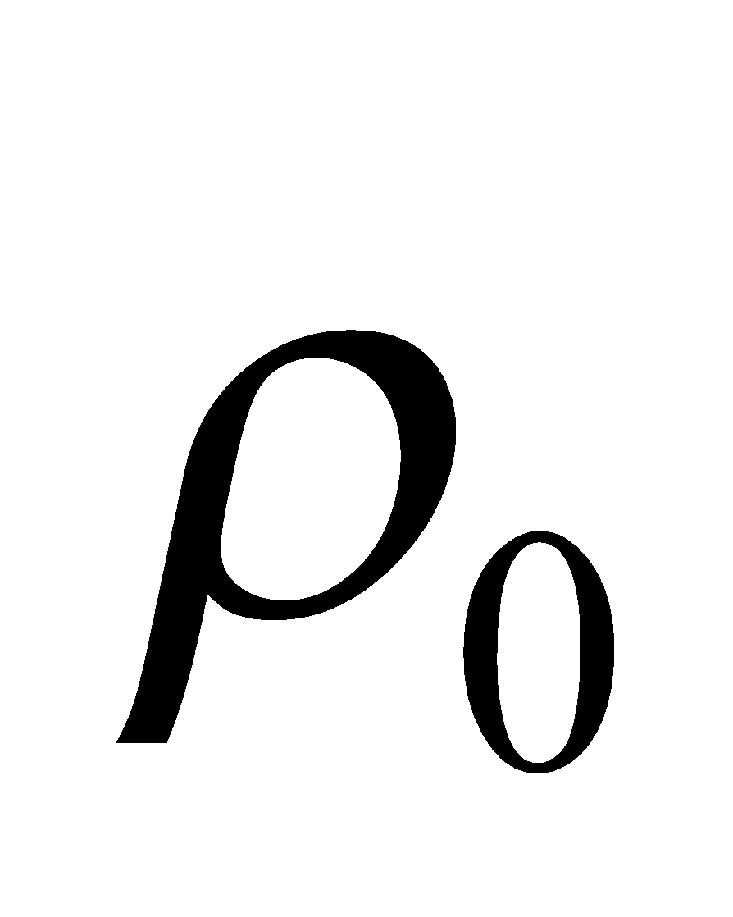 and decreases as *r*2. At 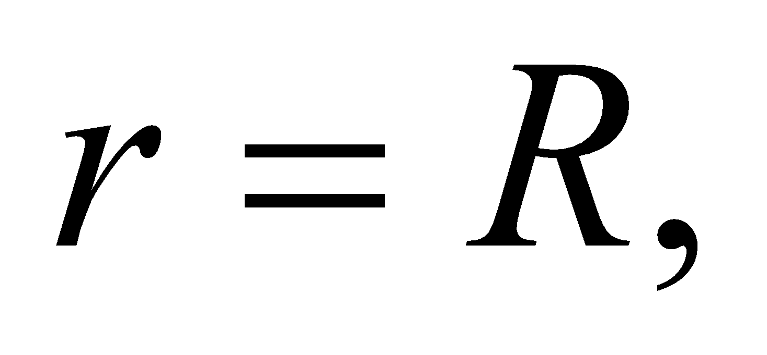 the density is

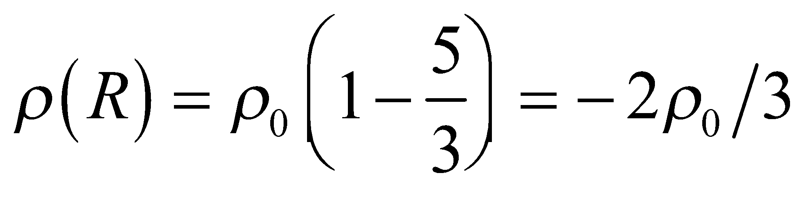

Note that 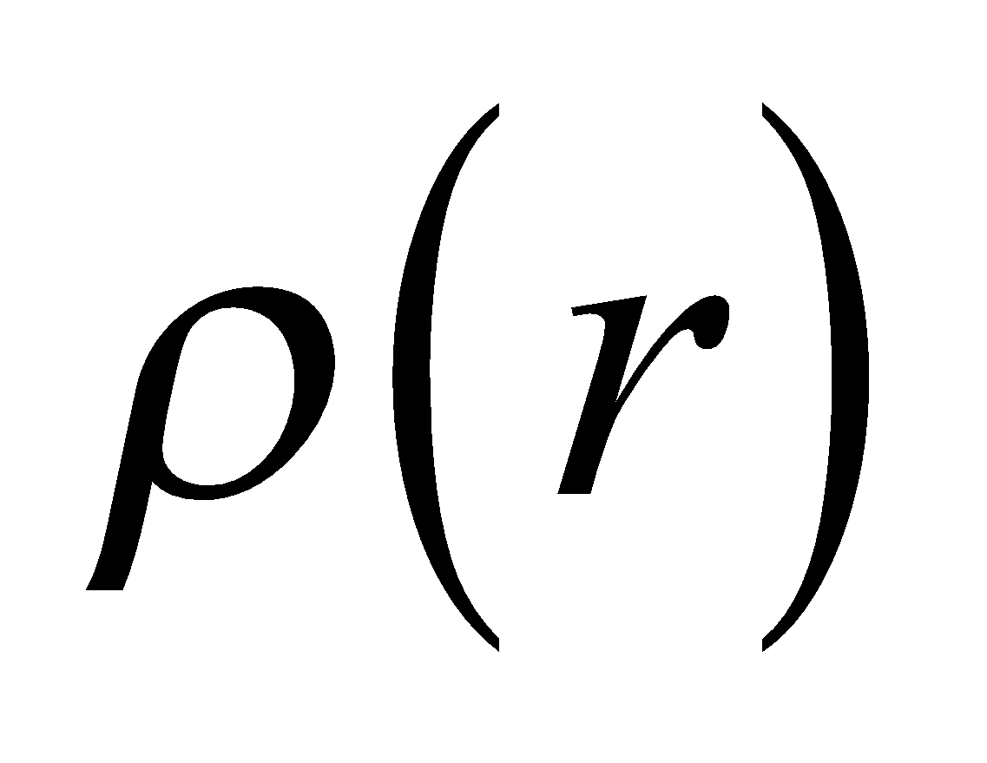 must change sign (from positive to negative) in order for 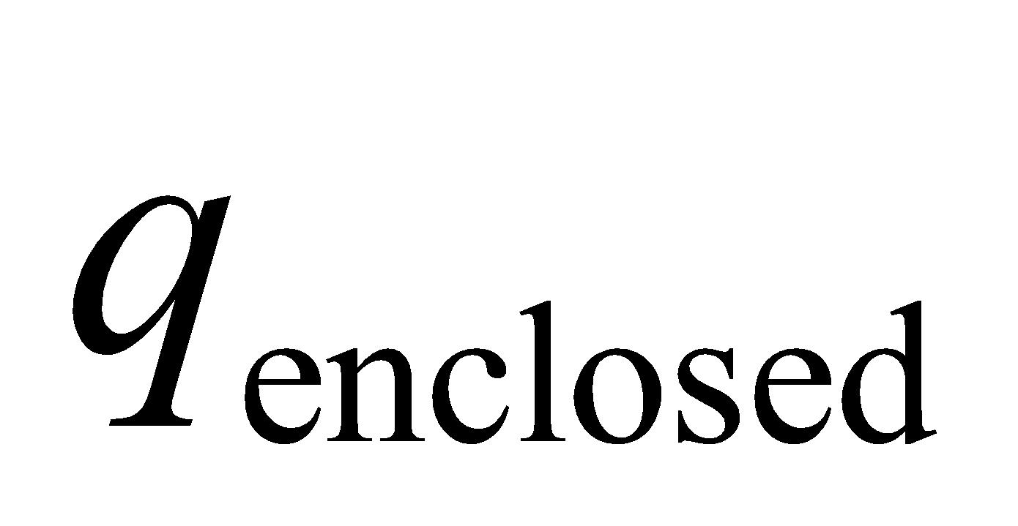 to be zero at *r* = *R*.

**68.** **Interpret** We are to calculate by integration the electric field inside and outside a uniformly charged spherical shell of radius *R* and total charge *Q.*

**Develop** We will divide the spherical surface up into rings around an axis that includes the field point. Each ring

has radius  and width 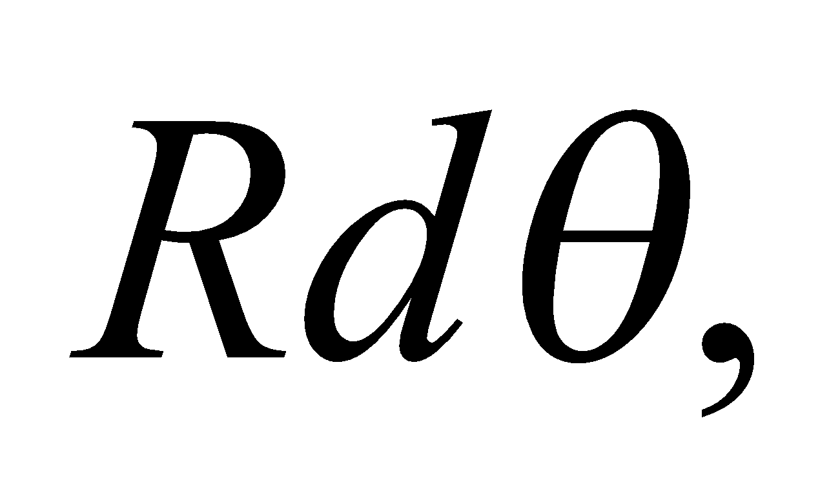 and holds a charge 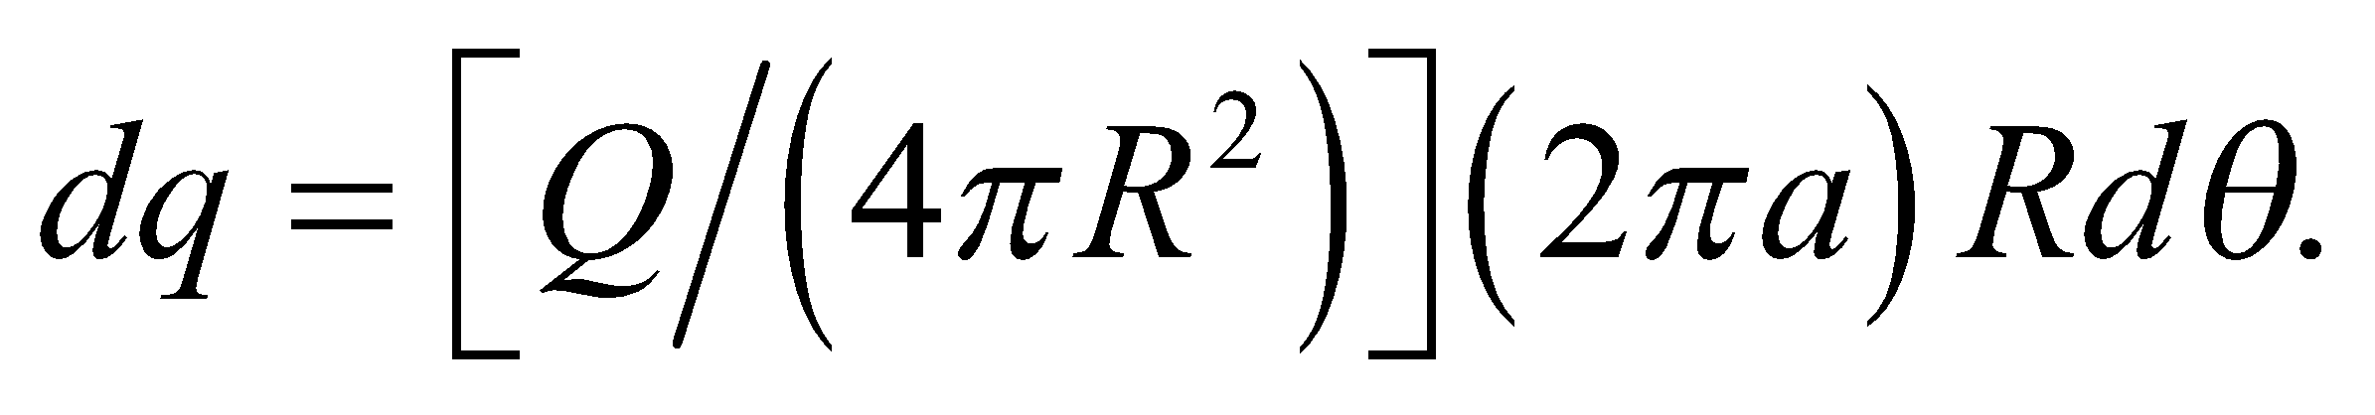 The electric field due to each ring is

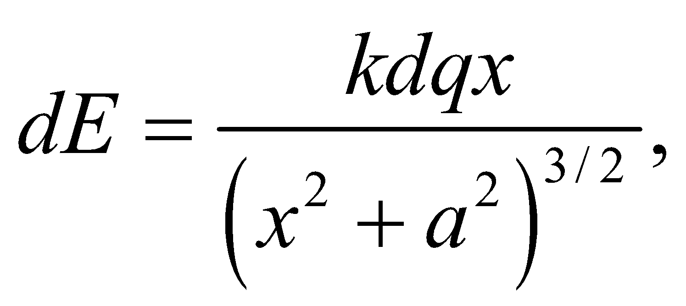

where *x* is the distance from the field point to the ring, 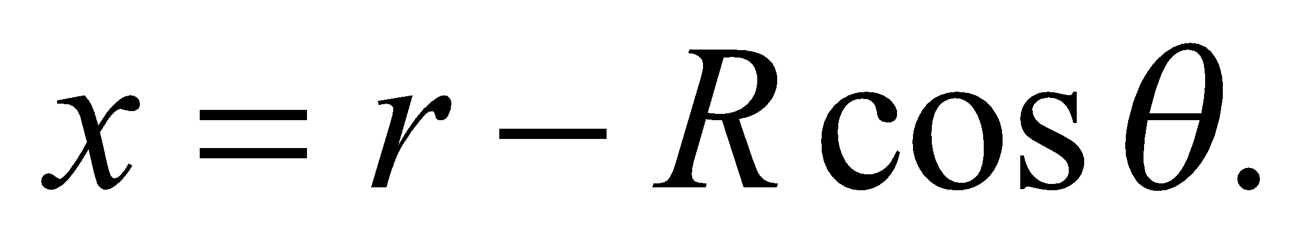 We will integrate from *θ* = 0 to *π*.

**Evaluate**

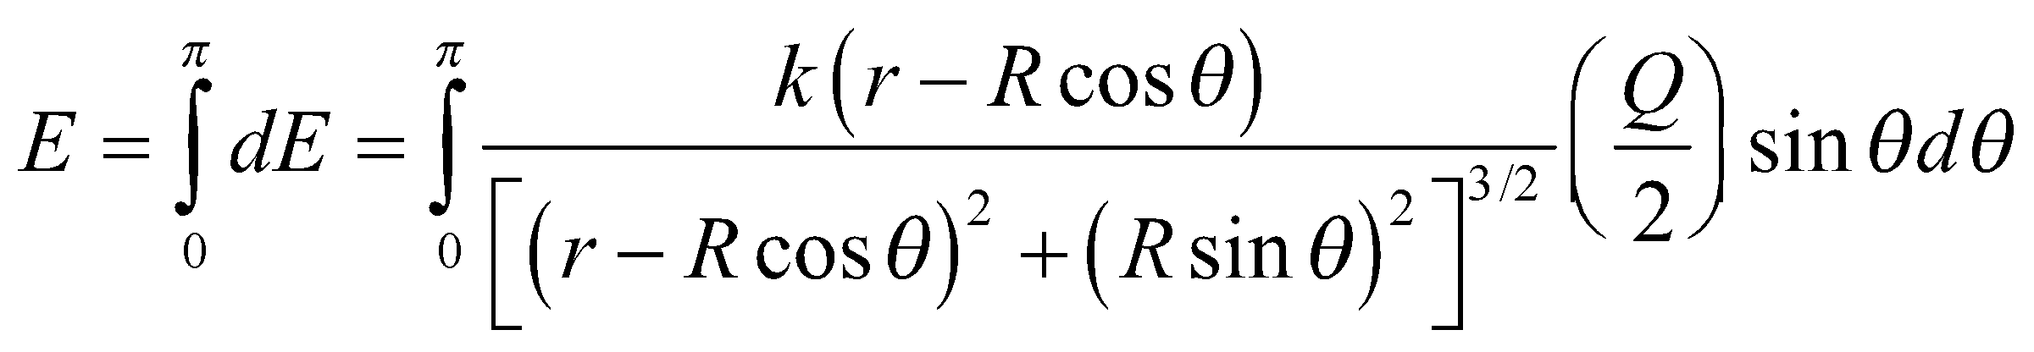

Use of an integral table or computational package shows that for 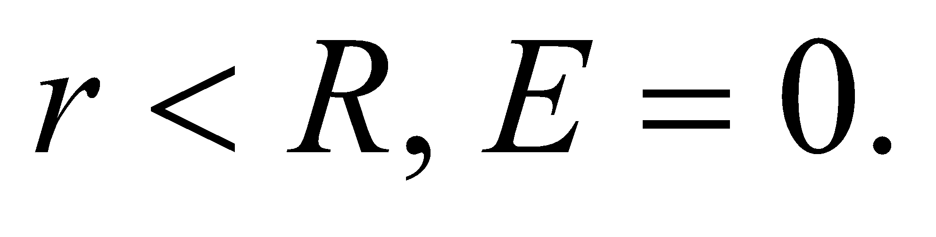 For *r* < *R*, the integral becomes 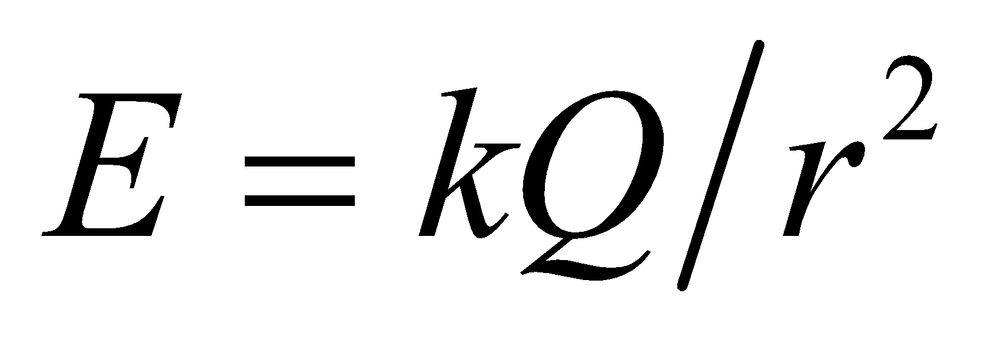.

**Assess** In both cases, this somewhat complicated integral gives us the same results as Gauss’s law.

**69. Interpret** Given a spherically symmetric charge distribution in a sphere, we are to find the electric field at the surface of the sphere. We will use Gauss’s law, and integrate the charge density to find the charge enclosed.

**Develop** The charge density is given by 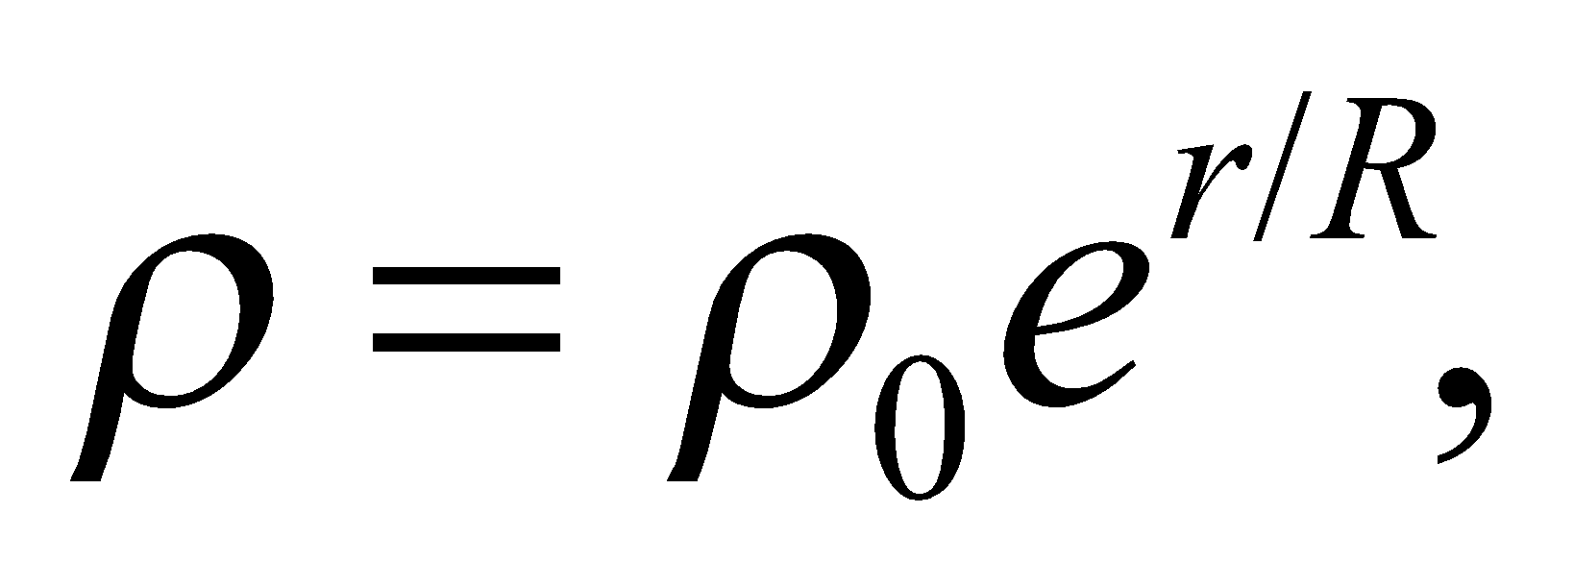 where *r* is the distance from the center and *R* is the radius of the sphere. Gauss’s law tells us that

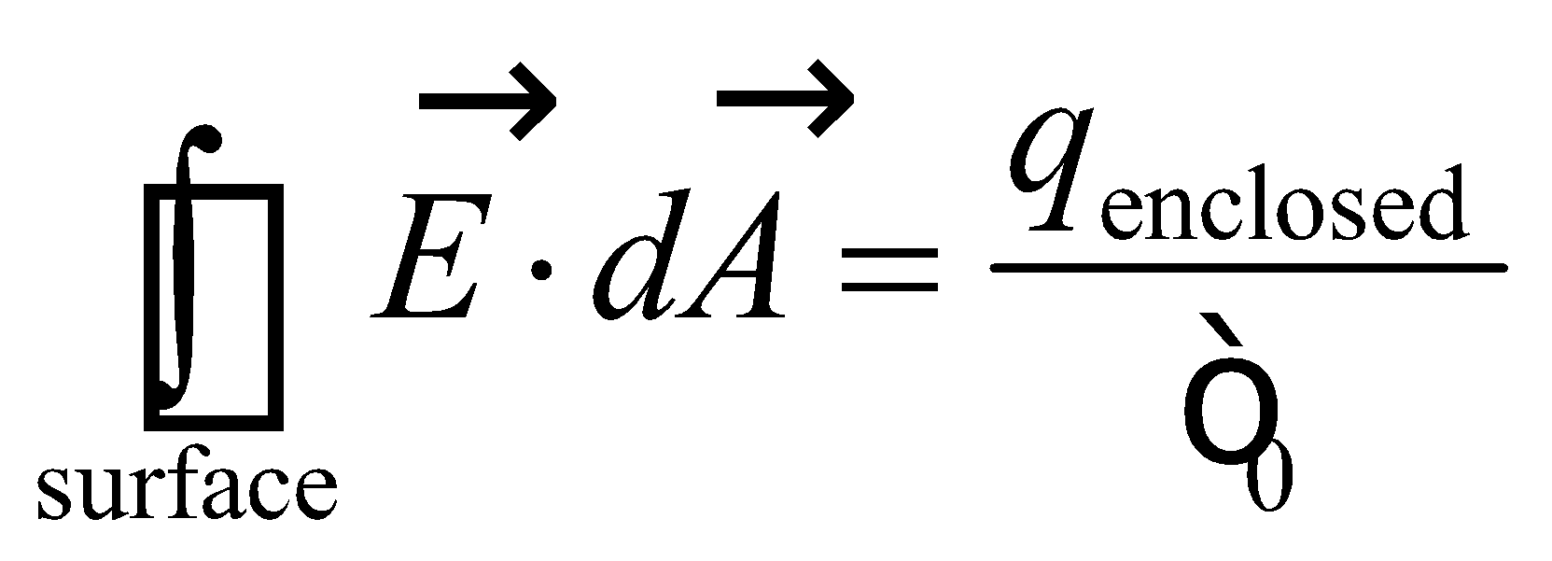

Because the charge density is spherically symmetric, we know that the electric field will not be angularly dependent. In other words, it will be constant over a spherical surface centered at the center of the charged sphere. Furthermore, the same reasoning tells us that the direction of the electric field must parallel to 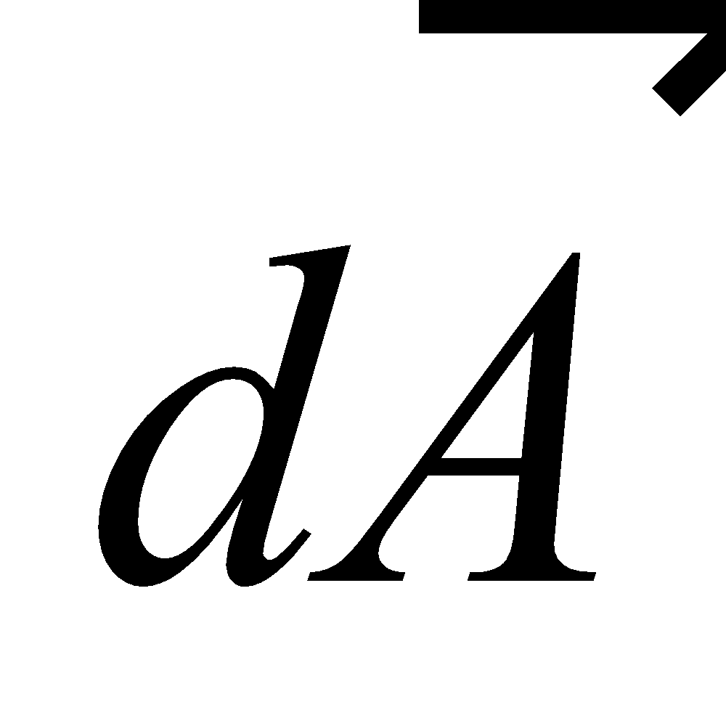 (i.e., radial) so the dot product gives a factor of unity. Finally, the charge enclosed can be calcualated by integrating the charge distribution in the sphere. Thus, we have



**Evaluate** Performing the integration gives

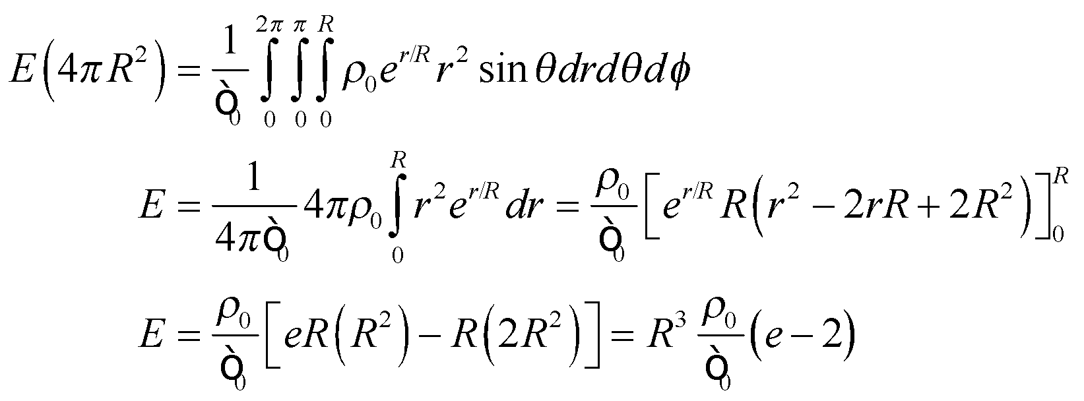

**Assess** This answer is positive so the field points away from the sphere. It is also linear in 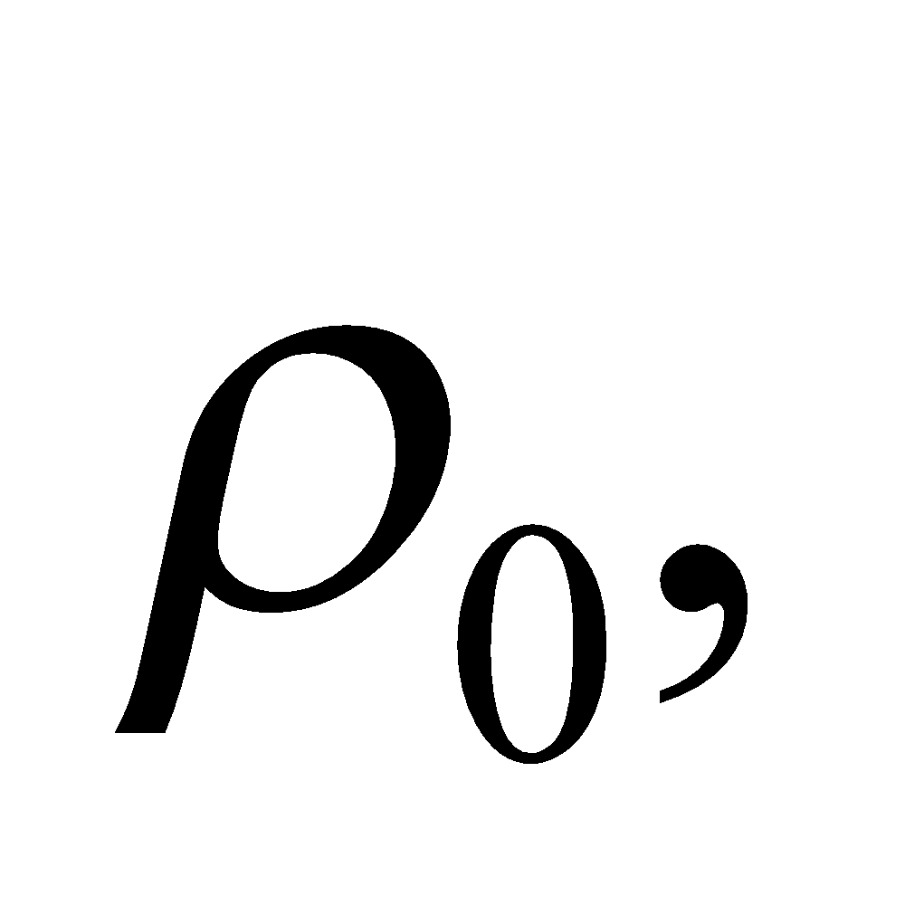 as we would expect.

**70.** **Interpret** We are asked to derive what the gravitational field would be in a hypothetical hole drilled to the center of the Earth.

**Develop** To apply the gravitational version of Gauss's law, we need to choose a suitable Gaussian surface. The gravitational field will point radially inward, so clearly a sphere centered on the Earth is the right choice (see Example 21.1 for a uniformly charged sphere). We will assume that the Earth has a uniform mass density, 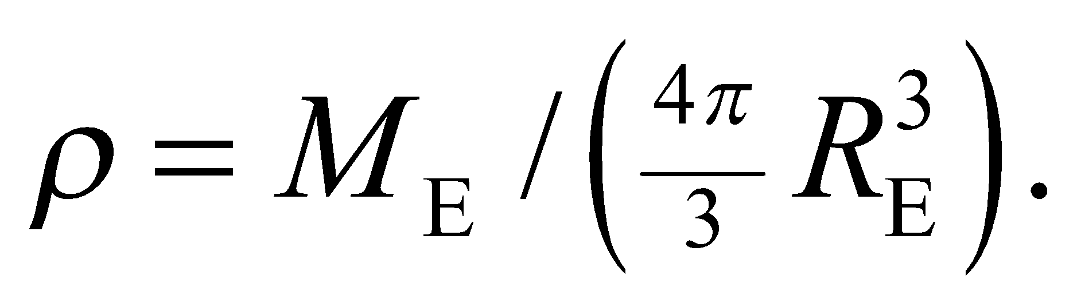

**Evaluate** The mass enclosed by a Gaussian sphere of radius *r* (for 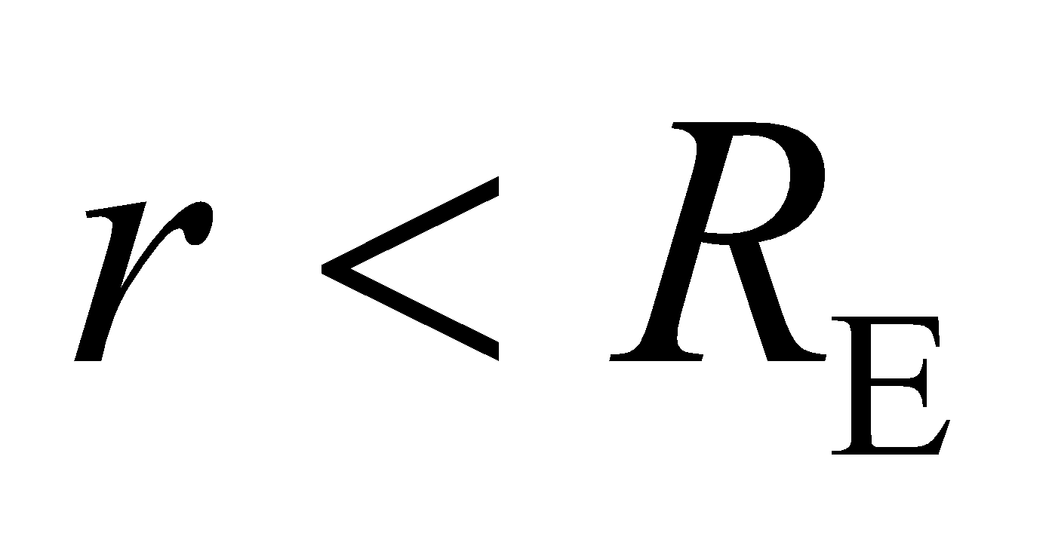) is

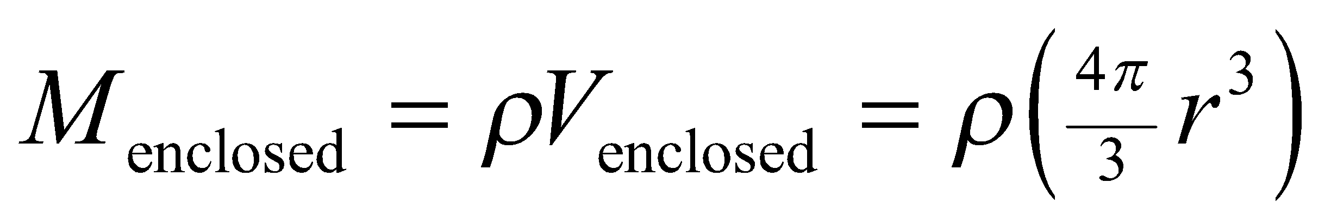

Thus, the gravitational version of Gauss’s law gives



We can simplify this by noting that for 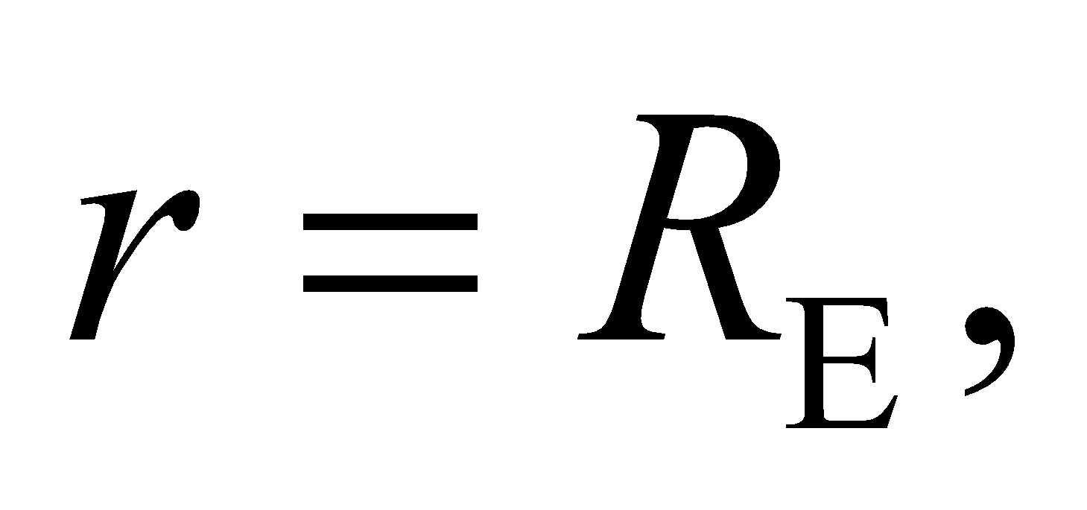 the formula gives the gravitational field at the Earth's surface: Therefore,

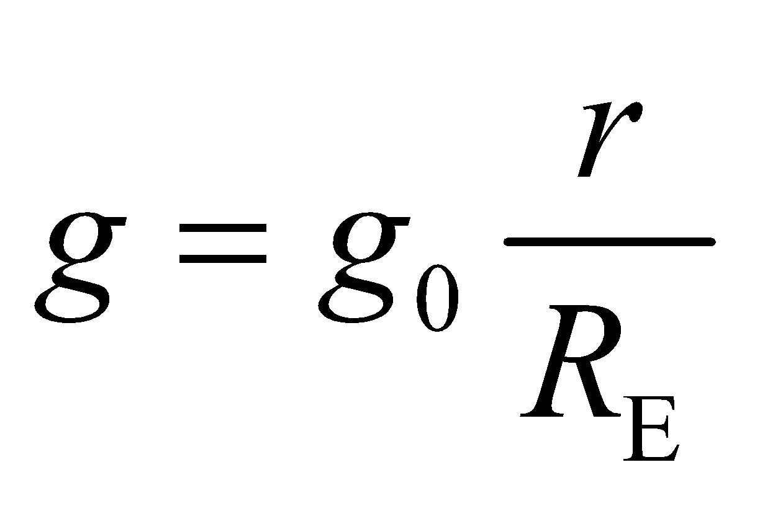

**Assess** The field is negative, corresponding to the attractive nature of gravity. Note that for 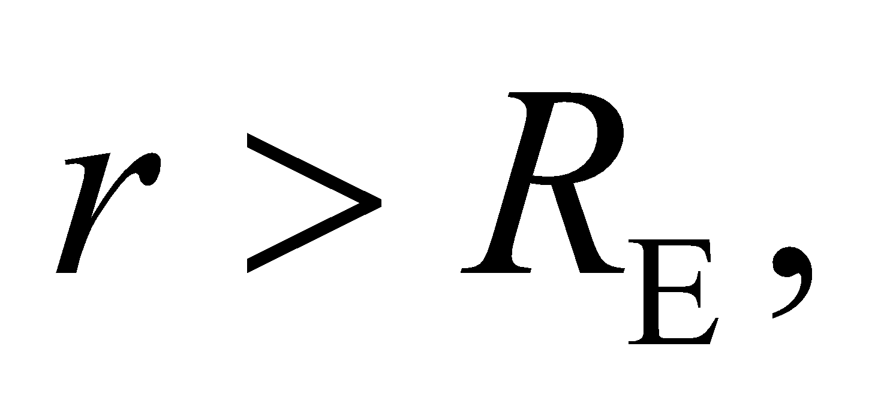 the mass enclosed is the total Earth mass, 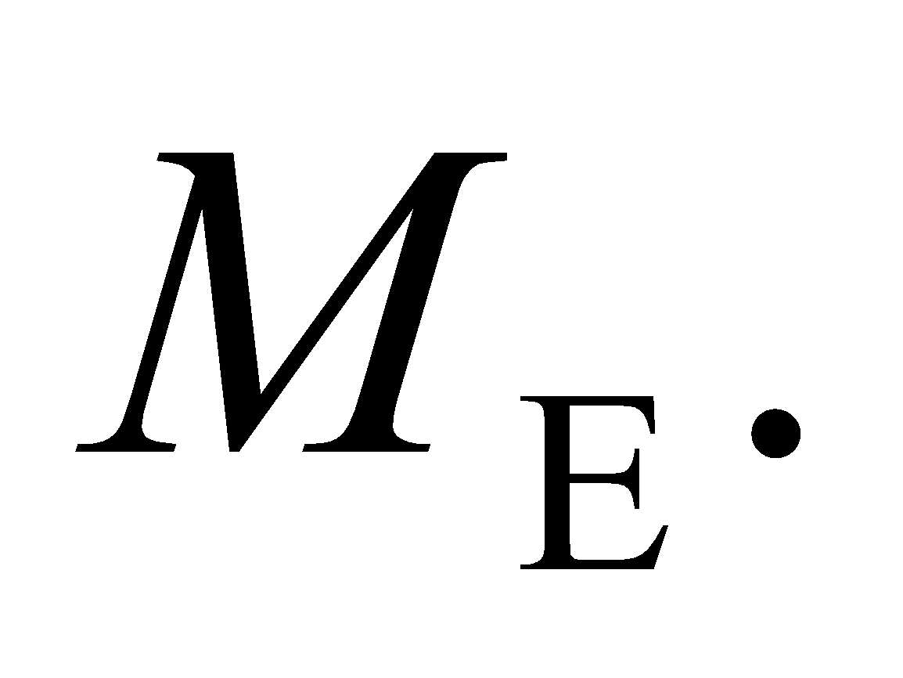 In this case, Gauss's law gives: 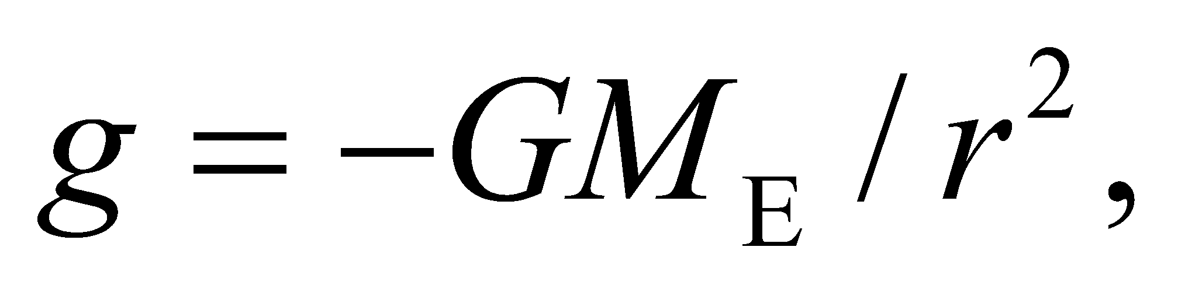which is what we get from Newton's law of gravity (Equation 8.10).

**71.** **Interpret** We consider the electric fields associated with a coaxial cable.

**Develop** The electric field has to be zero within the wire and the shield, since they are both conductors. Charges will line up on the surface of each to ensure that the net field cancels inside. To illustrate this, we draw the cross-section of the coaxial cable in the figure below, assuming for argument's sake that the inner conductor has negative charge and the outer has positive charge.



In the figure, we also include the cross-section of a Gaussian cylinder. If there is a field somewhere, it will be perpendicular to the curved surface of such a cylinder.

**Evaluate** In the region between the wire and shield, the enclosed charge is that of the wire. Since this is non-zero, the field in this region will be non-zero. As for the region outside the shield, the enclosed charge is both that of the wire and the shield, which are equal and opposite. The net charge will be zero, so the field will be zero in this region. To sum up, the only place where the field is not zero is between the wire and shield.

The answer is (a).

**Assess** Unlike the conductors, the insulation can have a non-zero electric field. It's charges are not free to move around until the internal field is zero. However, the insulation may be dielectric, in which case, the alignment of electric dipoles in the material will partially reduce the field (see Figure 20.24).

**72.** **Interpret** We consider the electric fields associated with a coaxial cable.

**Develop** As we argued in the previous problem, the electric field will be zero inside the shield. We have to think what sort of charge distribution will ensure this.

**Evaluate** Let's assume as before that the wire has a negative charge, –*Q*, and the shield has positive charge, *Q*. Let the shield have inner radius 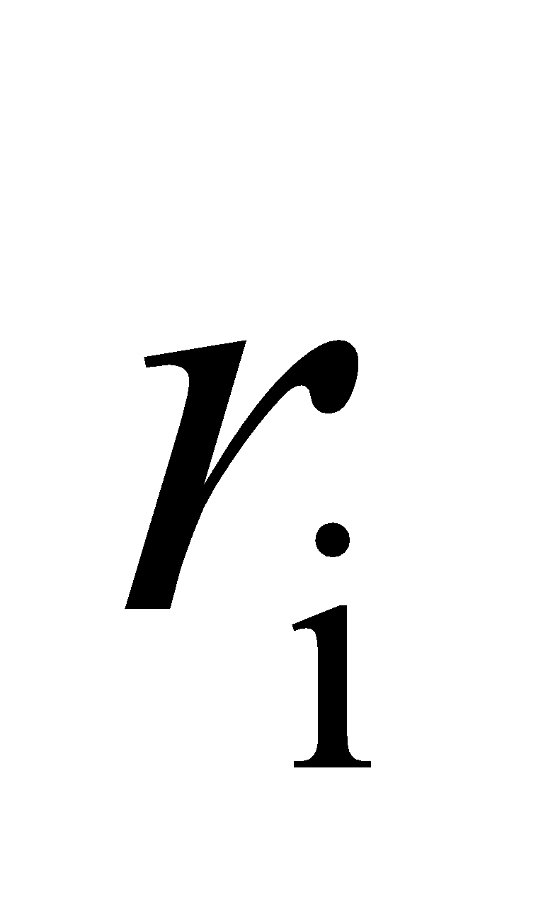 and outer radius 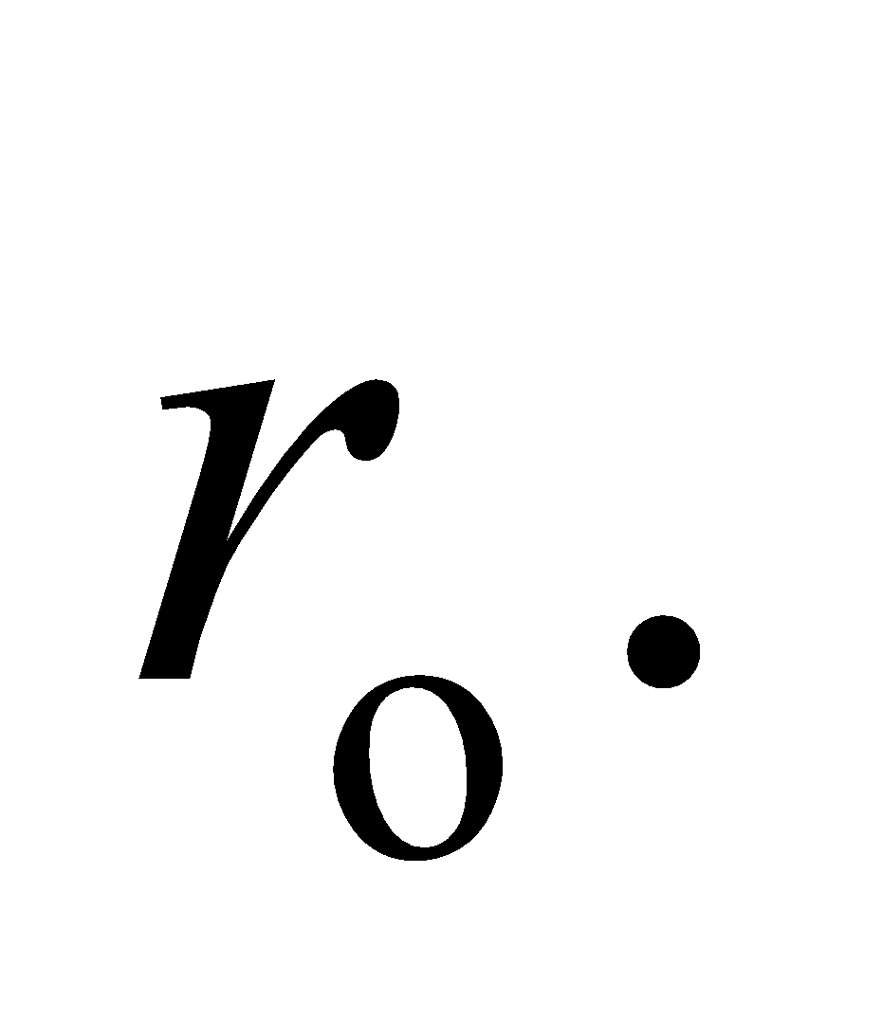 If we choose a Gaussian cylinder with radius *r* such that 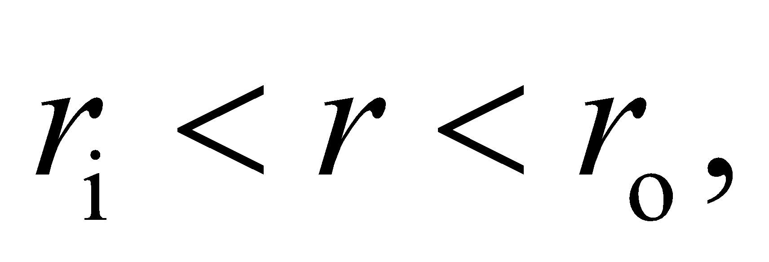then the electric flux will be zero on the surface (since it's curved surface is inside the conductor). This implies that the enclosed charge is zero, which can only occur if all of the shield's excess charge (*Q*) lies on the shield's inner surface.

The answer is (c).

**Assess** We might have guessed at this answer by imagining all of the positive charge in the shield being pulled as close as possible to the negative charge on the wire.

**73.** **Interpret** We consider the electric fields associated with a coaxial cable.

**Develop** To find the field between the wire and the shield, we can use a Gaussian cylinder with length *L* and radius *r* that lies between the two conductors (see figure in Problem 21.71).

**Evaluate** The cylinder will enclose the charge on the wire: 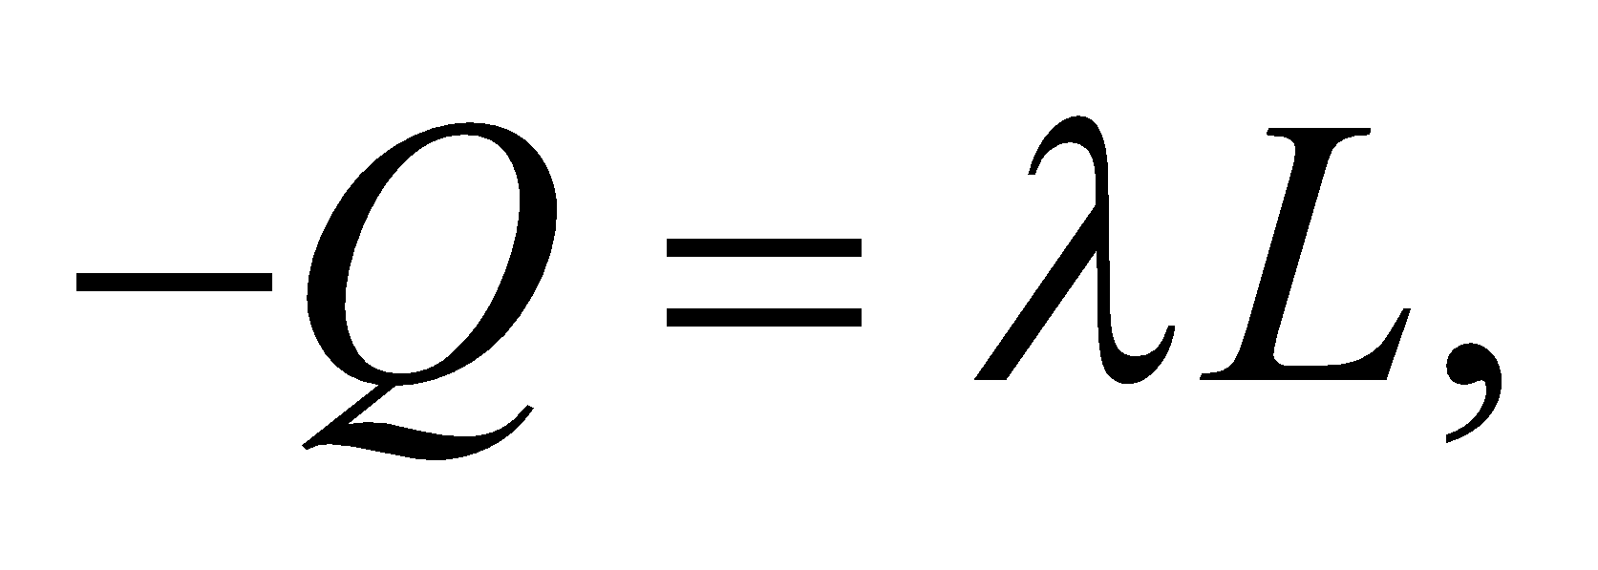 where 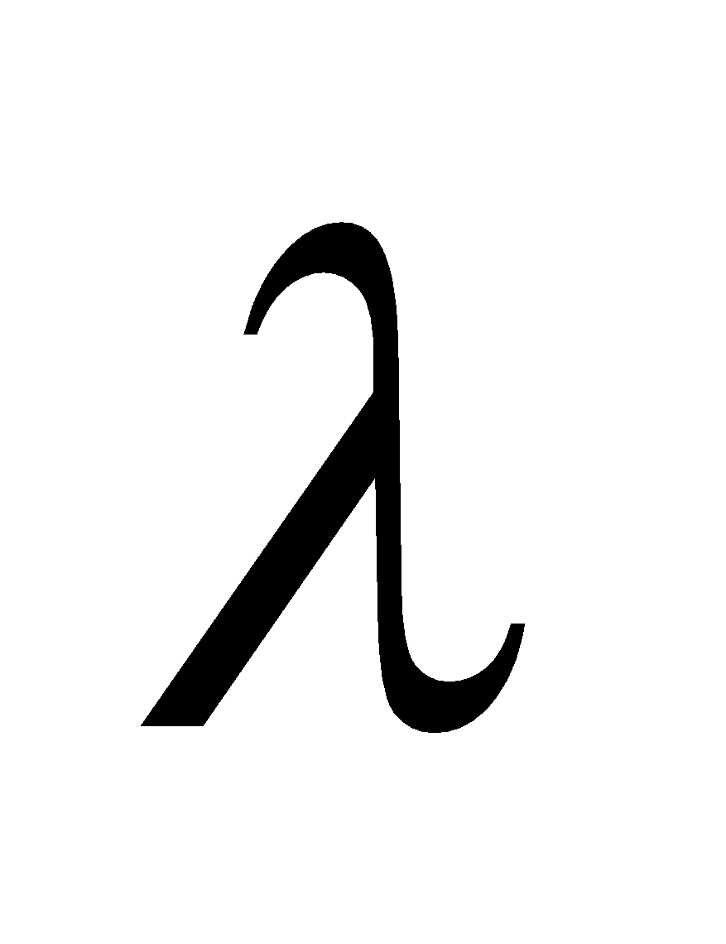 is the charge per unit length. The electric flux is limited to just the outer curved surface:  (see Example 21.4). So the electric field in between the wire and shield will be proportional to 1/*r*.

The answer is (b).

**Assess**Because of the symmetry, the wire's electric field is the same as that of an infinite line of charge. The shield only contributes to the field outside its inner radius.

**74.** **Interpret** We consider the electric fields associated with a coaxial cable.

**Develop** Doubling the charge on the shield will create another layer of charge *Q* on the outer surface. See the figure below. This will maintain zero field inside the conductor (between  and 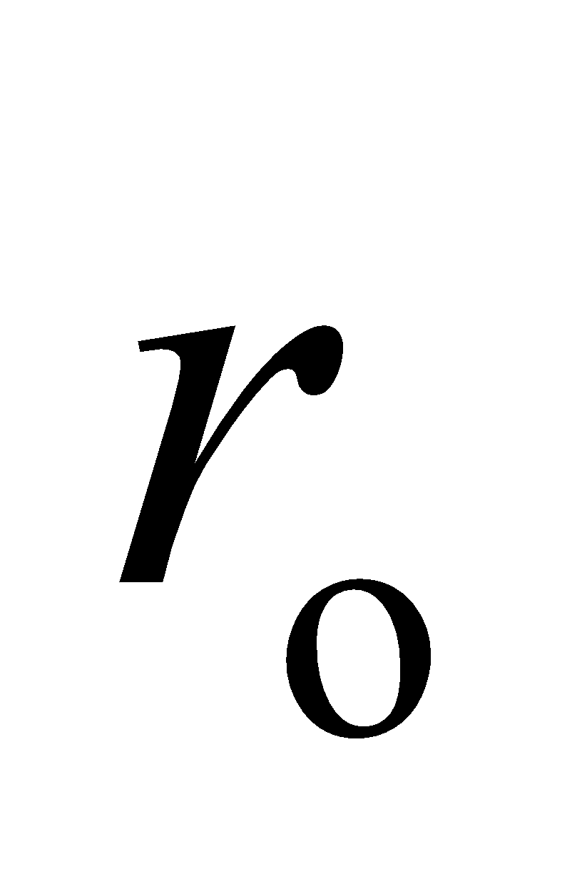), but as a result the field outside the shield will no longer be zero. Note that doubling zero is still zero, so answer (b) is eliminated.



**Evaluate** The additional charge has no effect on the field between the wire and shield, since the same amount of charge (–*Q*) is still enclosed. The field at the inner surface of the shield will be 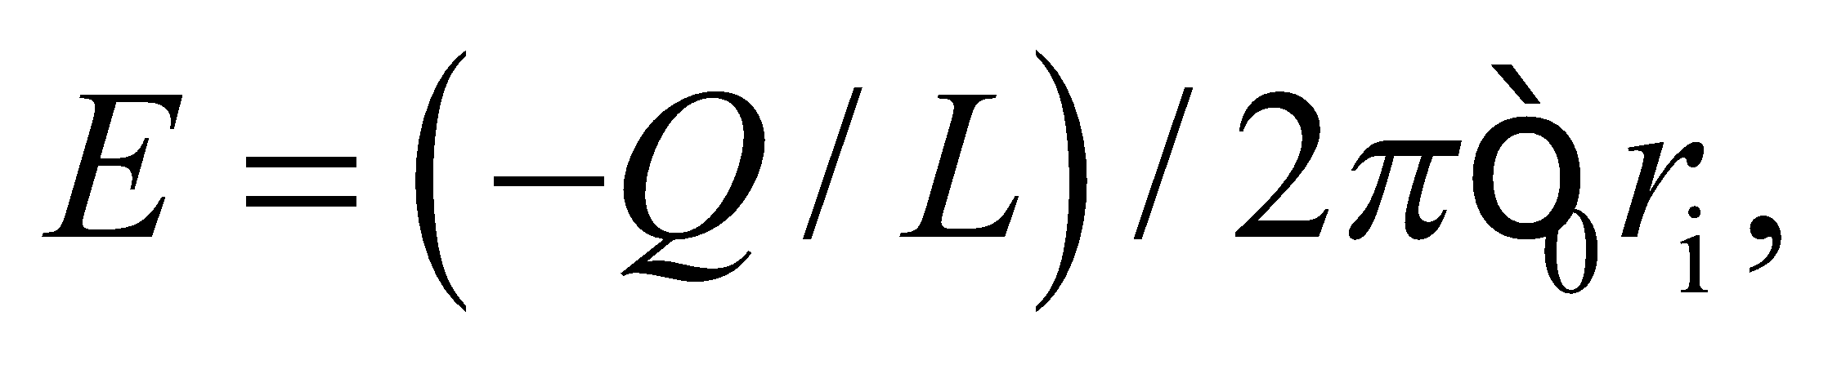where we assume *L* extends for the length of the cable. At the outer surface, the enclosed charge is 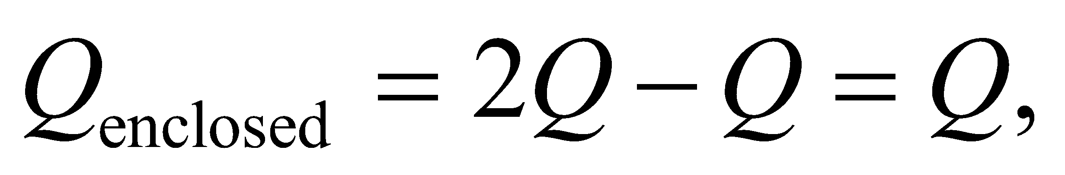 so the field will be  If we assume that the shield is extremely thin, then 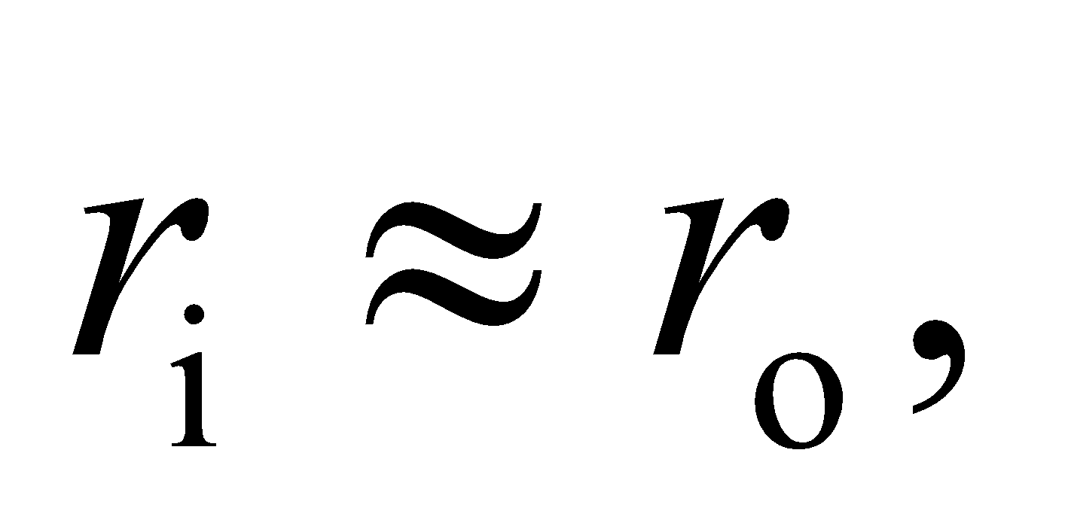and the fields at the inner and outer surface will have equal magnitude.

The answer is (d).

**Assess**The fields have equal magnitude, but they will point in opposite directions. The field on the inner surface points inwards (hence the negative sign in the derivation above), whereas the field points outward on the outer surface.